“Survey based observational Study to Know awareness and Attitude towards social media addiction andAyurveda with its role in De- addiction”
Ranjana Pandey*¹, BalGovind Tiwari²,
M.D. (Roganidan and VikritiVigyan), PhD , Medical Officer Ayurveda , Department of AYUSH, AIIMS Bhopal ( M.P.) dranjanapandey@gmail.com
M.D. (Kayachikitsa), Associate Professor, Department of AgadTantra, Government Ayurvedic College, Atarra (U.P.) vdbalgovind@gmail.com
Abstract-
Introduction-Digital India 2024 report shows that there is 751.5 million internet users are present in India in which 462 million people are social media users. Addiction is defined as a process of inability to control the behavior in repeatedly manner. It brings instant pleasure and provides relief from internal discomfort.
The objectives of the study are related to know awareness and attitude towards Social Media Addiction, to know awareness and attitude towards Ayurveda and to explore role of Ayurveda in the De-addiction.
Methods-The study adopted the self -structured google form basedobservational survey study. A questionnaire was developed having 23 questions. The Google form was circulated on various social media platform through a link.The participants of this survey study were age group of from 18-85 years irrespective of sex. The study population was 300 and out of the 300 participants questionnaires distributed,273participants responded and fill the questionnaire.
Result-The result of the study reveals that mostly all age groups are using the social media especially for entertainment to be happy and for fun. The commonly used social media platform are whats app, Youtube, Instagram and Facebook.62.6% participants have knowledge about social media addiction and its treatment.71.1 % participants are aware about role of Ayurveda in mental health.85% participants prefer Ayurveda and Yoga for the treatment of social Media addiction.
Conclusion-This is the time to explore Ayurvedic principles for the De-addiction of social media users. Need of this Tech era is to develop Ayurvedic psychiatry which would be helpful to our society.

सारांश-
परिचय-डिजिटल इंडिया 2024 रिपोर्ट से पता चलता है कि भारत में 751.5 मिलियन इंटरनेट उपयोगकर्ता मौजूद हैं जिनमें 462 मिलियन लोग सोशल मीडिया उपयोगकर्ता हैं। लत को बार-बार व्यवहार को नियंत्रित करने में असमर्थता की प्रक्रिया के रूप में परिभाषित किया गया है। इससे तुरंत आनंद मिलता है और आंतरिक परेशानी से राहत मिलती है।
अध्ययन का उद्देश्य सोशल मीडिया की लत के प्रति जागरूकता और दृष्टिकोण जानना, आयुर्वेद के प्रति जागरूकता और दृष्टिकोण जानना और नशा मुक्ति में आयुर्वेद की भूमिका का पता लगाना है।
विधियाँ -अध्ययन में स्व-संरचित गूगल फॉर्म आधारित अवलोकन सर्वेक्षण अध्ययन को अपनाया गया। 23 प्रश्नों वाली एक प्रश्नावली विकसित की गई। Google फॉर्म को एक लिंक के माध्यम से विभिन्न सोशल मीडिया प्लेटफॉर्म पर प्रसारित किया गया था। इस सर्वेक्षण अध्ययन में भाग लेने वाले लिंग की परवाह किए बिना 18-85 वर्ष के आयु वर्ग के थे। अध्ययन की जनसंख्या 300 थी और वितरित किए गए 300 प्रतिभागियों में से 273 प्रतिभागियों ने उत्तर दिए और प्रश्नावली भरी।
परिणाम-अध्ययन के नतीजे से पता चलता है कि ज्यादातर सभी उम्र के लोग खुश रहने और मौज-मस्ती के लिए खासकर मनोरंजन के लिए सोशल मीडिया का इस्तेमाल कर रहे हैं। आमतौर पर उपयोग किए जाने वाले सोशल मीडिया प्लेटफॉर्म व्हाट्स ऐप, यूट्यूब और फेसबुक हैं। 62.6% प्रतिभागियों को सोशल मीडिया की लत और इसके उपचार के बारे में जानकारी है। 71.1% प्रतिभागियों को मानसिक स्वास्थ्य में आयुर्वेद की भूमिका के बारे में जानकारी है। 85% प्रतिभागी उपचार के लिए आयुर्वेद और योग को पसंद करते हैं। सोशल मीडिया की लत से.
निष्कर्ष-यह समय सोशल मीडिया उपयोगकर्ताओं की लत छुड़ाने के लिए आयुर्वेदिक सिद्धांतों का पता लगाने का है। इस तकनीकी युग की आवश्यकता आयुर्वेदिक मनोचिकित्सा को विकसित करने की है जो हमारे समाज के लिए सहायक होगी।

Introduction-Digital India 2024 report shows that there are 751.5 million internet users are present in India in which 462 million people are social media users. Statistical data shows that Globally 6.8 billion means 80% population are smart phone users in worldwide [1].Addiction is defined as a process of inability to control the behavior in repeatedly manner. It brings instant pleasure and provides relief from internal discomfort. The person feels inability to control Internet and social media use which leads to anxiety, irritability and dysfunctional behaviors in daily routine. Social Media Addiction may be classified as a behavioral addiction. Study shows that Social Media Addiction would be the main cause for developing various mental disorders in upcoming years. [2, 3]
Ayurveda is not only a medical science but it is science of life with the holistic approach to health and personalized medicine [4]. Asatmyaindriyarth Sanyoga, Pragyapradh and parinaam these three are the main causative factor for diseases in Ayurveda in which it Asatmyaindriyarth Sanyoga means improper use of senses is one of the most important direct cause for mental diseases [5].
This study is carried out to know awareness and Attitude towards social media addiction as well as towards Ayurveda and Role of Ayurveda in the De-addiction. When persons get unwilling things and don’t get willing things means do not fulfilled their desires, then there is vitiated mental doshas in the form of manas bhavas i.e., harsha, kaam, krodha, irshya, shoka etc (Ca. su.11/45). These can be changed into manas vikaras when they will meet a triggering factor with uncontrolled mana and troubled mind (disturb state of dhee, dhriti and smriti). This is the time to explore these Ayurvedic principles for the De-addiction of social media users. Need of this Tech era is to develop Ayurvedic psychiatry which would be helpful to our society. Ayurveda covers all the factors of mental health in the umbrella of Ahhar, Achaar, vichar, Rasayana, Achara Rasayana, Satvavajay chikitsa and yoga with Panchakarma therapies. Satvavajay means Ayurvedic psychological counseling play an important role in de-addiction of social media. [6, 7]

Material and Methods-
Study Design-The study adopted the self -structured google form based observational survey study. A questionnaire was developed having 23 questions. These are closed ended questions with multiple choice and dichotomous answers. This questionnaire was reviewed by subject experts for content validation. After receiving inputs, the questionnaire was developed and used in the survey. For effective collection and distribution of data the structured questionnaire was used.
Sample Size-The population of the study are general public of adult population between 18-85 years of age group irrespective of sex.
Due to wide variation in the prevalence of social media addiction and the less available literature, P is considered as 0.5. By using the formula 4pq/l2, where L was 10% of P, the calculated sample size to be 400. The Google form was circulated to only 300 participants for the study due to short duration for survey.273participants responded and fill the questionnaire.
Aims-
The aim of the study is to explore role of Ayurveda in De-addiction.
Objectives-
- To Know awareness and Attitude towards social media addiction and Ayurveda
Measures-
The Google form was circulated on various social media platform through a link and data was collected with the consent of participation, to know awareness and attitude towards social media addiction and Ayurveda in our society. The Survey study method was used to assess the opinions of the respondents on the awareness about social media addiction and Ayurveda, its impact on health and its various treatments. The aim of the study is to explore role of Ayurveda in De-addiction. This area of research is chosen due to close proximity and very less research on awareness and attitude towards social media addiction and Ayurveda.
Result- 98.2% participants gave their response as ‘Yes’ ready to participate in this survey study and result of this study is as follows-
1. Pie chart showing the Age wise distribution of registered cases
The maximum number of participants were observed in the age group of 18--25(57.1%), followed by the age group 26-35 years(27.8%) and 36-45 years (8.8%) and the minimum frequency was observed in the age group of 66-85 years.
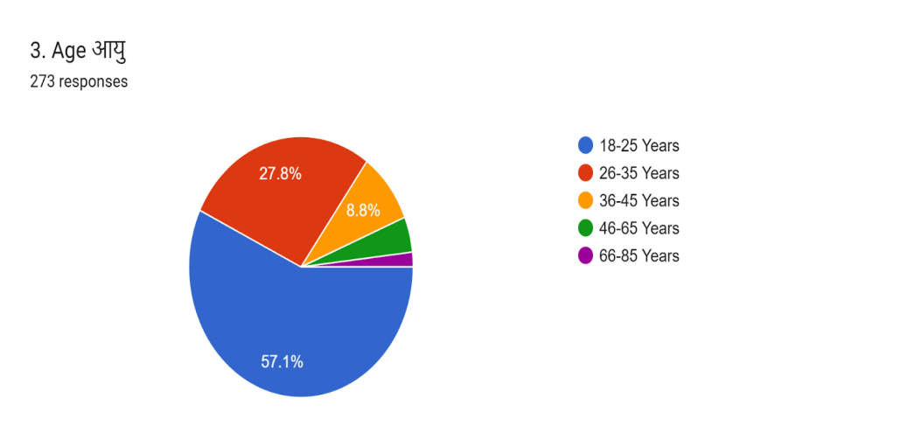
2. Pie chart showing the gender wise distribution of registered cases
Out of total sample of 273 participants 55.7% were male and 44.3% were female. 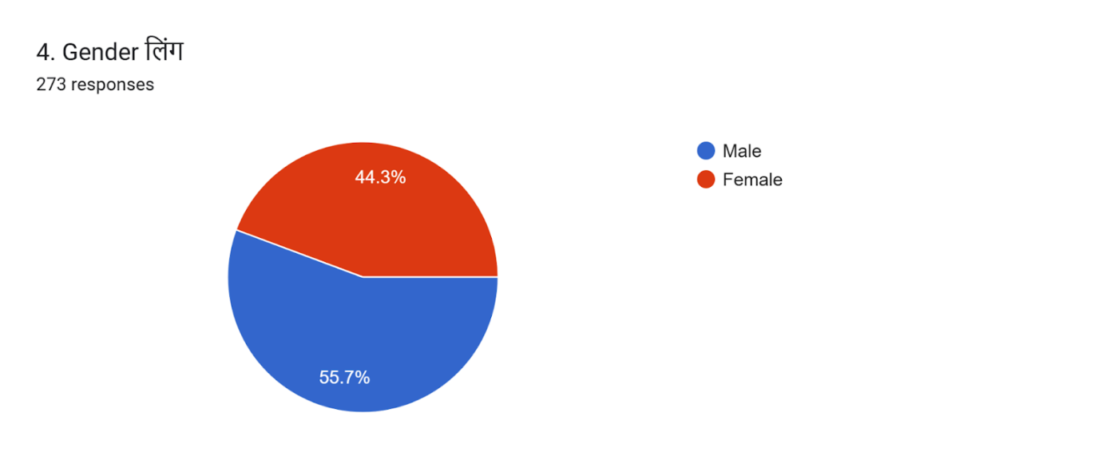

3. Pie chart showing the education wise distribution of registered cases
The maximum number of participants 65.9% were Graduate followed by 17.2% were post-graduate.
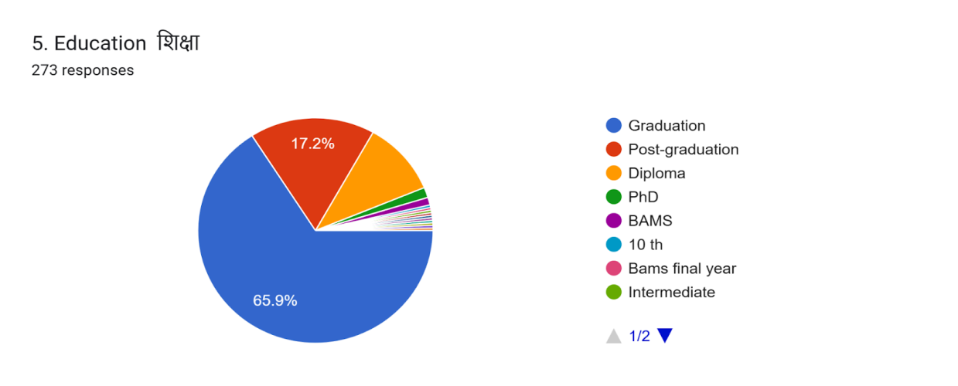
4. Pie chart showing the occupation wise distribution of registered cases
The maximum number of participants 72.5% were students followed by 11% were Private employee and 8.4 % were Government employee.
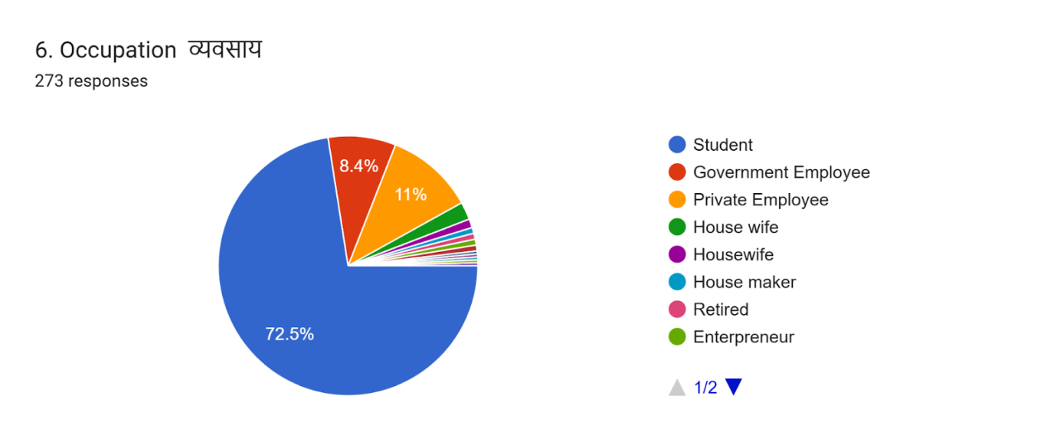
5. Pie chart showing the resident wise distribution of registered cases
The maximum number of participants 52% were belong to urban area followed by 34.8% were residing at rural area.
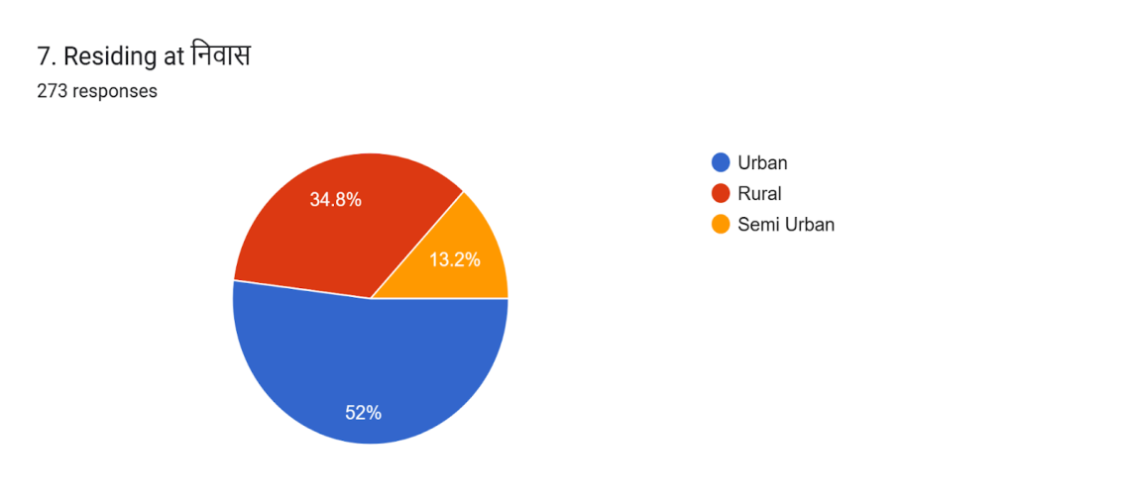
6. Pie chart showing the other Addiction wise distribution of registered cases
The maximum numbers of participants (93.8%) have no other addiction.
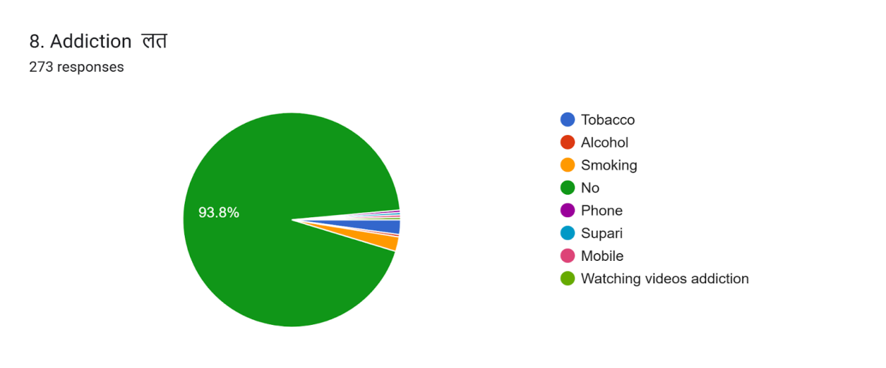
7. Pie chart showing the commonly used media platform wise distribution of registered cases
The maximum number of participants 33% commonly used media platform was whats app followed by 31.1% Instagram and 28.2% Youtube then Facebook.
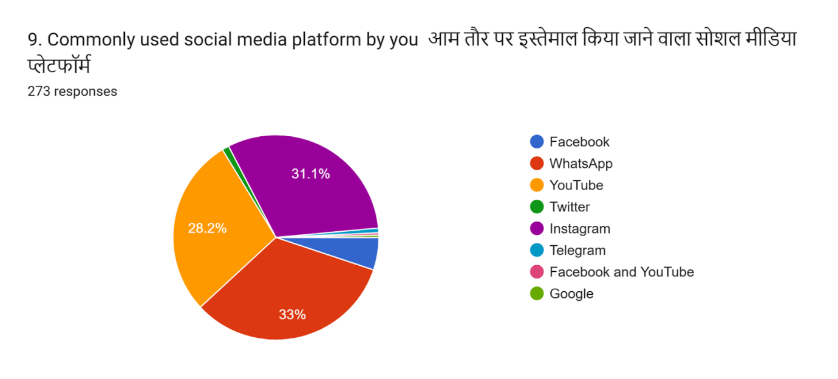
8. Pie chart showing the purpose wise use of social media app distribution of registered cases
The maximum number of participants 46.5% used social media app for Entertainment/OTT/ web series followed by 39.6% for educational purpose.
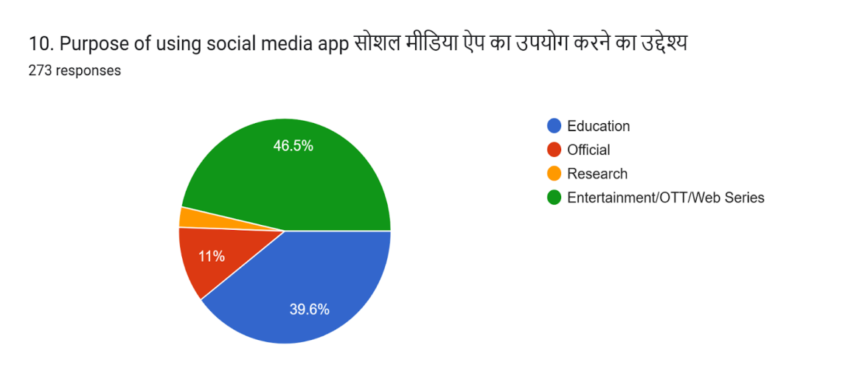
9. Pie chart showing the time spend on social media wise distribution of registered cases
The maximum numbers of participants 42.9% spend the time 1-2 hours on social media everyday for watching videos/reels followed by 30.4% spend 2-4 hours and 13.2% spend more than 4 hours.

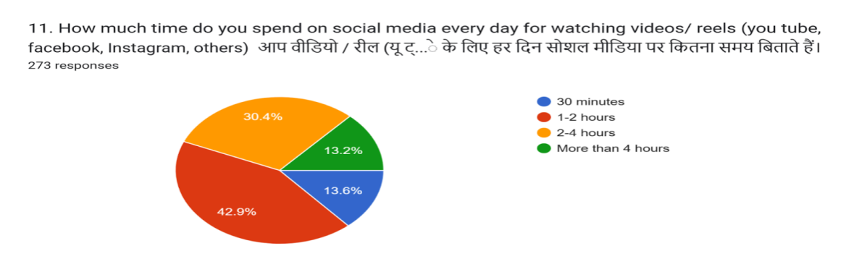
10. Pie chart showing the time distribution with family and friends of registered cases
42.1% participants spend more than 4 hours with family/ friends without social media followed by 38.5% spend only 1-2 hours.
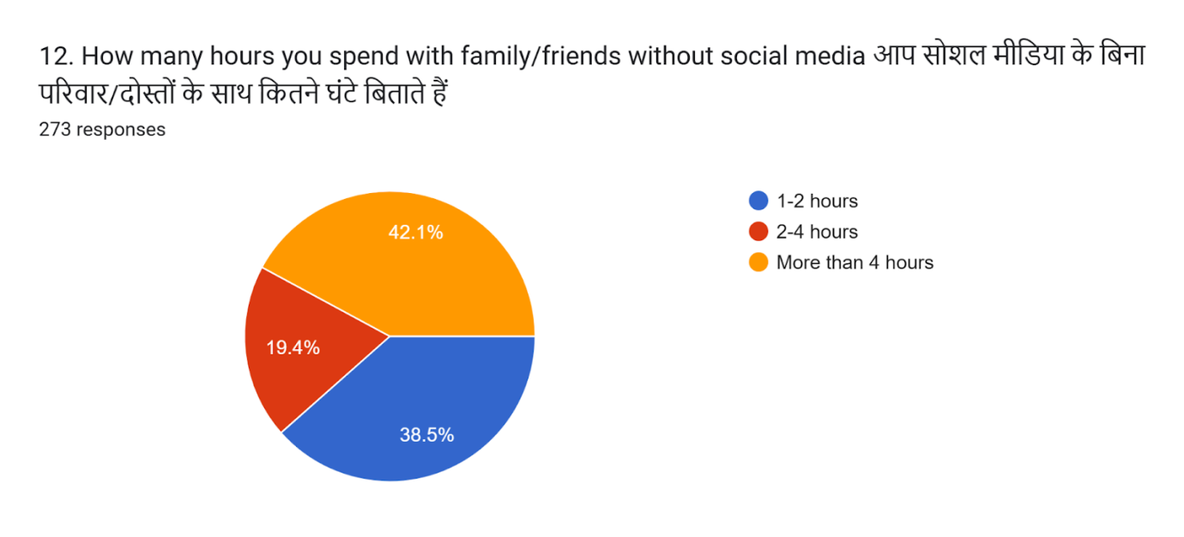
11. Pie chart showing the spend time on social media of registered cases
The maximum numbers of participants 58.2% spend time on social media to be happy and for fun followed by 22.7% to avoid loneliness and boredom.
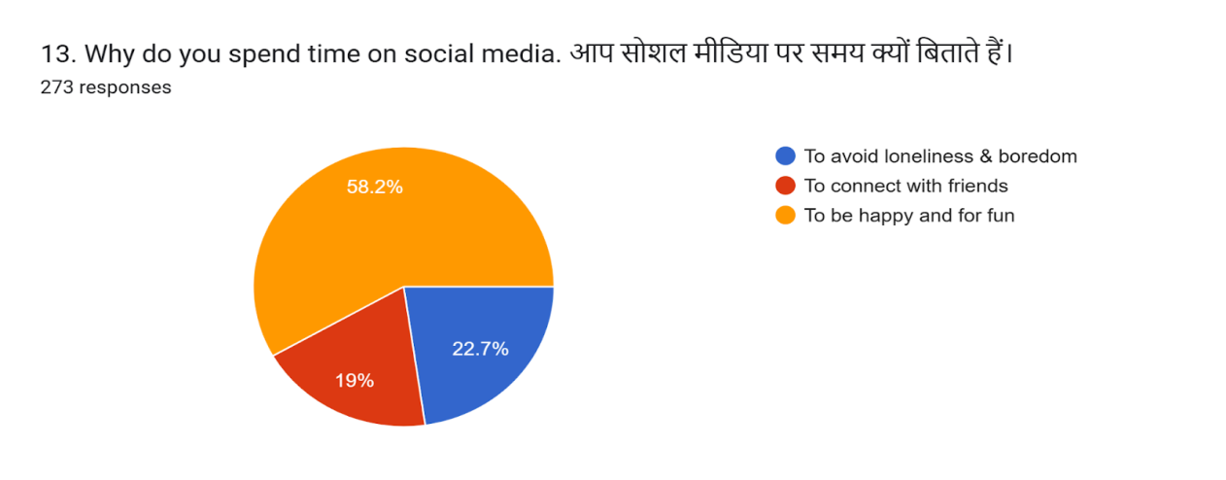
12. Pie chart showing the feeling on unable to use of registered cases
20.9% participants feel irritability/ anxious/angry when unable to use social media.
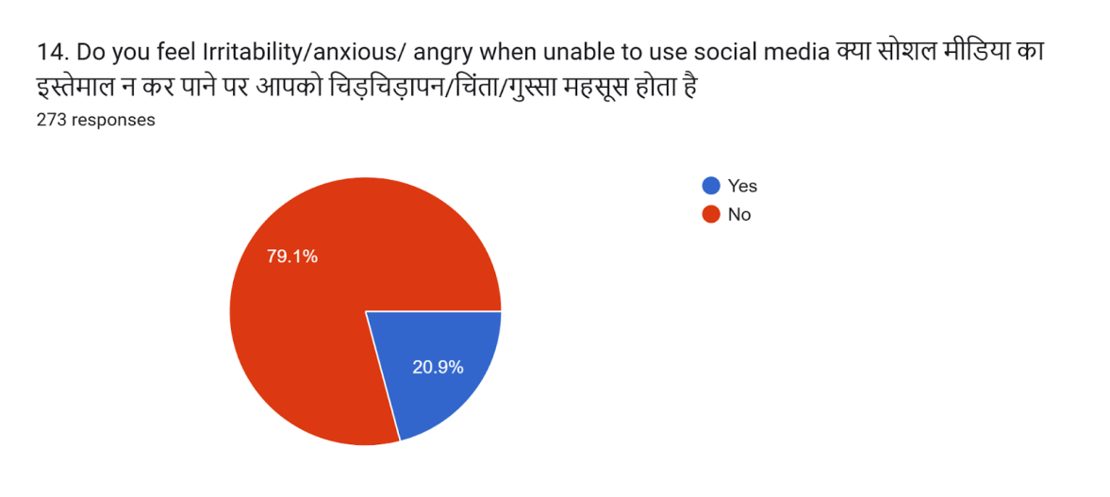
13. Pie chart showing the effect of long use of social media on relation of registered cases
24.5% participants accept that relation with family members or friends are affected due to long use of social media.
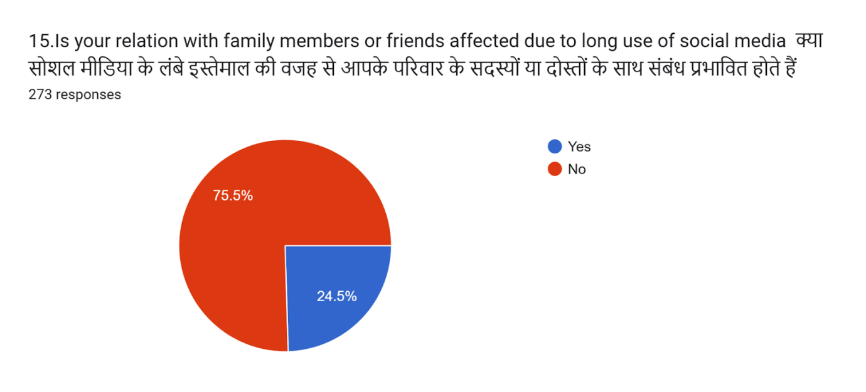
14. Pie chart showing the unable to give proper time to family and friends of registered cases
24.5% participants accept that they are unable to give proper time to family and friends due to long use of social media.
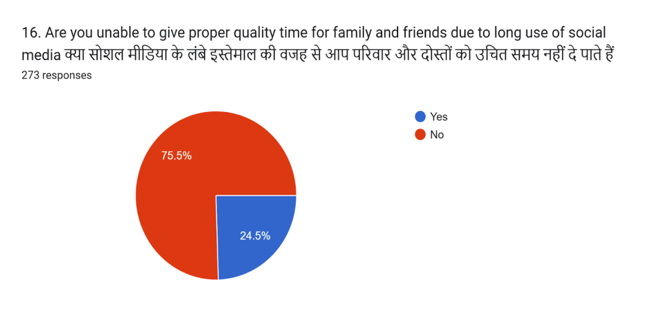
15. Pie chart showing the frequency of other addiction reduced due to social media of registered cases
44 % participants feel that frequency of other addiction is reduced due to social media.
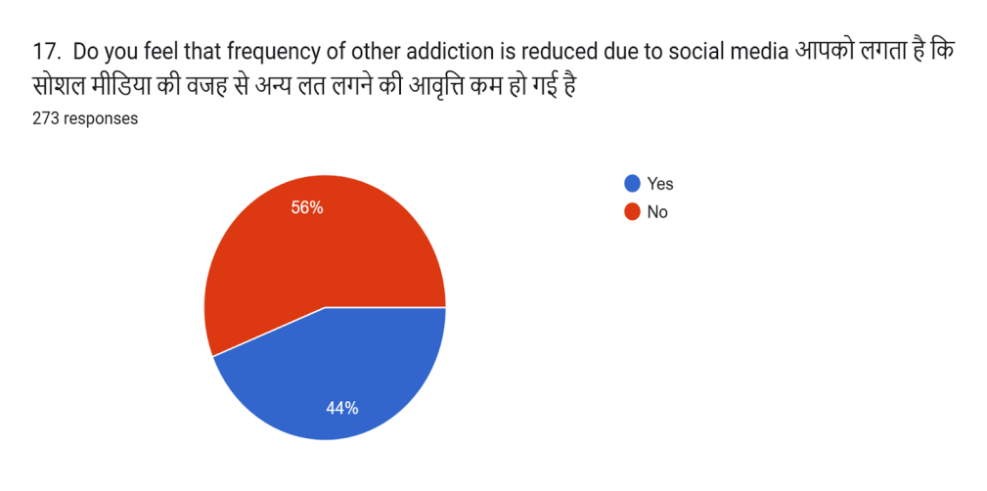
16. Pie chart showing the social media use has negative impact on health of registered cases
The maximum number of participants 62.3% feel that social media use has negative impact on their health (Physical health Mental health Both).

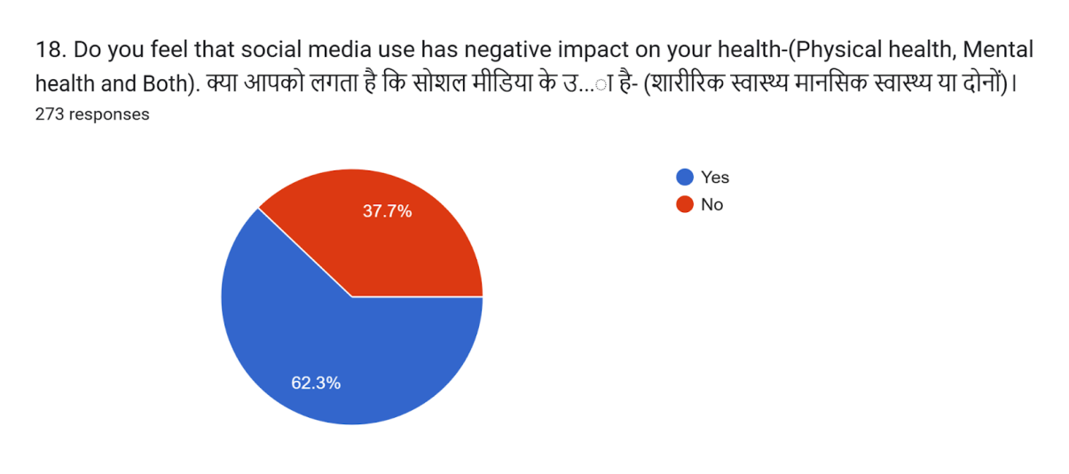

17. Pie chart showing escape from social family or friend gathering of registered cases
35.2% participants avoid social/family/friends gathering or parties.
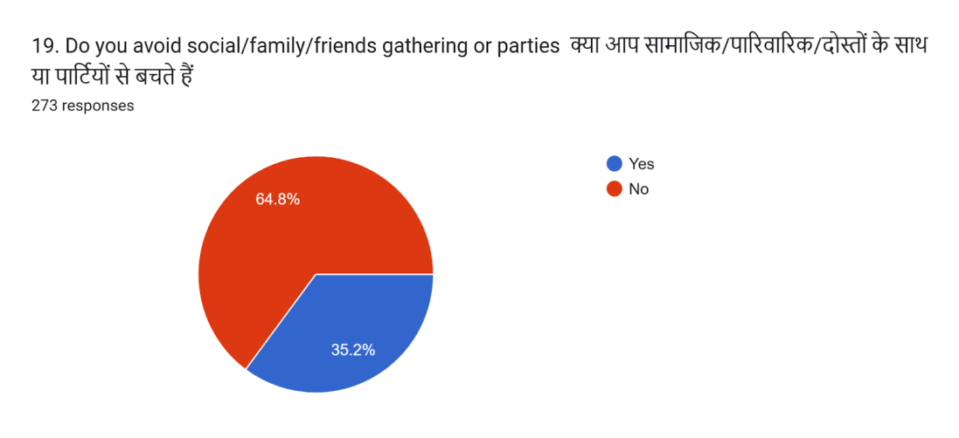
18. Pie chart showing knowledge about social media addiction of registered cases of
The maximum numbers of participants 62.6% accept that they have Knowledge about social media addiction and its treatment.
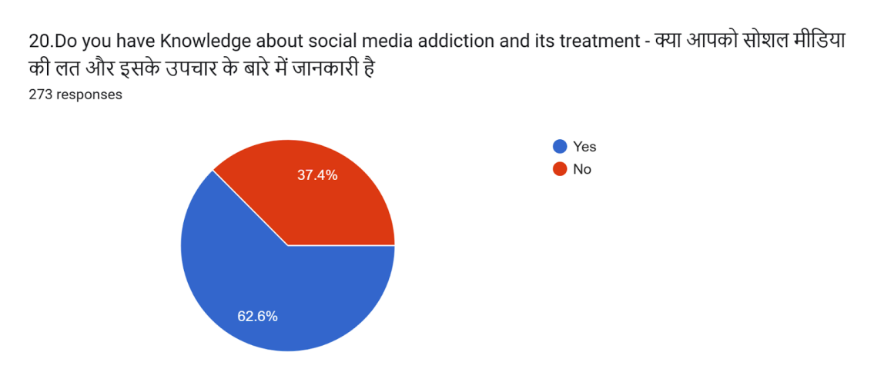
19. Pie chart showing the awareness of Ayurveda for mental health of registered cases
The maximum numbers of participants 71.1% are Aware about Role of Ayurveda for your mental health.
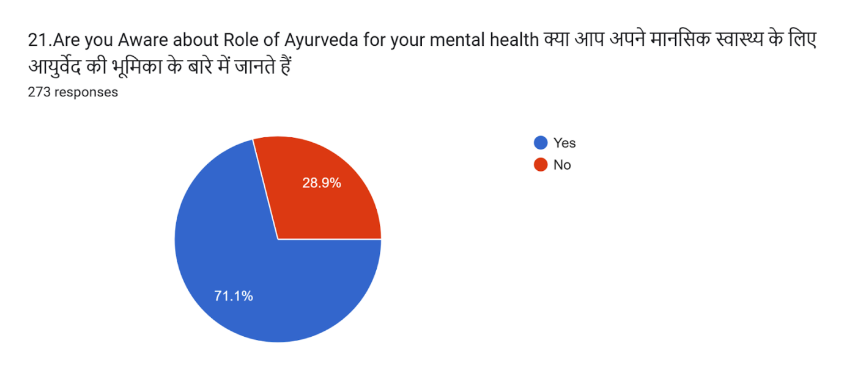
20. Pie chart showing the willing to take advice for social media addiction of registered cases
The maximum numbers of participants 62.3% don’t want to take advice/ counseling/ therapy/ consultation for social media addiction and 37.7% want to take advice/ counseling/ therapy/ consultation for social media addiction.
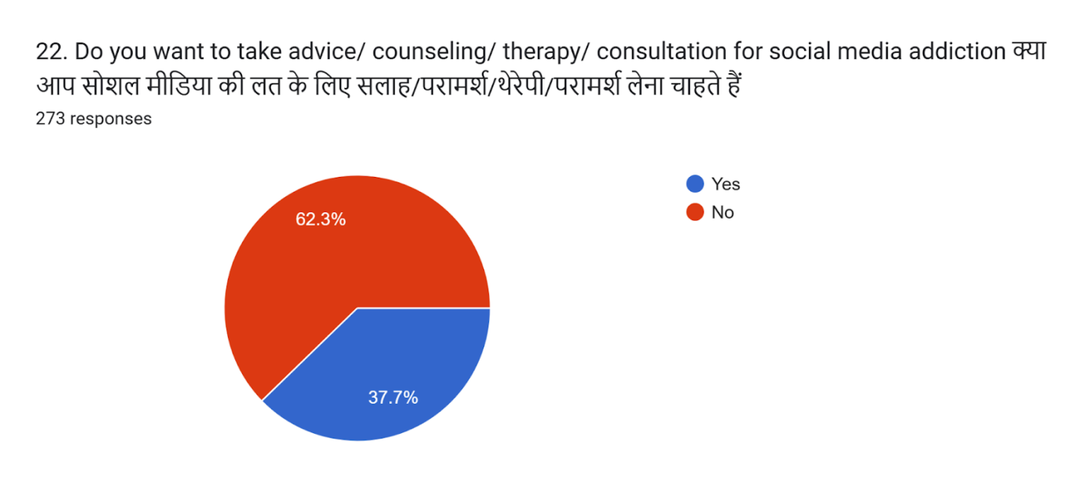
21. Pie chart showing the treatment interest for social media addiction of registered cases
The maximum numbers of participants 85% would prefer Ayurveda and Yoga treatment for their social media addiction.
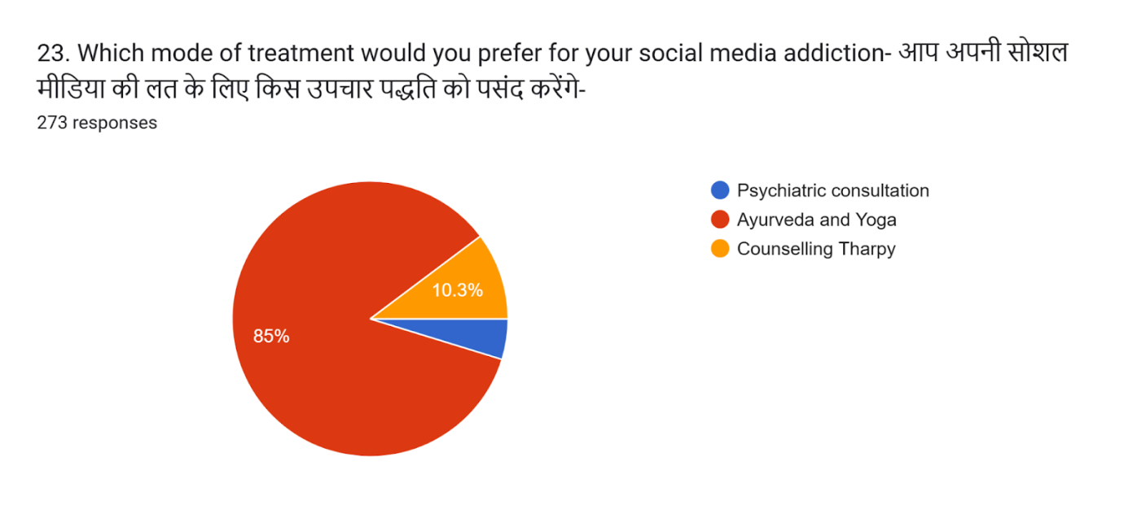
Discussion- Out of total sample of 273 participants 55.7% were male and 44.3% were female Some Earlier research studies show that there is no positive association in between gender and cell phone usage.[8]However, a few Indian researchers suggest that phone usage was higher among males than the females.[9,10]
The maximum number of participants were observed in the age group of 18--25(57.1%), the maximum number of participants 72.5% were students and 65.9% were Graduate. This is student age group of graduation and few Studies state that young adults 18-25 never switched off their cell phones and it increases as the age advances till 35 years. [11]
Present study shows that the commonly used social media platform are whats app, Youtube, Instagram and Facebook and 46.5% participants used social media app for Entertainment/OTT/ web series followed by 39.6% for educational purpose and 13.2% participants spend more than 4 hours. 38.5% participants spend only 1-2 hours with family and friends. 58.2% spend time on social media to be happy and for fun. Earlier study shows that social media sites may be one of the reasons for the excessive use of smart phones by the adolescents. [12]
20.9% participants feel irritability/ anxious/angry when unable to use social media and 24.5% participants accept that relation with family members or friends are affected due to long use of social media and unable to give proper time to family and friends due to long use of social media. It shows behavioral/ technology addiction towards mobile phones and social media. [13, 14]
44 % participants feel that frequency of other addiction is reduced due to social media. It may be a positive impact to reduce substance addiction like tobacco, alcohol, smoking etc.
62.6% participants have knowledge about social media addiction and its treatment.71.1 % participants are aware about role of Ayurveda in mental health.85% participants prefer Ayurveda and Yoga for the treatment of social Media addiction. This study shows that awareness towards Ayurveda is increased today and society shows positive attitude towards Ayurveda and prefer to take Ayurveda for mental health.

Psychoanalytic Approach of Ayurveda for De-addiction
All the Mental functions are basically performed in three steps at the level of conscious, subconscious and unconscious mind.
1. Cognitive phase (Thought) of mental functions- Mana, Buddhi, Sangyagyan,
Smriti (Conscious mind)
2. Affective phase (Emotions) of mental functions- Sangyagyan, Smriti,
Bhakti and sheela) Subconscious mind
3. Behavioral phase (Actions) of mental functions-(Cheshta & Achaar) Unconscious mind
Social Media addiction may be defined as Behavioral phase mental dysfunction which comes under Cheshta and Achaar vibhram in Ayurveda. There are four basic constituents for mental level i.e., sensory & motor organs (indriyas), their objects (indriyarthas), sattva (mana) & buddhi. Chakrapani says that aharcheshta and acharcheshta both are basic necessitate for maintaining physical and mental health (Chakrapani Ca.su.8/1-2).
The Ayurvedic plan for De-addiction depends upon following things:
1. Ahara cheshta (food habits- what, when and how)
2. Achaar Chesta [Behavioral phase (Actions) of mental functions]
3. Satmaindriyartha samyoga
4. Use of sadvritta
5. Use of achar rasayana
6. Prakriti specially manas prakriti
7. Medhya Rasayan with other medicines
8. Pnchakarma Therapies with Satvaavajay Chikitsa

Conclusion- Ayurveda gives more emphasis on the examination of any mental patient in the aspect of eight mental faculty i.e., mana, buddhi, sangyagyana, smriti, bhakti, sheela, cheshta and achara. (Ca.Vi.7/5). In swasthadhikar Chakrapani says that aharcheshta & acharcheshta both are basic necessitate for maintaining physical & mental health. In which mental health is indirectly depend upon aharchesta and directly depend upon acharchesta. Indriyopkramdiya, Sadvritta, Achar Rasayana and Manas Prakriti with other contributing factors are included in acharchesta. So these play an important role in the prevention and treatment of mental illness. This survey study shows that our society is aware about social media addiction and its impact on physical and mental health and it shows positive attitude towards treatment of addiction with the help of Ayurveda and Yoga. This is the time to explore Ayurvedic principles for the De-addiction of social media users as well as for mental health. Need of this Tech era is to develop Ayurvedic psychiatry which would be helpful to our society.
Source of Support: Nil
Conflict of Interest: None
Acknowledgments: The authors extend special thanks to Dr. Bipin Mishra, Associate Professor, Department of Roga nidan and vikriti vigyan, Swami Kalyandev Government Ayurvedic Medical College Muzzafar Nagar, Uttar Pradesh, for helping in framing and circulating the questionnaire. Dr. Durga Prasad Das , Associate Professor, Department of Basic Principles, Government Ayurvedic Medical College, Atarra, Banda, Uttar Pradesh for giving their valuable suggestions during the study. Authors are also grateful to all the subject experts who spend their valuable time for developing questionnaire and all the participants who participated in this survey.
Criteria for inclusion in the authors'/ contributors' list-
- Author 1-a. Literature Review
b. Introduction, Methedology, framing of questionnaire
c. Discussion and conclusion
2. Author 2- a. Reframing and finalizing the questionnaire
b. Observation and Result
c. Framing of chart and proof reading of article.

References-
- https://www.statista.com/statistics/330695/number-of-smartphone-users-worldwide/
- Adamu Ismaila1 , Mustapha Abubakar Jumare2 Yunusa Hassan the Use Of Social Networking Sites And Its Effects On Undergraduate Students Of National Institute Of Ayurveda Jaipur, India 2nd ICETEMR-17 May 2017 www.conferenceworld.in
- Chauhan et al.A Cross -Sectional Study On Concept Of Asatmya Indriyarth Sanyoga (Atiyoga Of Chakshuindriya) With Special Reference To Internet Addiction (I.A)World Journal of Pharmaceutical ResearchVol 13, Issue 6, 2024.www.wjpps.com
- Chauhan A, Semwal DK, Mishra SP, Semwal RB. Ayurvedic research and methodology: Present status and future strategies. Ayu., 2015 Oct-Dec; 36(4): 364-369. doi: 10.4103/0974-8520.190699. PMID: 27833362; PMCID: PMC5041382.
- Dr. Deepmala Rathore1, Dr.S.N. Tiwari2, Dr.PravanjanAcharya. AsatmyendriyarthaSamyoga is a Major Culprit for Life Style Disorders. International Journal for Multidisciplinary Research (IJFMR), March-April 2023; 5(2).IJFMR23022559 3.
- Sharma et al.Neutralizing The Stress Caused As An Outcome Of Social Media Over Addiction Through Ayurveda- A ReviewWorld Journal of Pharmaceutical ResearchVol 12, Issue 11, 2023. │ ISO 9001:2015 Certified Journalwww.wjpps.com
- Amit et al.Repercussion Of Internet Use And Its Ayurvedic RestorationWorld Journal of Pharmaceutical ResearchVol 10, Issue 13, 2021.www.wjpps.com
- Bianchi A, Phillips JG. Psychological predictors of problem mobile phone use. CyberpsycholBehav. 2005;8(1):39-51
- P. Stalin, Sherin Billy Abraham, K. Kanimozhy, R. Vishnu Prasad et al. Mobile phone usage and its health effects among adults in a semi-urban area of southern India. Journal of clinical and diagnostic research.2016;10(1):LC14-LC16.
- Chimatapu Sri Nikhita,Pradeep R Jadhav, Shaunak A. ajinkya. Prevalence of mobile phone dependence in secondary school adolescents. Journal of clinical and diagnostic research, 2015;9(11):VC06-VC09
- Jose De Sola Gutierrez, Fernando Rodriguez de Fonseca, Gabriel Rubio. Cell phone addiction: A Review. Frontiers in Psychiatry.2016;7:175. doi: 10.3389/fpsyt.2016.00175.
- Körmendi A. Smartphone usage among adolescents. PsychiatriaHungarica. 2015; 30(3):297-302.
- Grant J E., BrewerJA., Potenza M N. The Neurobiology of Substance and Behavioral Addictions. CNS Spectrums. 2006; 11(12): 924- 930.
- Choliz M. Mobile phone addiction: a point of issue. Addiction. 2010;105:373-374
- American Psychiatric Association [APA].Diagnostic and Statistical Manual of Mental Disorders (5th ed.). Arlington, VA: AmericanPsychiatricAssociation.2013
- Sharma G. et.al. : Mobile phone addiction in adolescents Annals of Ayurvedic Medicine Vol-10 Issue-2 Apr.-Jun., 2021

