AN AYURVEDIC MANAGEMENT BY JALOUKAVACHARANA AND SHAMANA CHIKITSA ON INDRALUPTA (ALOPECIA AREATA): A CASE STUDY
Dr. Saleha Gayasuddin Ansari*¹ and Dr. Vinod M. Choudhari ²

¹P.G.Scholar, Department of Rachana Sharir, Shree Ayurved Mahavidyalaya, Nagpur, Maharashtra
²HOD and Guide, Department of Rachana Sharir, Shree Ayurved Mahavidyalaya, Nagpur, Maharashtra

ABSTRACT

Hair is considered an essential part of overall identity, especially for women, for whom it often represents feminity and attractiveness. As hair is considered as barometer of beauty each one is over conscious about it and is in search for a better remedy for the maintenance and management of their crowning glory. Alopecia areata is characterized by acquired skin ailment that can affect all the hair bearing skin including scalp, beard, which is characterized by localized areas of non-scarring hair loss which can be compared with Indralupta. In Ayurveda, Indralupta is described under Kshudra Roga except Vagabhatta who has mentioned it under Kapala Roga. Its main treatment in contemporary science is corticosteroids which is having harmful side effects and is not advisable for long term use. So world is expecting some remedies from Alternative Medical Sciences. Ayurveda offers different effective treatment modalities for the management of different autoimmune diseases like psoriasis, eczema, alopecia areata, etc. In Ayurveda, both Shodhan and Shaman treatments are described for Indralupta. Here is a case of 10 Y/O female patient suffering from Indralupta (Alopecia areata) successfully treated with Jalaoukavcharana and Shamana Chikitsa.
KEYWORDS: Indralupta, Alopecia areata, Jaloukavacharana, Leech Therapy,
Raktamokshana

INTRODUCTION:

Hair is one of the defining characteristics of mammals. Men typically associate a full head of hair with youth and vigor. Although they may be aware of pattern baldness in their family,

many are uncomfortable talking about the issue. Hair thinning is therefore a sensitive issue for both sexes. Hair loss may not harm physically that much but it might lead to psychological impact and may cause depression. For sufferers, it can represent loss of control and feelings of isolation. Alopecia areata, an autoimmune disease characterized by hair loss can be correlated with Indralupta in Ayurveda. Alopecia areata is an autoimmune disease characterized by hairloss on body especially on scalp without any clinical inflammatory signs. Its prevalence in general population was estimated at 0.1-0.2% with a lifetime risk of
1.7 %⁽ ¹⁾. Male was reported to be more affected with the disease while it causes more emotional problems in woman and children due to cosmetic concern ⁽²⁾.
In Ayurveda, Alopecia areata can be correlated with Indralupta. Acharya Sushrut has mentioned Indralupta under Kshudra Roga⁽³⁾ while Acharya Vagabhatta has mentioned it under Kapala Roga⁽⁴⁾. According to Ayurvedic fundaments Kesha is Mala of Asthi Dhatu⁽⁵⁾. According to Acharya Sushrut and Vagabhatta, Vata Dosha along with Pitta Dosha resides in Romkoopa (hair root) resulting in hairfall (Keshapatan). After then Kapha Dosha along with Rakta Dosha block Romkoopa (hair root) so no more hair produce on that place which results in Indralupta⁽⁶⁾. Indralupta occurs due to Rakta Dushti⁽⁷⁾ and major Acharya stated Prachchhana karma to be treatment of it. For the treatment of vitiated Rakta, Raktamokshana is the line of treatment ⁽⁸⁾. There are many formulations for Indralupta mentioned for local use in various texts of Ayurveda.
According to modern science, Alopecia types are Alopecia areata, Alopecia totalis, Alopecia universalis, Androgenic alopecia, Traction alopecia, Scarring alopecia. But as per the symptoms of Indralupta, it is correlated with Alopecia areata. Alopecia areata is the general term for patchy hair loss. It is the most common disease in all age group. In modern medical science, topical steroids, topical immunotherapy, topical minoxidil, oral corticosteroids are used for treatment but that is not a permanent treatment, after sometimes symptoms of Alopecia areata reappears.

CASE REPORT

A 10 year old female came to the clinic with C/O patchy hair loss over the scalp. The patchy hair loss was gradually increasing day by day since 1.5 years. On enquiry it was told that loss of hair was associated with Keshapatan, Kesha Tanutva, Kesha Rukshata, Shirahkandu and Darunaka (since 1.5 years). She was unable to gain weight since 3 years. Her weight was
17.6 kg since last 3 years along with Kshudhamandya (loss of appetite). She took

consultation with allopathic and homeopathic doctors, but no improvement was noticed. Due to steroids withdrawal, the bald patchy areas started developing pus. She came to the OPD after pus subsided but there were scabs when treatment was started (Fig. 1). The patient was clinically diagnosed as case of Indralupta (Alopecia areata) and was advised with Jalaoukavacharana (leech therapy) alongwith Shaman therapy.

HISTORY OF PAST ILLNESS:

History of Typhoid in January 2021. No H/O DM/HTN/Koch’s/Asthma/Surgical intervention was present in the patient. Also, no family history of psoriasis, eczema was found.

DASHVIDHA PARIKSHA:

- Sharir Prakriti – Vata-Pittaja
- Vikriti – Tridoshaj
- Sara – ------
- Samhanana – Heen
- Satva – Avara
- Satmya – Madhyam
- Ahara Shakti – Heen
- Jaran Shakti – Heen
- Vyayam Shakti- Heen
- Vaya – Bala
- Desha - Saadharan

ASHTAVIDHA PARIKSHA:

- Nadi – 70/min, regular
- Mala – Samyaka
- Mutra – Samyaka
- Jivha – Sama
- Shabda – Spashta
- Sparsha – Ruksha

- Druk – Pallor
- Akriti – Heen

GENERAL EXAMINATION:

- Pulse – 70/min
- Blood pressure – 90/60 mm Hg
- Height – 135 cm
- Weight – 17.6 kg (same since 3 years )
- Respiratory rate – 14/min
- Temperature – 99.F
- Tongue - Pallor

DISEASE SPECIFIC EXAMINATION:

- Site of involvement - Scalp

- Pattern – Multiple, asymmetrical patches
- Skin colour – Slight whitish

- Discharge – Absent

- Sensation – Mild

- Scaling – Present
- Dryness – Present

NIDANA PANCHAK

Nidana: Faulty food habits. It was told that patient used to have junk food, packaged chips, wafers and biscuits frequently.
Purvaroopa: Keshapatan (hairfall), Shirahkandu (itching on scalp), Kshudhamandya (loss of appetite).
Roopa: Baldness in patches on scalp, itching and scaliness on scalp, no growth on areas other than patches on scalp.

Samprapti: Nidana sevan → Vata-Pitta dosha prakopa → Rakta-Kapha dushti →
Romakoopaavrodha → Indralupta Nidana sevan
- Vata prakop (Ruksha, Khara, Chala Guna)
- Pitta prakop(Ushna, Tikshana Guna)
↓

Aggravated Pitta (Bhrajaka Pitta) supported by vitiated Dehoshma burns Keshabhoomi

↓

Increased Vata gives rise to more frequent and comparatively prolonged Shirasankocha by its
Ruksha, Khara Guna

↓

Snigdhatva and Pichchhilatva properties of Kapha Dosha get abrupted due to Ushna, Tikshna, Ruksha, Khara Guna of Vata and Pitta
↓

This vitiation dries up the scalp

↓

Causes hair fall and obstructs growth of new hair and causes Indralputa

TREATMENT

Optimum washout period for previous medicine was adopted. She was advised internal and external therapies. External therapy consists of leech therapy and local application of Gandhak Druti. Internal therapy consists of medications as follows (table 1)

Table 1: Prescribed medicines

Sr.No. | Medicines | Dose with  Anupana | Pharmacological actions | Therapeutic indications
1. | Chitrakadi vati | 1 BD after  meal | Digestion, Appetizer | Deepan,Pachana
2. | Gandhak Rasayan | 1 BD after meal | Antiviral, Antibacterial ,Antioxidant | Kushtha, psoriasis, eczema
3. | Vidangaarisht a | 5ml BD after meal | Antibacterial, Antihelminthic, Antioxidant, Antifungal | Krimi, deepan ,pachana
4 | Guduchi+Ama laki Churna | 2 gm BD after meal | Immunomodulating, Antimicrobial, Antiulcerogenic, Antioxidant | Kushtha, jwara, raktapitta, kamla, daha

She was advised to remove scalp hair for leech therapy and treatment (Figure 2). Leech therapy sittings were done with 15-20 days interval. Within 1 sitting of leech therapy, the diameter of baldness patch was reduced (Figure 3). Also other complaints like itching and scaliness on scalp was reduced. On 4th visit, visible and dense hair growth was seen (figure 4). On 5th visit, the bald patches were reduced and good hair growth was observed. But still some bald patches were visible (Figure 5). She was further advised to again remove her scalp hair and to go for another leech therapy sitting (Figure 6). On 7th visit, the bald patches were completely gone and hair growth was dense and normal (Figure 7). On further observation after 1 month, no hair loss and bald patches reoccur.

RESULTS

Gradual reduction in hair loss was noticed. No new itching and bald patches were found. Bald patches over scalp were covered with minute hairs within 6 weeks. After 4 months, normal hair growth was seen on scalp. Also, her appetite was increased and in result her weight also increased. Earlier it was 17.6 kg which was constant since 3 years and it increased up to 21.4 kg within 4 months. Also, her complaints of Keshatanutva, Kesharukshata, Shirakandu were totally reduced.

DISCUSSION

Because of the altered lifestyle, the cases of Alopecia areata are increasing day by day. Cosmetically hairs are important part of personality and baldness produce lots of side effects
e.g. lack of confidence, personality defects, and inferiority complex. According to Ayurvedic principles, vitiated Vata and Pitta are responsible for hair fall and vitiated Rakta and Kapha obstructs the channels of hair follicles. Closed follicles lead to stoppage of regeneration of new hairs, the condition known as Indralupta, Khalitya or Ruhya. Our Acharyas have considered this condition under Shiro Rogas, but according to some Acharyas it also comes under Kshudra Roga, but the root cause is almost same. Acharya Vagbhatta mentioned about Keshada Krimi which also contributes towards the ultimate hairloss. Hence keeping all this in mind, Vidangaarishta was given as internal medication. Acharya Sushrut advises Rasayana in Kesa Vikara⁽⁹⁾ and Rasayana drugs acts as immunomodulators in Indralupta. With this benefit the patient was advised to take Guduchi and Amalaki Churna as Rasayana Dravyas to enhance hair growth. As it is mentioned in Ayurveda that the cause of all disease is Mandagni, hence Chitrakadi Vati was given as Deepan and Pachana to increase the Agni (appetite) of the body. Gandhak Rasayana was used due to its antiviral, antibacterial and antioxidant properties. Gandhak Druti application was advised on bald patches due to its antigungal and antibacterial properties. Drugs used for oral therapy are mainly Tridosha Shamaka, Rakta Shodhaka and Rasayana in nature. Line of treatment for this condition is Snehana (Oleation), Swedana (Fomentation) followed by Raktamokshana (Bloodletting)⁽¹⁰⁾.
Rakta, being the vehicle to carry and transport absorbed nutrients, oxygen, metabolites etc. from one place to another, so correction of any abnormality in the Rakta by taking it out (Bloodletting) effectively cures number of diseases. Leech therapy is an ideal method for Raktamokshana in blood vitiated by Pitta and also for females, children, and old age persons. Leeches have more than 20 bioactive molecules in their secretions. These molecules have analgesic, anti-inflammatory, platelet inhibitory, anticoagulant, and thrombin regulatory functions, as well as extracellular matrix degradative and antimicrobial effects. Leech sucks the blood and improves local blood circulation mainly by injecting histamine like substances that causes vasodilation. After the evacuation of vitiated blood from the affected site, rechannelization of blood flow is stabilized. This is the reason for selecting the combination of topical application, systemic medications and leech therapy for treating this particular case.

The treatment available in modern medicine is mainly based on steroids and minoxidil, etc. which have their own side effects.

CONCLUSION

The Keshya, Balya and Rasayanika properties of the specified Ayurvedic drugs showed excellent results on Indralupta. In this study, Krimi were also responsible for the development of pathogenesis/samprapti of Indralupta along with Pitta and Raktadushti. Result concludes that Krimighna drugs not only remove the Krimi, but also balances vitiated Doshas and improves digestion helpful for nourishment of drugs. Leech therapy along with Ayurvedic systemic therapy has a definite role in alopecia areata especially of recent origin. Hence, if done on a large scale, this treatment can be a successful management for alopecia whose sure-shot management is not known till now.

REFERENCES

  - Tan E, Tan YK, Goh CL, Chin Giam Y. The pattern of alopecia areata in Singapore- A study of 219 Asians. Int J Dermatol.2002;41:748-53.
  - Al-Multairi N, Eldin ON. Clinical profile and impact on quality of life : seven years experience with patients of alopecia areata. Indian J DermatolVenereolLeprol.2011;77:489-93.
  - K. A. Shastri, Sushrut Samhita with Ayurveda Tatva Sandipika, 14th edition,Varanasi, Chaukhamba Sanskrit Sansthan,Nidansthana- 13/32-33,page 368
  - Pandit Hari Sadasiva Sastri Paradakara Bhisagacharya, Ashtanga Hridaya with the commentaries Sarvangasundara of Arundatta and Ayurveda Rasayana of Hemadri,Reprint-2010,Varanasi,Chaukhamba Orientalia, Uttartantra 23/24-25,page 1053
  - Vaidya Jadavaji Trikamji Acharya, Charak Samhita - Ayurveda Dipika Commentary of Chakrapanidatta, Edition reprint 2009, Varanasi, Chaukhamba Sanskrit Sansthan, Chikitsastana-15/19, Page 456\
  - K. A. Shastri, Sushrut Samhita with Ayurveda Tatva Sandipika, 14th edition, Varanasi, Chaukhamba Sanskrit Sansthan,Nidansthana- 13/32-33,page 368
  - K. A. Shastri, Sushrut Samhita with Ayurveda Tatva Sandipika, 14th edition, Varanasi, Chaukhamba Sanskrit Sansthan,Sutrasthana – 24/11 ,page 132

  - K. A. Shastri, Sushrut Samhita with Ayurveda Tatva Sandipika, 14th edition, Varanasi, Chaukhamba Sanskrit Sansthan,Sutrasthana- 25/15,page 134
  - K. A. Shastri, Sushrut Samhita with Ayurveda Tatva Sandipika, 14th edition, Varanasi, Chaukhamba Sanskrit Sansthan, Chikitsasthana- 20/25-26,page 117
  - K. A. Shastri, Sushrut Samhita with Ayurveda Tatva Sandipika, 14th edition, Varanasi, Chaukhamba Sanskrit Sansthan, Chikitsasthana- 20/24,page 116

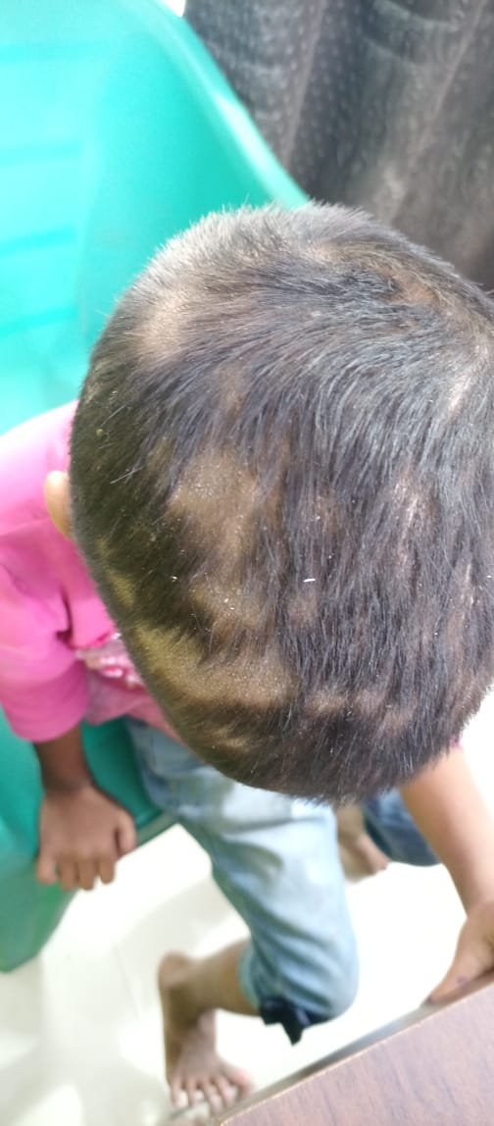
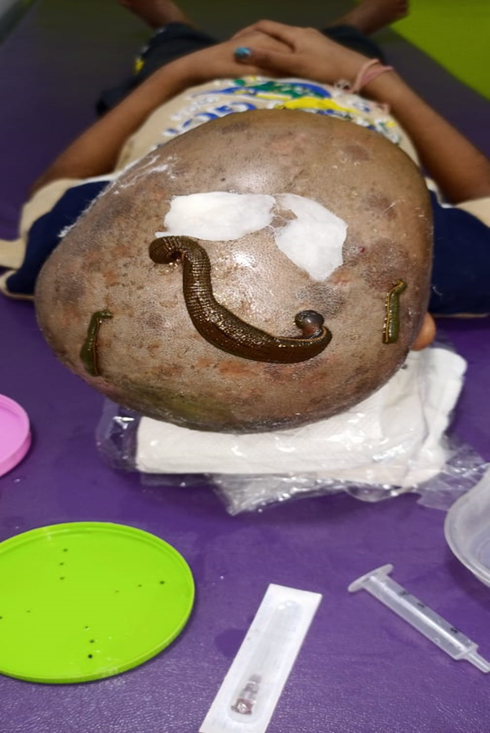
Fig.1 Fig.2

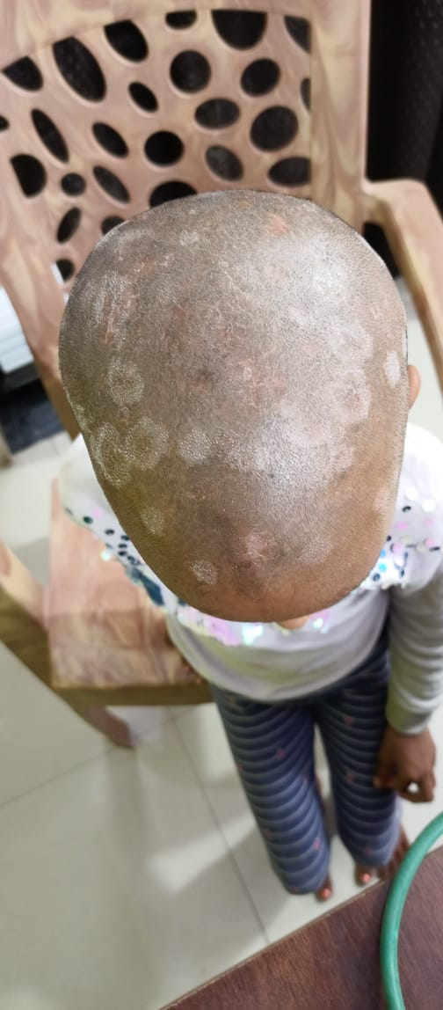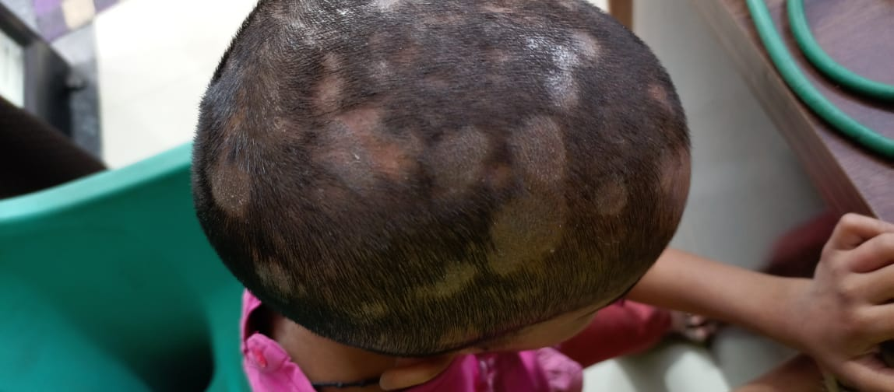
Fig.3 Fig.4

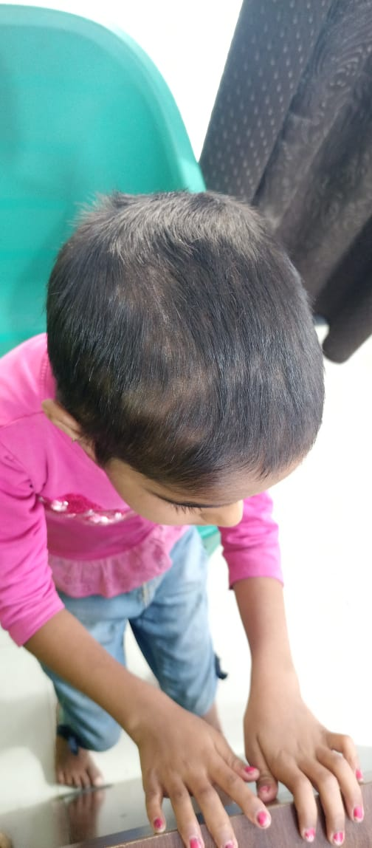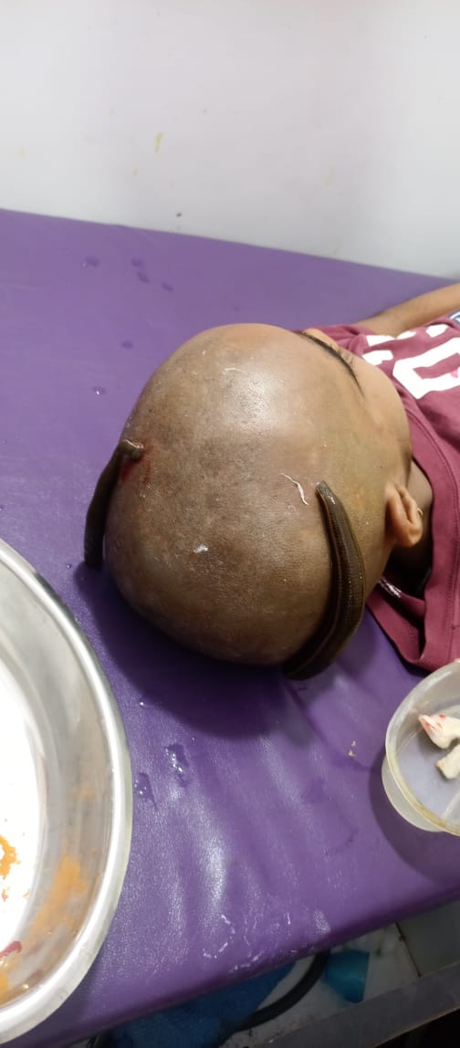
Fig.5 Fig.6

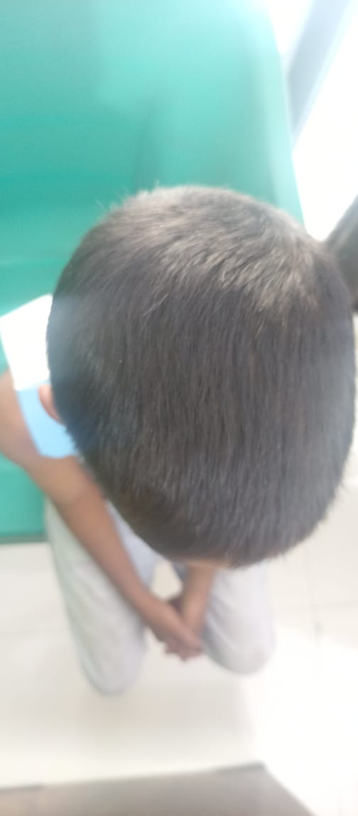

Fig.7

