EFFECT OF EKVISANTIKO GUGGUL ORALLY AND VIDRAVAN TAILAM TOPICALLY IN THE MANAGEMENT OF KITIBHA KUSTHA (PSORIASIS): A CASE STUDY

Dr. Sayali Shrikant Sirsat¹, Dr. S. B. Jamdhade² , Dr. Y. P. Dhuddhalwar,³ Dr. Pradnya S. Jamdhade⁴

1)P. G. Scholar, 2) Hod, Guide and associate professor, 3) Associate Professor, 4) Assistant Professor
Department Kayachikitsa
D. M. M. Ayurveda Mahavidyalaya, Yavatmal, Maharashtra

Corresponding Author:- sirsatsayali518@gmail.com

ABSTRACT :-
Kitibha Kustha present with Symptoms Shyavam, Kinakarasparsha and Parusha which closely resembles with symptoms of Psoriasis. All the skin diseases in Ayurveda have been discussed under the broad heading of “Kustha”. Psoriasis is a proliferative autoimmune skin disease which effect 2% of worldwide population. Modern medical science treats the psoriasis with Psoralen and Ultraviolet therapy (PUVA) and steroid therapy. These have serious side effects like liver failure, renal failure etc. But the disease has very high recurrence rate. On the contrary Ayurveda provides safe and effective remedy for psoriasis. Present case report is of 58 years old male patients suffering from Psoriasis since one year. Ayurvedic management showed encouraging result with Shamana Chikitsa.

KEYWORDs :- Kitibha Kustha, Psoriasis, Shamana Aushadhi, Vidravan tailam, Ekvisantiko guggul

INTRODUCTION :-
Skin is one among the sense organ which protects us from various external invasions. Skin is the larger one which is available for inspection by eyes as well as exposed to injury and disease. It is the seat of complexion which depends on factors like nutrition, hygiene, circulation, age, immunity, genetic traits, psychological state etc.
According to the study of WHO the prevalence rate of psoriasis at world level is in between 0.09% to 11.43% and 0.44% to 2.8% in Indian population. In ayurveda, the psoriasis can be correlated with the kitibha kushta. Kushta is caused by the vitiation of doshas in the person due to daily consumption of virudha ahar and virudha vihar sevan, vegavrodha.
Virudha ahar :- lavan + dughda, Matsya+ dugdha, atishit jalpaan
Virudha vihar :- avayam, arvayam, Diwaswap,
Vegavrodha :- always suppression of the urge for vomiting and other natural urge in daily regimen.
There are 18 types of kushta explains in granthas which are derived as follows :-
1)7-Mahakushta. 2)11-kshudrakushta
Kitibha kushta is the type of kshudra kushta
“Shyam kinkharsparsha parusham kitibha smrutam” ( Ch. Chi. 7/20)Whereas:
- Shyam it is blackish brown in colour
- Kinakharsparsha it is rough in touch like a scar tissue
- Parusham it is hard to touch it occurs due to increase of vata and kapha doshas.
The sign and symptoms of psoriasis are scratching, rough, itching, course and blackish discolorations over skin are correlated with the kitibha kushta, The management done for this case is shaman chikitsa .

Method :- A Case Study ( Report)
A 58years male patient came to opd of Kayachikitsa department of L. K. Ayurveda Hospital, Yavatmal with chief
C/O –
- shyava Varna ( blackish discoloration)
- Kinakharsparsha (Rough in touch)
- Parusham (Hard to touch )
- Kandu (itching) all over body
Patient having above complaint since 1 year.
Past History :-
K/C/O :- HTN on treatment ( since 12 years)
N/H/O :- DM/ Thyroid/ T.B
N/H/O :- No any major illness

History of Present illness :-
A 58 years old male patient came with above complaints, pt was treated by local doctors many times but after stop medication pt symptoms was aggregated then pt came to L. K. Ayurveda Hospital, Yavatmal for ayurvedic treatment and management.

Rugna Parikshan :-
Astavidha pariksha :-
- Nadi – 82/min
- Mala - malavsthamba
- Mutra - samyak
- Jivha - saam
- Netra - Alpapitavarna
- Shabda – spashta
- Sparsha - samshitoshna
- Aakruti - madhyam
- Nidra - khandit
Samanya pariksha :-
- BP – 140/80mmhg
- Temp – Afebrile
- RR – 18/min
- Weight – 65 kg
Assessment Criteria :-
Scale | 0 | 1 | 2 | 3
Shyava Varna | Normal skin tone | Mild brown discoloration | Moderate discoloration | Severe discoloration
Kinakhar  sparsha | Normal skin | Mild rough lesion on touch | Moderate rough lesion on touch | Severe rough lesion on touch with scaling
Parusham | Normal skin | Mild hardness of lesion | Moderate hardness of lesion | Severe hardness of scaling
Kandu | No itching | Mild / tolerable itching | Moderate generalized itching | Severe itching causes disturbance to sleep

Material and Methods :-
Methods :-
- A Case Study
- Centre :- P. G. Department of Kayachikitsa L. K. Ayurveda Hospital, Yavatmal, affiliated to D. M. M. Ayurveda College, Yavatmal
Material :-
Table no. 1. Showing material of case study :-
Sr. No. | Dravya | Dose | Duration | Anupana
1 | Ekvisantiko guggul | 1 gm BD | Twice a day | Luke warm water
2 | Vidravan tailam | Local application | Twice a day | -

Table no. 2. Mode of action of formulations used in chikitsa :-
Sr. No. | Dravya | Mode of Action/ Use
1 | Ekvisantiko guggul | Kushtahar, krumihar, dushta vranahar
2 | Vidravan tailam | Kanhughna, krumihar, kushtahar

Observation and Results :- assessment according to gradation:-
Sr. No. | Assessment criteria | BT | AT
1 | Shyava Varna | 3 | 1
2 | Kinakharsparaha | 3 | 0
3 | Parusham | 3 | 0
4 | Kandu | 3 | 0

Before treatment :-
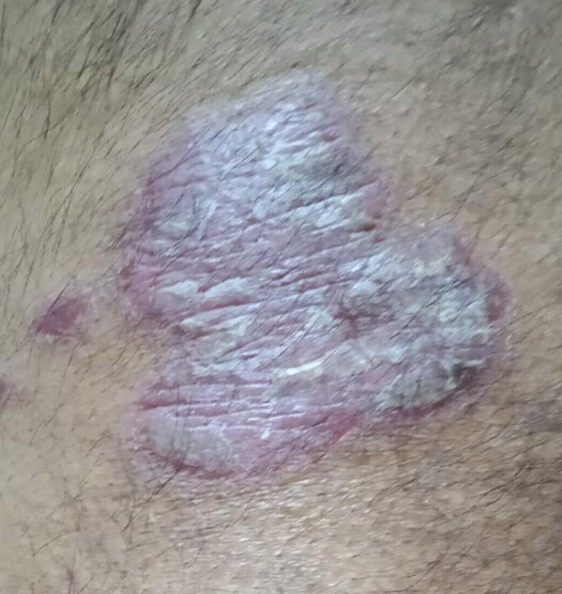

After treatment:-
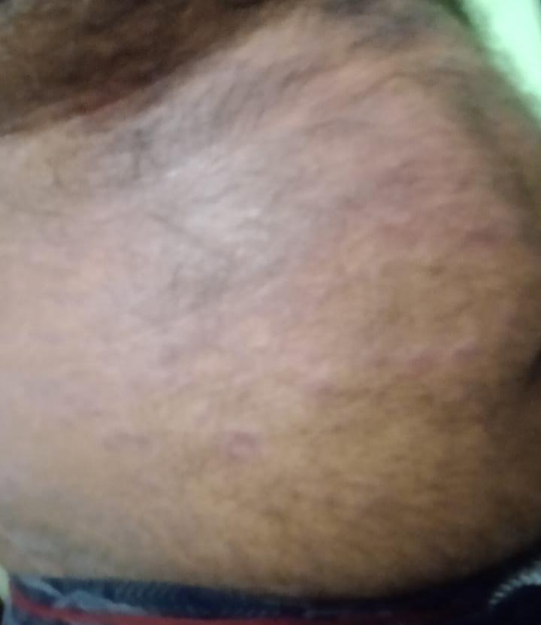

Discussion :-
Samprapti Ghataka :-
- Dosha - Vata, Pitta, Kaphaja
- Dushya - Rasa, Rakta, Mamsa,
- Upadhatu - Twacha, lasika
- Agni - Jatharagni, Dhatwagnimandya
- Strotas - Rasavaha, Raktavaha, Mamsavaha
- Strotodushti - Vimrgagumana /Sanga.
- Udbhavasthana - Amashaya
- Sancharastana - Sarvashareera
- Adhishtana - Twak, Rakta, Mamsa, Lasika
- Rogamarga - Bahya
- Swabhava - Chirakuri
- Sdhyaasadhyata – Yapya

Ekvisantiko guggul gives effect on Kitibha kushta which is indicated in kushta & skin diseases with secretions for which it is administered along with Vidravan tailam. Combination of this Ayurvedic medicines acts on Skin & blood circulatory system and improves the function of blood & detoxify the blood impurities as well.
The patient had started improving during treatment and the symptoms decreased gradually.

CONCLUSION :-

The prevalence of Kitibha Kushta is increasing day by Day. Kitibha kuskta though it is difficult to manage
But if proper diagnosis is made at proper time many Complication can be avoided. In this case study we
Found significant results in signs and symptoms with Ekvisantiko guggul orally and Vidravan tailam topically.. This is one among the relapsing type of Skin disease, so patient is advised to follow Pathyaapathya like Ahara, Vihara, Achara and Vichara .

Reference :-

- Charak samhita Charak samhita. Vol-2 chikitsasthanchapter 7 page no 184 shloke no.21 hindi commentary
2. Sushrut samhita Sushrut samhita. Vol 1 nidansthan chapter 5 page no 302 shloke no.14 hindi commentary
- Ashtanghridayam By Dr. Bramhanand Tripathi nirmala hindi commentary, published by chaukhamba Sanskrit pratishthan, Delhi 1970, India. Ash.Hri. nídansthan chapter no 14 page ло.204
- Dravya guna Vignan vol.2, by P.V Sharma published by Bharati Academy, Varanasi, 1995, Chathurthaadh yaya pa ge no.
- www.ncbi.nih.gov.articles
- www. Psoriasis.org.content.statics
- https://www.nejm.org
- https://www.nchi.nlm.nih.gov
- Bhaishjyaratnavali by Professor Sidhhinanadan Mishr published by Chaukhamba Surbharati Prakashan, Varanasi page no.871
- Bhaishjyaratnavali by Professor Sidhhinanadan Mishr published by Chaukhamba Surbharati Prakashan, Varanasi page no.582 11. Bhaishjyaratnavali by Professor Sidhhinanadan Mishr published by Chaukhamba Surbharati Prakashan, Varanasi page no.884,

