ETHNOMEDICINAL REVIEW OF TRADITIONAL MEDICINAL PLANT “GARAMBI” FROM MAHARASHTRA STATE.

Golatkar Sushmita ¹ Dhalpe Bipin ²

- MD Scholar , Department of Dravyaguna, R.A. Podar Medical College (Ayu) ,Worli ,Mumbai .

- Assistant Professor ,Department of Dravyaguna, R.A. Podar Medical College (Ayu) ,Worli ,Mumbai .

Address for correspondence :
Dr. Sushmita .S. Golatkar , R. A. Podar Medical College (Ayu) , Worli , Mumbai -400018

Email Id :
sushgo07@gmail.com

ABSTRACT:
"Ethnomedicine” is the study of “Traditional medicine” of ethnic communities, their knowledge and practices that transmitted orally over centuries. Entada scandens auct. non. (L)Benth belonging to Leguminosae family and Mimosaceae a subfamily . It is locally known as " Garbeej " . It is a large woody climber .The plant is found in Central and East Himalaya ,Nepal, Andaman ,Africa, Tropical Asia, Australia and in the small part of the Pacific Island. The plant also has occurrence in Maharashtra state in India where the seed of the plant is known as "Garambi ". The plant has been used by the Folkloric medicinal practitioners since very long period . The seed of the plant is used to treat Rheumatism, Fever and Dysentery. Seeds are used in pains of the loins, in debility and in glandular swelling. The plant is also used in the treatment of skin ulcer , snake bite, stomach disorders and ureterolithiasis . They are given internally as an Emetic. The kernel of the seed is employed by the people living in the hills as febrifuge. This Ethnomedicinal review aims to explore and analyze the traditional uses, phytochemical constituents, pharmacological activities, and potential therapeutic applications of Entada scandens (Garambi) based on indigenous knowledge .

Key words :- Ethnomedicine , Garambi, Folklore medicine , Maharashtra state .

INTRODUCTION

India harbors a rich history of traditional medicine and a great knowledge of medicinal plants. India is inhabited by about 645 indigenous tribes having rich knowledge of wild flora and fauna to manage or cure diseases with other miraculous use. Most of this “Traditional wisdom” is undocumented and orally passed over generations.⁽¹⁾. Ethnomedicine, also known as traditional or indigenous medicine, refers to the medical knowledge, practices, and remedies that have been developed and utilized by various cultures and communities over generations. It encompasses a wide range of beliefs, therapies, and rituals aimed at maintaining health, preventing illness, and treating diseases. Ethnomedicine is deeply rooted in cultural traditions, local beliefs, and the natural environment. One of the key elements of ethnomedicine is the use of natural resources . Garambi is one of the traditional herb used by folklore practitioners in Maharashtra.
Garambi having botanical name Entada scandens auct. non. (L)Benth belongs to Mimosaceae a subfamily of Leguminosae family ⁽²⁾. It is a large woody climber with twisted and angled stem . Seed of this plant is commonly called as Gilla in Sanskrit and Garambi in Marathi . Seeds are hard ,circular ,flattened and chocolate brown in color. Paste of seed pulp is used as an herbal medicine to reduce inflammation and pain of joints and lymph nodes ⁽³⁾. The seed of the plant is used in treatment of Rheumatism, Fever and Dysentery. They are also used in pains of the loins, in debility and in glandular swelling. The plant is also used in skin ulcer , snake bite, stomach disorders and ureterolithiasis treatment⁽²⁾ .The seeds of Entada scandens are slightly bitter-acrid in taste and mildly cooling in nature ⁽⁴⁾ . They are given internally as an Emetic. The kernel of the seed is employed by the people living in the hills as febrifuge. The plant is used as fish poison⁽⁵⁾. This article aims to enlighten the benefits of garambi used by folklore practitioners in treatment of various ailments.

MATERIAL AND METHODS
Material :
- Indian Materia Medica book by Dr. K.M. Nadkarni.
- Indian Medicinal Plants book by Kirtikar and Basu.
- Search engine such as Google scholar, Research gate, Pubmed, Wikipedia etc.
Methodology :
- Drug Garambi was selected by discussing with the folklore practitioners.
- Information was gathered about the selected drug .
- Literary Review was done by using texts such as Indian Materia Medica and Indian Medicinal Plants to find medicinal properties of the drug .
- A Comprehensive review was done on Entada scandens by using databases Research gate , Google scholar etc .

RESULT AND OBSERVATION

1.Botanical name :- Entada scandens auct. non. (L)Benth .

2. Synonym :- Entada phaseoloides(L.) Merr. , Entada rheedii Spreng.

3. Regional name :-
Sanskrit | Gilla ⁽⁶⁾, Prthvika⁽⁹⁾
English | Elephant creeper ⁽⁷⁾, African dream herb⁽⁷⁾,Entada bean ⁽⁷⁾
Marathi | Garambi ⁽⁷⁾, garbi ⁽⁷⁾
Hindi | Barabi ⁽⁸⁾, Ghila⁽⁸⁾ , Gila⁽⁸⁾
Kannada | Ganape kaayi ⁽⁸⁾
Malayalam | perim-kakuvalli ⁽⁸⁾
Tamil | Irikki .⁽⁸⁾
Telugu | Gillateega, Tikkativva⁽⁸⁾
Table-1

4. General habitat :-
Evergreen forests along sides of rivers⁽⁷⁾

5. Distribution :-
- Maharashtra: Thane , Kolhapur, Pune, Raigad, Ratnagiri, Satara⁽⁷⁾ Tungareshwar , Karnala , Alibag ⁽⁸⁾, Sangli ⁽¹¹⁾ .

- Global distribution- Nepal, Andaman ,Africa, Tropical Asia, Australia and in the small part of the Pacific Island.

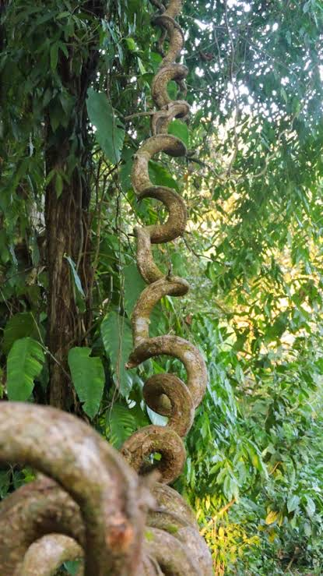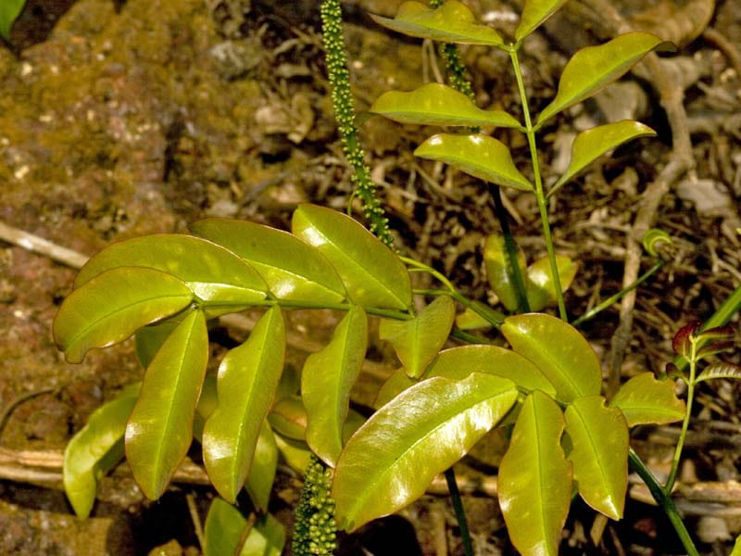
Fig:1 - Stem of Entada scandens Fig:2 - Leaves of Entada scandens

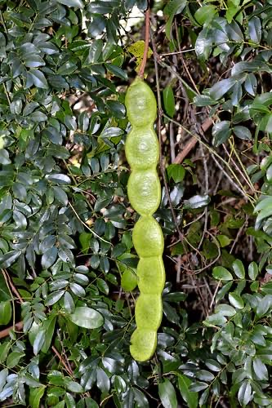. 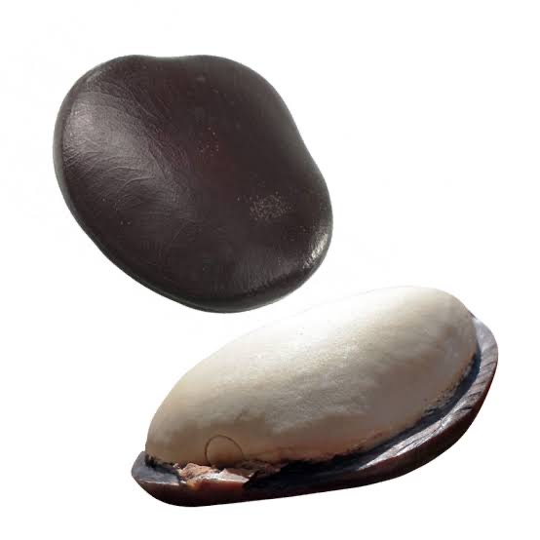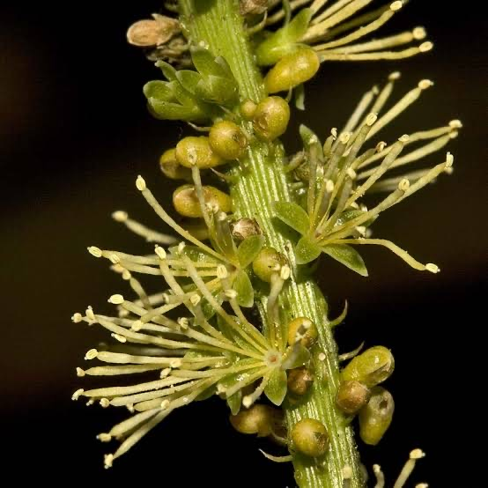
Fig: 3 - Fruit of Entada scandens. Fig: 4 - Seed of Entada scandens. Fig:5- Inflorescence of Entada scandens.

6. Description :-
Garambi is a gigantic woody climber with glabrous stem . Leaves bipinnate ,pinnate 2 or 3 pairs, terminal pair modified into a tendril ; leaflets 4- 7 pairs curved oblong ,obtuse .Flowers are roughly cup shaped , densely packed and yellow in color. Fruits - Pods of the climber are 1m long ,thick ,woody cremate on both sutures. Seeds are biconvex ,orbicular ,smooth ⁽⁷⁾.

7. Part used :-
Seed , Leaves , Bark, Stem , Root .

8. Phytochemical constituent :-
Triterpenoid ,Saponins, Tannins, Phenolic acids, Glycosides, Flavonoids, Minerals, and Amino acids ⁽¹⁰⁾.

10. Pharmacological Activity :-

- Anti-inflammatory and Analgesic Activity ⁽⁴⁾
- Anti Arthritic Activity ⁽⁴⁾
- Antidiabetic and Hypolipidemic Activity ⁽⁴⁾
- Anti-Toxicity Activity ⁽⁴⁾
- Antimicrobial Activity⁽⁴⁾
- Antioxidant and Cytotoxic Activity ⁽⁴⁾
- Anti-ulcer Activity ⁽⁴⁾
- Anthelmintic Activity ⁽⁹⁾
- Wound healing Activity⁽⁹⁾
- Neuroprotective Activity ⁽⁹⁾
- Molliscicidal Activity ⁽⁹⁾

Table -2

11. Therapeutic applications :-
Pain in the Lymph nodes and Joints, Injury, Gastrointestinal problems, Circulatory problems, Inflammation etc .⁽¹⁰⁾

12. Folkloric uses:-

Sr.no | Part used | Indication
1 | SEED | 1.Seed paste was applied to hand and foot swelling brought on by overall weakness, pain in the loins and joints, and inflammatory glandular swelling in the axilla⁽⁹⁾.  2.For Abdominal aches and colic, crush the seed kernels, combine them with oil, and apply them as a poultice to the affected area ⁽⁹⁾.  3. For Jaundice and oedema brought on by malnutrition, take 3 to 9 grams of powdered seeds orally with water⁽⁹⁾.  4.For Emesis, seeds are used. It is utilized as a febrifuge as well⁽⁹⁾.  5.Seeds are used to wash hair⁽⁹⁾.  6.Used as a stimulant for hair growth⁽⁹⁾.  7.In South Africa, seeds are utilized as teething toys for young children⁽⁹⁾.  8.It is utilized as a treatment for Cerebral haemorrhage as well ⁽⁹⁾.
 | ROOT | In India’s Tripura for the treatment of jaundice, a paste of root bark is ingested with water in small doses ⁽⁹⁾.
 | STEM | 1.The stem used as an Emetic and make a washing soap by macerating it in cold water ⁽⁹⁾ .  2. A decoction made from dried vine components is used to treat contusions, sprains, and rheumatic leg discomfort ⁽⁹⁾.  3.In Dinalupihan, Bataan, Ayta people used pounded stems as soap to treat dandruff and heal wounds ⁽⁹⁾.
 | BARK | 1.The area with the itch is cleaned with a decoction of the bark ⁽⁹⁾.  2.The bark is also used for head lice⁽⁹⁾.  3.In Samar, water mixed with pounded bark is used as a bath soap or shampoo for dandruff⁽⁹⁾.  4.Bark juice is used for Conjunctivitis in the Philippines ⁽⁹⁾.
Table -3

13. Other uses -
- Fatty oil extracted from the seeds is used as an illuminant.The oil is used in lamps for illuminating purposes ⁽⁴⁾
- The bark fibre is used for cordage and nets⁽⁴⁾
- The hard and smooth-shelled seeds are used for burnishing pottery, polishing hand-made paper and crimpling linen ⁽⁴⁾
- The seeds are hollowed out and employed in making trinkets and small receptacles e.g., snuff and tinder boxes⁽⁴⁾
- The large seeds are used as beads, the smooth shining seeds are used for games. Some tribes believe the seeds possess magical abilities to bring the owner good luck ⁽¹¹⁾.
- The seeds are strung together and used as jewellery.⁽¹¹⁾.

Conclusion

One of the main pillars of Ayurveda is the medicinal resources used by ethnic communities (Ethnomedicine) and plant-based treatments using different parts of plants including roots, leaves, fruits, bark and seeds ⁽¹⁾.Garambi is found in state of Maharashtra . Traditional practitioners mainly use this plant in treatment of rheumatoid arthritis , fever , jaundice as it posseses anti inflammatory, antipyretic and hepatoprotective properties etc . It is also used to stimulate hair growth. According to its uses its guna veerya vipak can be postulated . That will legitimize its use in Ayurveda .As Garambi there are many herbs which are used as medicine through generations by folklore medicinal practitioners. Attempt should be made to identify this herbs scientifically . Their rasa, guna , veerya ,vipak , karma can be determined . It will help in expanding treatment modalities using this folklore medicines .

Reference

- Mahapatra AD, Bhowmik P, Banerjee A, Das A, Ojha D, Chattopadhyay D. Ethnomedicinal Wisdom: An Approach for Antiviral Drug Development. New Look to Phytomedicine. 2019:35–61. doi: 10.1016/B978-0-12-814619-4.00003-3. Epub 2018 Oct 26. PMCID: PMC7149776.

- Dey SK ¹, Hira A¹, Ahmed A¹, Howlader Md. SI², Khatun A³, Rahman M⁴*, Siraj Md. A¹ , Phytochemical Screening and Pharmacological Activities of Entada Scandens seeds,International Journal of Applied Research in Natural Products,Vol. 6 (1), pp. 20-26.

- Jayashree S Dawane, Vijaya A. Pandit, Experimental evaluation of anti-inflammatory effect of topical application of Entada phaseoloides seeds as paste and ointment,N Am JMed Sci.2011,Nov;3(11): 513-517. (Pubmed).

- Chandana Choudhury Barua¹, Mousumi Hazorika¹and Jyoti Misri², An Overview of Entada phaseoloides: Current Research and Future Prospects,Journal of Pharmacy and Pharmacology, 2(2014) 1-18.

- Kirtikar K.R , Basu B.D , Indian medicinal plants, Lalit Mohan Basu publishers, Allahabad, volume 2 (907).

- K.M.Nadkarni , Indian Material Medica ,Bombay Popular Prakashan,vol-1 (485).

- Entada rheedii ://indiabiodiversity.org/species/show/229596.

- https://efloraofindia.com/2011/02/27/entada-rheedei/

- G Sharanya, A Srivani and G Krishna Mohan, Phytochemical and pharmacological properties of Entada phaseoloides (L.): A review,Journal of Pharmacognosy and Phytochemistry 2022; 11(6): 111-119.

- Jitendra Pandey a, Bhawana Dhakal b, Pramod Aryal a c, Ravin Bhandari e, Hari Prasad Devkota ,Entada phaseoloides (Linn.) Merr.Himalayan Fruits and Berries: Bioactive Compounds, Uses and Nutraceutical Potential,2023, Pages 153-164.

- Deokar Rekha ,Mane Satish ,Kamble Shubhangi , Patil Sarjerao , A New Locality Record for endangered Plant species Entada rheedii Sprong. (Mimosaceae ) in Sangli District, Maharashtra, WJPR vol 6 ; Issue 17,405-409.

