ASSESSMENT OF PURISHVAHA SROTAS DUSHTI IN THE PATIENTS OF SANDHIGATA VATA W.S.R. TO SERUM CALCIUM LEVEL: AN OBSERVATIONAL STUDY
¹Chhangani Jaikrishna S., ²Rathod Chetana D., ³Garje Pramod F.
- Guide and Associate Professor
- PG Scholar
- Professor and HOD
Department of Rognidan Evum Vikriti Vigyan,
Shri Ayurved Mahavidyalaya, Nagpur, Maharashtra, India
Corresponding Author: - chetanarathod012@gmail.com
Abstract
Background -
Among the Tridosha, Vata plays an important role and is responsible for all the cheshta. Sandhigata Vata is 1st explained by Acharya Charaka as Sandhigata Anil and is a type of Vatavyadhi which disturbs the physical and mental health. Sandhigata Vata is the second most rheumatological problem with prevalence of 22-39% in India. In the intestine (pakwashaya) the smooth layer consists of Ca-Na (Kala Purishdhara Saa Eva Asthidhara) ion channel. The pakwashaya can be considered as a sthan of both Purishdhara kala and Purishvaha srotas and it is the vishesh sthan of vata dosha. Interference at pakwashaya sthana, ultimately act on vata dosha and this vitiated vata dosha may be responsible for purishvaha srotas dushti, impaired function of purishdhara kala (Asthidhara kala) and various Vatavyadhi and Sandhigata vata is nothing but Vatavyadhi. In this, efforts will be taken to study imbalance in the Serum Calcium level w.s.r. to Purishvaha Srotas Dushti Lakshanas in sandhigata vata patients. Objectives- The present cross-sectional study was planned to assess the purishvaha srotas dushti in sandhigata vata patients w.s.r. to serum calcium level. Methods- Total 81 pre diagnosed patients of sandhigata vata fulfilling the inclusion and exclusion criteria were selected from OPD and IPD of Pakwasa Samnawaya Rugnalaya, Nagpur and purishvaha srotas dushti was assessed in sandhigata vata patient. Results - Out Of 81 Patients, Kruchchhenaalpalpa malapravritti was present in 79 (97.57%) patients, in 64 (79.01%) patients hypocalcaemia was found. The p value was less than 0.05, purishvaha srotas dushti is significantly associated with serum calcium level. Conclusion - Purishvaha srotas dushti is present in sandhigata vata and purishvaha srotas dushti is associated with serum calcium level in sandhigata vata patient.
Keywords- vata, pakwashaya, purishvaha srotas, purishdhara kala, sandhigata vata, serum calcium level
Introduction
Ayurveda is an ancient science of health promotion; disease prevention and treatment. It is a holistic science of medicine providing its service to mankind. The chief aim of Ayurveda is to promote health of healthy individual and secondary aim is to treat illness ^{[1]}. There are Three Doshas in our body. Altogether three Doshas, Vayu is Ayu and Bala, without Vata the other two Doshas are unable to work ^{[2]}. Vata is liable for all chesta and all diseases of old age. Important role of vayu in health. In Ayurvedic Samhitas & Sangraha granthas, the aetiopathogenesis, symptoms and treatment of Sandhigata vata is described under Vatavyadhi. Sandhigata Vata with prevalence of 22-39% in India ^{[3]} is that the commonest form of articular disease which limits everyday activities like walking, dressing, bathing etc thus making patient disabled /handicapped. Sandhigata Vata is responsible for early degenerative changes in bodily tissue. The sthan of Vata dosha is Sarvasharir and vishesh sthan is Pakwashaya ^{[4]}. Vayu which is produced within the Pakwashaya is poshak Vayu, nourishes poshya Vayu of the body ^{[5]}. Due to lifestyle changes, there is a formation of vikrut Vata which affects all sthana of Vata dosha, especially asthi dhatu ^{[6]}. As we all know Pakwashaya is one of the mulasthana of purishvaha srotas ^{[7]} and pakwashaya is additionally vishesh sthana of vata dosha. Interference at pakwashaya sthan, ultimately act on vata dosha and this vitiated vata dosha is responsible for purishvaha srotas dushti and various Vatavyadhi and Sandhigata vata is nothing but Vatavyadhi. The calcium sodium ion channels, necessary for the motor functioning of the intestine, present in the smooth muscle layer in large intestine(pakwashaya) is considered as purishdhara kala (Asthidhara kala) of the pakwashaya. According to modern science the function of large intestine is mainly the formation, holding, proper excretion of stool (Purishvaha srotas) for appropriate time ^{[8]}. Of the total soluble calcium found in the entire intestinal tract, some 15% is found in the large intestine. Calcium that reaches the large intestine undergoes absorption there by both active and passive processes. About 15% of the dietary calcium is absorbed. About 200 mg of calcium is excreted in urine per 24 hrs. and remainder is recovered in faeces ^{[9]}. Any disruption at pakwashaya may affect serum calcium level, purishvaha srotas functioning. In this, efforts have taken to study purishvaha srotas dushti w.s.r. to serum calcium level in the sandhigata vata patient.
OBJECTIVE
1. To assess purishvaha srotas dushti in the patients of sandhigata vata.
2. To study the association of Purishvaha Srotas dushti and Serum Calcium level in Sandhigata Vata.
METHODS OF DATA COLLECTION –
Method Of Selection of Study Subject:
Patients – 81 pre diagnosed subjects of sandhigata vata were randomly selected from OPD and IPD of Pakwasa Samanwaya Rugnalaya, Shri Ayurved Mahavidyalaya, Nagpur irrespective of their gender, occupation, religion and socioeconomic status and informed consent was taken.
Selection Criteria: Patients were selected on the basis of inclusion and exclusion criteria.
a) Inclusion Criteria:
1. pre-diagnosed patient of Sandhigata Vata.
2. Patient between age group of 30 year to 60 year will be selected for Study.
3. Patient who are willing to include them into the study.
b) Exclusion Criteria:
1. Patient suffering from fracture or dislocation/displacement of joint.
2. Patient suffering with bone TB or tumour, osteopenia.
3. Sandhigata Vata case as a complication of other diseases like obesity, Vatarakta, DM, Carcinoma, Parathyroid diseases etc.
Study design -Observational, Cross-sectional study

Material and methodology –
Relevant To Objective:
Patient was assessed on the basis of subjective and objective Parameter; relevant data was collected for analysis.
Pre-diagnosed patients of Sandhigata Vata were taken for the study. And examination of each patient for Purishvaha Srotas Dushti was done on the basis of whether the lakshanas present or absent and Serum calcium test of patient was done on same day.
- Subjective Criteria:
Assessment parameter of Purishvaha Srotas Dushti on the basis of presence or absence of following lakshanas.
1. Kruchchhenaalpalpa malapravriti (KAA)
2. Sashabda malapravriti (SSBD)
3. Sashool malapravriti (SS)
4. Atidrava malapravriti (AD)
5. Atigrathita malapravriti (AG)
6. Atibahu malapravriti (AB)
Lakshana | Score
Absent | 0
Present | 1

B) Objective Criteria – Interpretation of serum calcium level
Hypocalcaemia | Less than 9mg/dL
Normal | 9-11
Hypercalcemia | More than 11

MATERIAL - STUDY INSTRUMENT/ DATA COLLECTION TOOLS:
1. Case record format
2. Pathological Investigation – Serum calcium test
3. Laboratory equipment’s-Semi Auto Analyzer – Model name- PRIMAN Model No. 250.
OBSERVATION AND RESULT
- Demographic observation
In this study, age limit was between 30-40 yrs. Out of 81, 23 and 22 patients were from 40-50 yrs. and 30-40 yrs. of age group respectively. 36 patients were from 51-60 yrs. age group. Out of 81 patients, 61 (75.31%) were females and 20 (24.69%) were males. Out of 81 patients, 2 (2.47%) patients were from upper class, 13 (16.05%) patients were from lower class and 66 (81.48%) were from middle class. Out of 81 patients, 6 were farmers, 31 were housewives, 10 were government servants, 4 were retired from work, 26 were workers, 4 were tailors.
In this study, out of 81 patients manya sandhi was involved in 13 (16.05%) patients, ansa sandhi in 15 (18.52) patients, kurpar sandhi was affected in 8 (9.88%)patients, manibandh sandhi was affected in 3 (3.70%) patients, hastanguli sandhi were affected in 9(11.11%) patients, kati sandhi was involved in 47 (58.02%)patients, Janu sandhi was affected in 52 (64.20%) patients, gulph sandhi in 9 (11.11%) patients and parshni sandhi was affected in 2(2.47%) patients and padanguli sandhi was affected in 2 (2.47%) patients.
- Observation of purishvaha srotas dushti-
Out Of 81 Patients, Kruchchhenaalpalpa malapravritti was present in 79 (97.57%) patients, Sashabda malapravritti in 74(91.36%) patients, Sashool malapravritti in 71(87.65%) patients, atidrava malapravritti in 21 (25.93%) patients, Atigrathita malapravritti in 58(71.60) patients, Atibahu malapravritti in 27 (33.33%) patients.
- Observation of serum calcium level-
Out of 81 patients, in 64 (79.01%) patients hypocalcaemia was found. normal serum calcium level was found in 13 (16.05%) patients. In 4(4.94%) patients hypercalcemia was found.
As value of p is less than 0.05, serum calcium compared between presence and absence of purishvaha srotas dushti lakshanas. Hence, it is concluded that purishvaha srotas dushti is significantly associated with serum calcium level.

Table no. 1 Association of purishvaha srotas lakshanas with serum calcium level.
 | Status | Serum Calcium Level |  | p-value
 | Status | Mean | SD | p-value
Kruchchhenaalpalpa malapravriti | Present | 8.34 | 0.98 | 0.0058,HS
Kruchchhenaalpalpa malapravriti | Absent | 10.54 | 0.93 | 0.0058,HS
Sashabda malapravriti | Present | 8.29 | 0.86 | 0.0018,HS
Sashabda malapravriti | Absent | 9.25 | 1.79 | 0.0018,HS
Sashool malapravriti | Present | 8.21 | 0.72 | <0.0001,HS
Sashool malapravriti | Absent | 8.21 | 0.72 | <0.0001,HS
Atidrava malapravriti | Present | 8.80 | 1.04 | 0.0314,S
Atidrava malapravriti | Absent | 8.73 | 1.08 | 0.0314,S
Atigrathita malapravriti | Present | 8.25 | 1.04 | 0.0380,S
Atigrathita malapravriti | Absent | 8.77 | 0.86 | 0.0380,S
Atibahu malapravriti | Present | 8.23 | 1.02 | 0.0446,S
Atibahu malapravriti | Absent | 8.71 | 0.18 | 0.0446,S

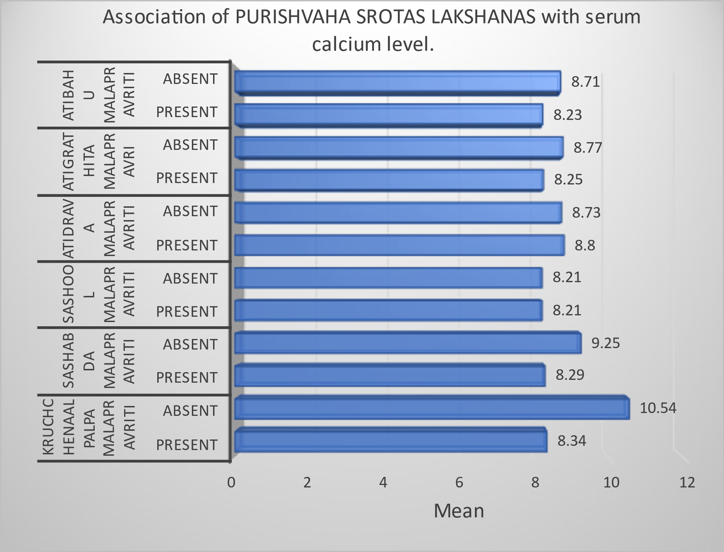

DISCUSSION
The previous studies present are mainly regarding the aetiopathogenesis, chikitsa of sandhigata vata, purish mala examination, mulasthana of purishvaha srotas (ayurvedic and modern view), importance of purishdhara kala. The improvements in serum calcium level after therapy brings symptomatic relief in Sandhigata vata therefore marked improvement in subjective parameters was observed in recent study. This can be attributed to the therapeutic benefits of therapy in sandhigata vata patients having low calcium level.
Now days, due to change in lifestyle, irregularity in daily routine, circumstances related to defecation are increasing that means purishvaha srotas mulasthana (pakwashaya) is also getting affected. The pakwashaya is considered as the principal place of vata. The meaning of calling the pakwashaya a special place is that the pakwashaya is the place of origin of Vatavyadhi. Vata permeates the whole body and conducts its Prakrit Karmas. Here, if the vata vikruti is pacified, then the Vata disorder located anywhere in the whole gets pacified by itself. If pakwashaya gets affected there is a likely chance to cause sandhigata vata and purishvaha srotas dushti.
- In the present study, maximum Number of patients were females.
- Majority of patients were having sandhigata vata symptoms involving Janu sandhi in 64.20% cases because it is a weight bearing joint followed by Kati sandhi.
- The rukshta in pakwashaya due the vata prakopa resulted in difficulty in passing the stool (Kruchchhenaalpalpa malapravritti). It was observed largely in vriddhavastha.
- In present study, hypocalcaemia is present in 64 (79.01%) patients.
- It is observed that Purishvaha srotas dushti is significantly associated with serum calcium level in sandhigata vata.
CONCLUSION
In sandhigata vata, due to vitiated dosha, the sthana of vata dosha i.e., pakwashaya gets disturbed producing purishvaha srotas dushti lakshanas. The absorption of calcium (purishdhara kala) gets affected resulting in decreased serum Calcium level. On the basis of 81 patients, study concluded that Purishvaha srotas dushti is present in sandhigata vata patients and purishvaha srotas dushti is associated with serum calcium in sandhigata vata patients.
REFERENCES
- Vaidya Jadavaji Trikamji Acharya, Charak Samhita By Agnivesh Of Chakrapanidatta, Chaukhamba Publication, Varanasi-Sutrasthan Adhyay 30 Verse No.26 Page No.187.
- Acharya Shriradhakrushna Parashar Sharangdhar Samhita Krushna Namak Hindi Bhashatika Sahita Sha.Purvardha 5/25.
- Dr. Surya Parkas, Prof. Pawankumar Godatwar, Dr. B.K. Sevatkar – A Nidanatmaka Study On Sandhigata Vata Among Local Community Of Jaipur.Journal Of Ayurveda Vol. Xii No. 1 Jan-March 2018 Page No. 9.
- Vatapitta Kapha - Hari Sadasiva Sastri Paradakara Bhisagacarya, Asthanghridaya With The Commentaries By Arundatta And Hemadri Chaukhamba Publication Sutrasthan Adhyay 12 Verse No.1 Page No 192.
- Vaidya Jadavaji Trikamji Aacharya Editor. Charaka Samhita By Agnivesha. Chaukhamba Publication New Delhi. Reprint 2017 Chakradatta Tika On Sutrasthan Adhyay 20, Verse 6
- Hari Sadasiva Sastri Paradakara Bhisagacarya, Asthanghridaya With The Commentaries By Arundatta And Hemadri Chaukhamba Publication Sutrasthan Adhyay 11 Verse No.26 Page No.186 .
- Vaidya Jadavaji Trikamji Aacharya Editor. Charaka Samhita By Agnivesha. Chaukhamba Publication New Delhi. Reprint 2017 Vimansthan Adhyay 5, Verse 8 Page No.251.
- A Review Article On Pureeshvaha Srotas With Special Ref To Its Applied Anatomy. Iamj March 2022.
- Nutritional Aspects Of Calcium Absorption Felix Bronner, Danielle Pansu. The Journal Of Nutrition, Volume 129, Issue 1, January 1999, Pages 9–12, Https://Doi.Org/10.1093/Jn/129.1.9.

