'Critical Study Of Konkan Territory Of Maharashtra State w.s.r. To The Concept Of Desha ln Ayurveda'
*1. Dr. P. A. NAGDEVE &
2. Dr. R. K. GOLGHATE

¹ Assistant Professor
² Associate professor
(dept. of Rognidan & V.V)
B. S. Ayurved College, Sawantwadi, MS. Pin code-416510

Corresponding Author -
Dr. Ravi K. Golghate
Associate Professor (dept. of Rognidan & V.V) B. S. Ayurved College, Sawantwadi, MS.
Email id- golghateravi3@gmail.com
Contact no- 9422030129/9860468644

Abstract-
Background- Desha Pariksha (examination) has been mentioned in the Charaka Samhita (cha.vi.8/84) which is considered as the oldest and the most authentic treatise of Ayurveda. Ayurveda has described three types of Desha viz. Jangl , Anup and Sadharan. Desha also known as Bhumi refers to the natural inhabitant of an individual. Desha is one of the factors which have to be assessed in ascertaining the Hetu (etiological factors) and also in deciding the treatment. Climate, diseases, food, treatment and so many factors may vary according to desh (habitat). An attempt has been made to critically analyse the konkan region of the state Maharashtra considering present climate conditions and geography in comparison to the concept of Ayurvedic desha description.
Methods- Authentic government web portals of this region have been visited to know the present climatic situations. Various research papers were also reviewed to discern the territory from other parts of the state.
Conclusion- After scrutinizing the facts over the past few years; it has been found that most of the regions of konkan fall under excess rainfall terrain. Flora and fauna is similar to that of wetland. The Konkan region of the Maharashtra State can be compared with Anup desha in Ayurveda.
Keywords- Anup desha, Ayurveda, konkan, Maharashtra

Introduction-
Ayurveda also called 'the science of life' originated 5000 years ago and is the most ancient system of healing known to man today. The study of ayurveda lays a powerful emphasis on prevention by balancing every individual's unique pattern of energy that manifests as physical, mental and emotional. The science involves a careful health assessment and examination of the root of imbalance in relation to key symptoms and also a thorough evaluation for suitability of treatments. In Ayurveda clinical examination desha pariksha is mentioned. Ayurvedic texts have given importance to desha pariksha while interrogating patients. desha means Bhumi desha (land) and Atur desha (patient body)¹. Bhumi desha is the land where a person lives. Person’s prakruti (constitution), Bala (strength) depends on desha.^{2,3,30} So it is necessary for an Ayurvedic physician to ask where the person was born? Where did he grow up? During stay in which area he felt ill? etc. According to Charaka, different religions, traditions, and dietary habits are followed by people living in different habitats. According to region, occupational variations are observed. Availability of food and medicinal herbs also differ in different regions. Diseases also differ region to region.^{4,30}
Medical geography which is gaining significance in contemporary medicine has its origin from Hippocrates. However, Charaka Samhita which was written centuries before Hippocrates elaborately speaks about medical geography. Though the text gives a vast outline of geography in terms of Jangala, anup, and Sadharana; it also mentions various places of India. The Indian climate varies from region to region. Based on the amount of annual rainfall, annual range of temperature, different climatic regions are identified in the country. As Ayurvedic samhitas are written by people living in Indian continent, description of desha represents the climate of the same only. Temperature, rainfall, type of soil, availability of water and natural resources are different in different areas.

Material And Method-
This article deals only with the Konkan region of Maharashtra State of India, as the authors are living and dealing with patients of this region and at present they are much more familiar with the environment of this area. For the study purpose, four representative districts of konkan viz. Sindhudurg, Ratnagiri, Raigad and Thane are chosen. Concepts regarding desha, available in various classical texts like Charaka samhita, Sushruta Saṃhita, Aṣthang Hridaya and other Nighanṭu were thoroughly reviewed. Published literature on Bhumi desha by scholars in various national & international indexed journals including the Central Database of PubMed was reviewed. To discern the comprehensive, accurate, reliable and one-stop source for the information and present climatic situation about the major districts considered in this study from the Konkan region. Authentic government web portals of those districts were visited and required information was extracted. Records produced from the classics and the various sources were critically reassessed to co-relate the type of desha mentioned in the classics and present scenario in the districts considered for the study.

Observations and Result-
Concept of Desha in Ayurveda-
In Ayurvedic classics, Brihattrayi i.e. Charak Saṃhita, Sushruta Saṃhita and Aṣhthang hriday one may find scattered description about Desha.
- Jangal desha - In Jangal desh land is parched with few rainfall, ground water level is low, wells are deep with less water. The soil is dry and full of uneven hard granites and rock-strewn. Trees are scattered and less. Dry and hot winds flow speedily. Due to the enormously dry condition of the soil and parched environment, there is a predominance of Agni. Jangal desha is considered as Vata, Pitta predominant area. Therefore vayu and Prithvi mahabhuta in turn produce plants containing prevalence Kashaya, Kaṭu and Tikta Rasa. Generally people of these areas are thin built but strong and stout and prone to have diseases of vata and Pitta Predominance. Jangal Desha is predominant in Akasha Mahabhoota and has vegetation that includes trees like Kadara (Acacia polyacantha Willd.), Khadira (Acacia catechu L.), Asana (Bridella retusa Spreng.), Ashwakarna (Dipterocarpus turbinatus Gaertn.), Tinisha (Ougeinia dalbergiodes Linn), Shallaki (Boswellia serrata Triana and Planch), Saala (Shorea robusta Roth), Badari (Ziziphus mauritiana Lam.), Tinduka (Diospyros melanoxylon Roxb), Ashwatha (Ficus religiosa L.), Vata (Ficus benghalensis L.), Amalaki (Phyllanthus emblica L.), Shami (Prosopis cineraria [L.] Druce), Kakubha (Terminalia arjuna [Roxb.] Wight and Arn.), Shimshapa (Dalbergia sissoo Roxb.) and birds include Lava, Tittira, Chakora, etc.^{5,6,8}
- Anup desha- In such areas rainfall is heavy. Ground water level is abundant. Wells and ponds have abundant water. This area is near the sea or surrounded by lakes and rivers with deep forests. The surrounding atmosphere is humid. Due to the moist and humid scenery of soil and influence of Prithvi and Apa mahabhutas, the plants from Anup area are predominant in Madhur and Amla Rasa. People are well nourished but tender (Sukumar) and soft and Kapha Vata predominant. They have a tendency of Kapha Vata predominant diseases. Banana, coconut, Palm trees are found in Anup desha with frequent cold winds. Anup has a rich vegetation of trees like Hintala (Phoenix paludosa Roxb.), Tamaala (Garcinia Morella Gaertn), Narikela (Cocus nucifera L.), Kadali (Musa paradisica L.), and various angiosperms. It is rich in water bodies like lakes and ponds and birds include Hamsa, Chakravaka, Balaaka, Nandimukha, Pundareeka, Kadamba, Bhringaraja, and Kokila. The people here enjoy the cool breeze. ^{7,8}
- Sadharana desha- Area shows character of both Jangal and Anup desha is called Sadharan desha and have mixed pictures. It holds the moderate land where the soil is gray, red or black in colour and the place is neither too humid nor too parched; neither has it had cornucopia of rock particles or sand, not the lakes and rivers. Sadharan desha is productive nourishing all kinds of plants and crops. Physiologically the Doṣas are generally maintained in a balanced state and the same is reflected in the health of inhabitants. It is the best bhumi desh.^{8,30}
- Anupa,Sadharana- Anupa Sadharana is the land which has more features of Anupa Desha. It is the originating place for Lavana and Amla Rasa^{.9}
- Jangala,Sadharana- It Is the land which has more features of Jangala Desha. Jangala Sadharana Desha is the originating place for Tikta and Kashaya Rasa.⁹

Geography of konkan region-
Maharashtra state is divided into konkan region, Ghat area, Khandesha, Marathwada and Vidarbha. In these areas we can observe different geographical climatic situations. Konkan is different from other parts of Maharashtra and also from India in terms of variation in geology, climate, soils, and environment. The konkan region receives heavy rainfall but differs from other tropical regions because of the strong influence of the Arabian Sea and the Sahyadri hilly ranges. konkan covers an area of nearly 30 lakh hectares and represents a coast line of 720 km. The region consists of coastal districts such as Raigad, Ratnagiri, Sindhudurg ,Thane, mumbai, mumbai suburban and Palghar. ¹⁰

Physiographic Divisions of the konkan Region-
Konkan is located between 15° 36' to 20° 15' N latitudes and 72° 40' to 73° 45' E longitudes. On the basis of lithology, geomorphic configuration, nature of hinterland and climate, konkan has been divided into the North konkan, Middle konkan and South konkan. This 3-fold division is also reflected in the broad physico-cultural zonations in the region (Dikshit, 1986). North konkan: This coastal belt lies roughly between Bordi-Dahanu in the north and Karanja in the south. North Konkan receives an annual rainfall of 1500 mm and more. Middle konkan: The coastal belt from Uran to Shrivardhan forms the Middle konkan, where the forested hills are more prevalent in the central part, with heights of 300-500 m ASL, and are formed dominantly of Deccan basalt. South konkan: This is the longest stretch of the konkan, and has the distinctive feature of 8-12 m thick capping of laterite over much of the terrain. Barren lateritic plateaus (150-200 m ASL), deeply entrenched stream channels and the piedmont plains at the foot of the Sahyadri escarpment are the significant land facets, and bear the imprints of lithological control (Karlekar, 1981).¹¹
Konkan has more vegetation. The major agricultural production in Konkan is rice. It is an important component in the food. konkani culture is essentially a coastal culture. They depend mainly upon fishing and farming for their livelihood. The konkani cuisine uses Coconut liberally in various forms such as grated, dry grated, fried, coconut paste and coconut milk. A lot of Masalas are used which have dry Red Chilies and other spices like coriander seeds, Peppercorns, Cumin, Cardamom, Ginger, Garlic etc. Some dishes also use Kokum, dried Kokum (Amsul), Tamarind, and Raw Mango (Kairi). Fish dishes mainly dominate the konkani cuisine. Some of the crops here are conventionally grown in the konkan region. Cereals like Rice, Jowar, Maize, Ragi, Kodra , Vari etc; Pulses like Gram, Mung, Tur, Udid, Kulthi, Wal, Chawali etc; Condiments and Spices Betel Nuts ,Coriander, Chilies, etc.¹⁰

Ratnagiri-
Ratnagiri is 17m above sea level. This district comes between 16.30 to 18.04 north latitudes 73.02 to 73.53 east longitude. This city has a tropical climate. The temperature here averages 26.4 °C | 79.5 °F. The rainfall here is around 2599 mm | 102.3 inch per year and the short dry season has little effect. Most of the precipitation here falls in July, averaging 827 mm | 32.6 inch. The total forest area of Ratnagiri district is 7001.67 hectares. In this forest, trees like teak, Nilgiri, Khair, Cashew, Mango, Cashew, Fanas, Mother, Dhaman, Shivan, Sugar, Khayar, Jambhul, Chinch and Shivari are found. Major rivers like washishi, savitri etc are running. Area under cultivation – 2 lakh 75 thousand hectare. Major crops- mango, coconut, jackfruit, betel nut, rice, ragi. According to Köppen and Geiger, this climate is classified as 'Am'.^{16,17}

Thane-
Thane is 14m above sea level. Thane district is on the North of Konkan division. It has a coastline of about 113 Kms. It lies Between 18°42′ and 20°20′ North latitudes and 72°45′ to 73°48′ East longitudes in eastern part of the state. The average annual temperature in Thane is 26.7 °C | 80.1 °F. The district gets assured rainfall of 2000 to 4000 m.m. from the South-West monsoons during the months June to September. It has Tropical and humid climate. This climate is considered to be 'Aw' according to the Köppen-Geiger climate classification.^{22, 23}

Sindhudurg
The district is located between north latitude 15°37’ and 16° 40’ and east longitude 73° 19’ and 74° 13’. The district has a geographical area of 5207 sq. km. out of which about 386.43 sq.km. is covered by forest, whereas cultivable area is 3222 sq. km. and net sown area is 1522 sq. km. The short dry season has little effect on the overall climate. The average temperature in is 26.5 °C | 79.6 °F. August has the lowest average temperature of the year. It is 24.9 °C | 76.8 °F. The district falls under the ‘Assured and High Rainfall zone’. The relative humidity during the southwest monsoon is very high (86 to 90%). The relative humidity during winter and summer months is also above 57%. The average annual rainfall ranges from 3000- 4000 mm. According to Köppen and Geiger, this climate is classified as Am. ^{25, 26}

Koppen climate classification²⁹
The Köppen climate classification system is one of the most common climate classification systems in the world. It is used to denote different vegetation growth.
Zone A: Tropical/equatorial climate- Climates occur in regions situated around the equator and expand to latitudes of 15°to 25° to the north and south. It can be defined by the following characteristics:
•It is the warmest of all the climate zones.
•Regions in this zone have an average monthly temperature of higher than 18° Celsius (64.4° Fahrenheit.)
•Annual precipitation exceeds 1500 millimeters in this zone.
•High humidity levels and warm temperatures result in frequent, almost daily occurrences of cumulus or larger cumulonimbus cloud formations. This zone is divided into three subcategories, which are classified according to temperature and dryness.
- Zone 'Af' - Tropical Rainforest Climate (no dry season.)
- Zone 'Am' - Tropical Monsoon Climate (short dry season)
- Zone 'Aw'- Tropical Savanna Climate (winter dry season).

This data shows that the konkan region comes under Anup desha (according to the Ayurveda ) and zone 'Am' (according to koppen climate classification).

Discussion-
Because the Konkan region receives heavy rainfall, natural vegetation is abundant and full of various useful trees, medicinal plants, heavy rainforest and so many major rivers as well as the districts included in present study i.e. Raigad, Thane, Ratnagiri and Sindhudurg should be categorized as Anup desha. This description favors the konkan region that comes under Anup desha according to Ayurveda. As the environment of konkan is vata kapha predominant , one should follow a Vāta-kapha pacifying diet. In spite of the innate qualities of the place, one should take precaution in diet, sleep, activities etc.

Conclusion-
Much can be learnt from the different geographical studies. By understanding the concept of desha, health-care providers can provide appropriate advice and treatment according to the needs of the regional community irrespective of the country. Further studies should be designed to precise and authenticate the findings of this work.

Figure 1: Maharashtra in the India map^{12.}
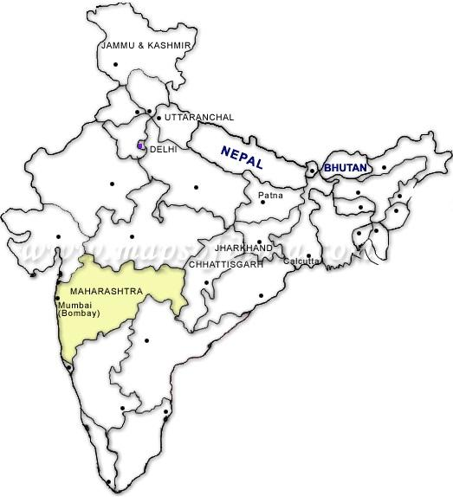
Figure 2: konkan map¹³
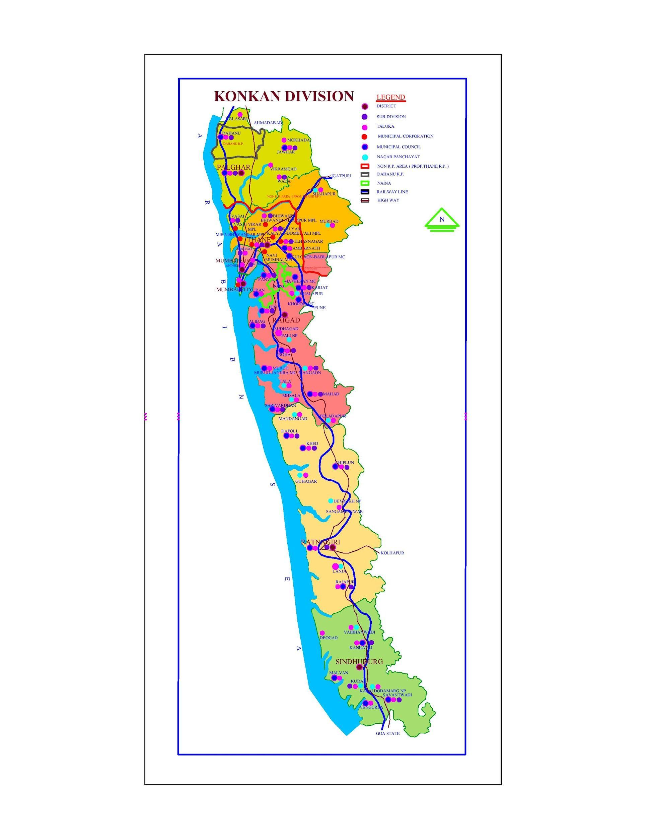
Figure 3: Rainfall statistics¹⁴
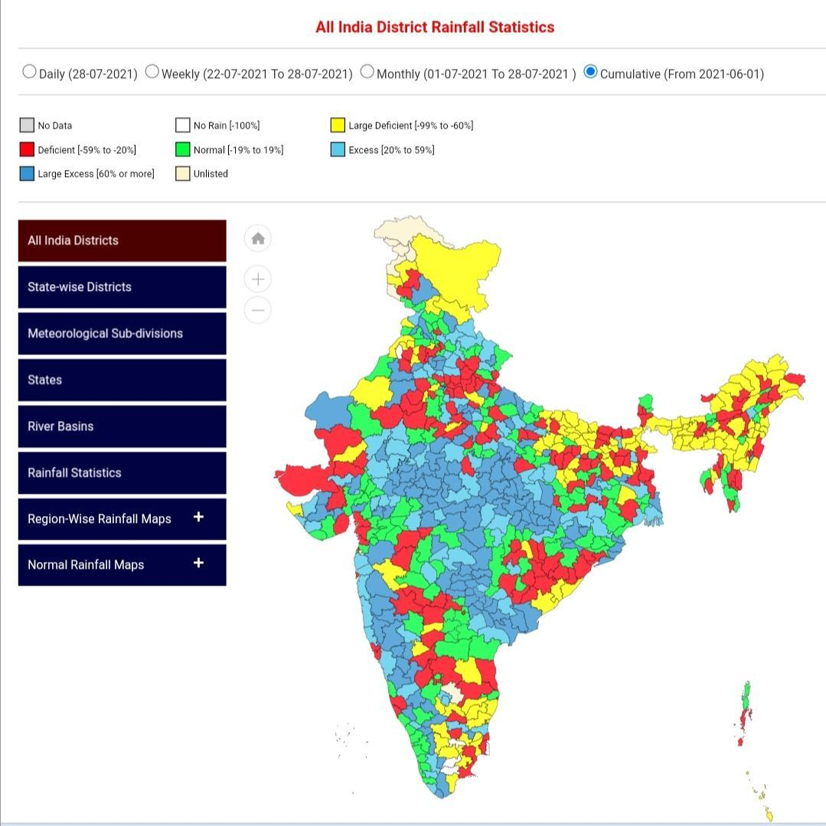

Figure 4: Variation of rainfall in different parts of konkan (Source: Anonymous 2016a)¹⁰
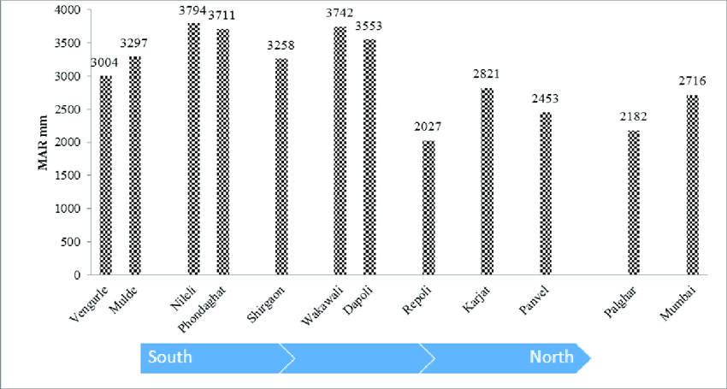

Figure 5: Area under forest in kokan district¹⁰

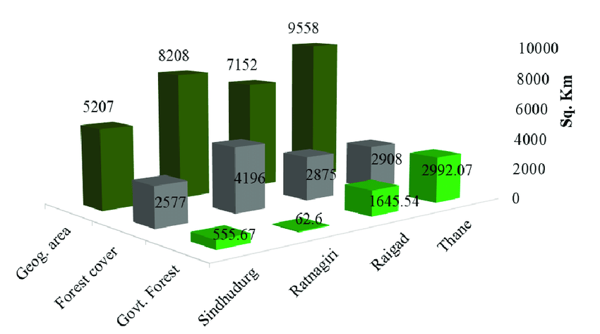

Figure 6: Major Field crops under rainfed kharif in konkan, Maharashtra (Source: Anonymous 2011a)¹⁰

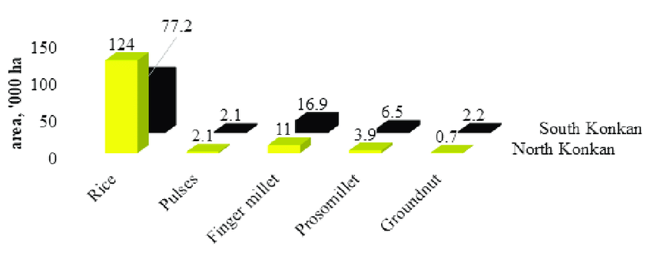

Figure:7 Ratnagiri map¹⁵
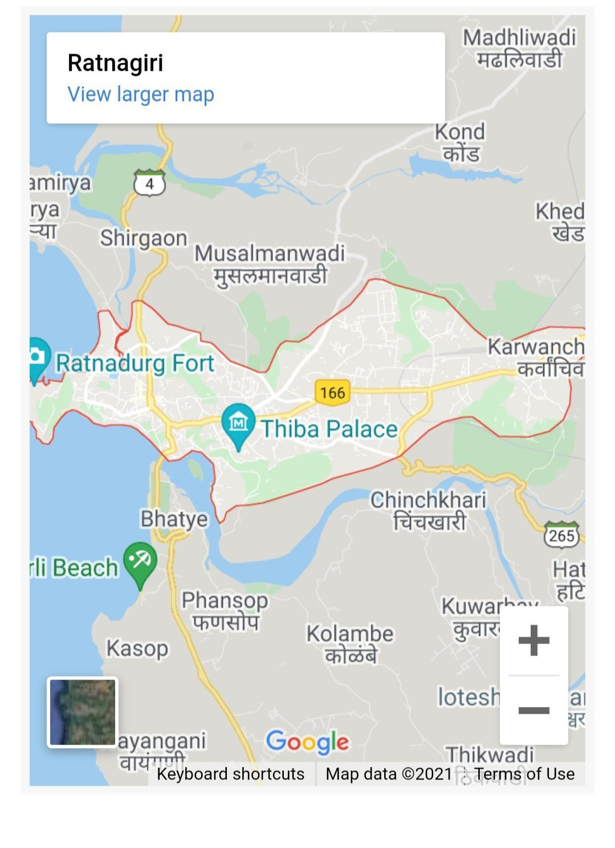
Figure 8: Raigad map ²⁰
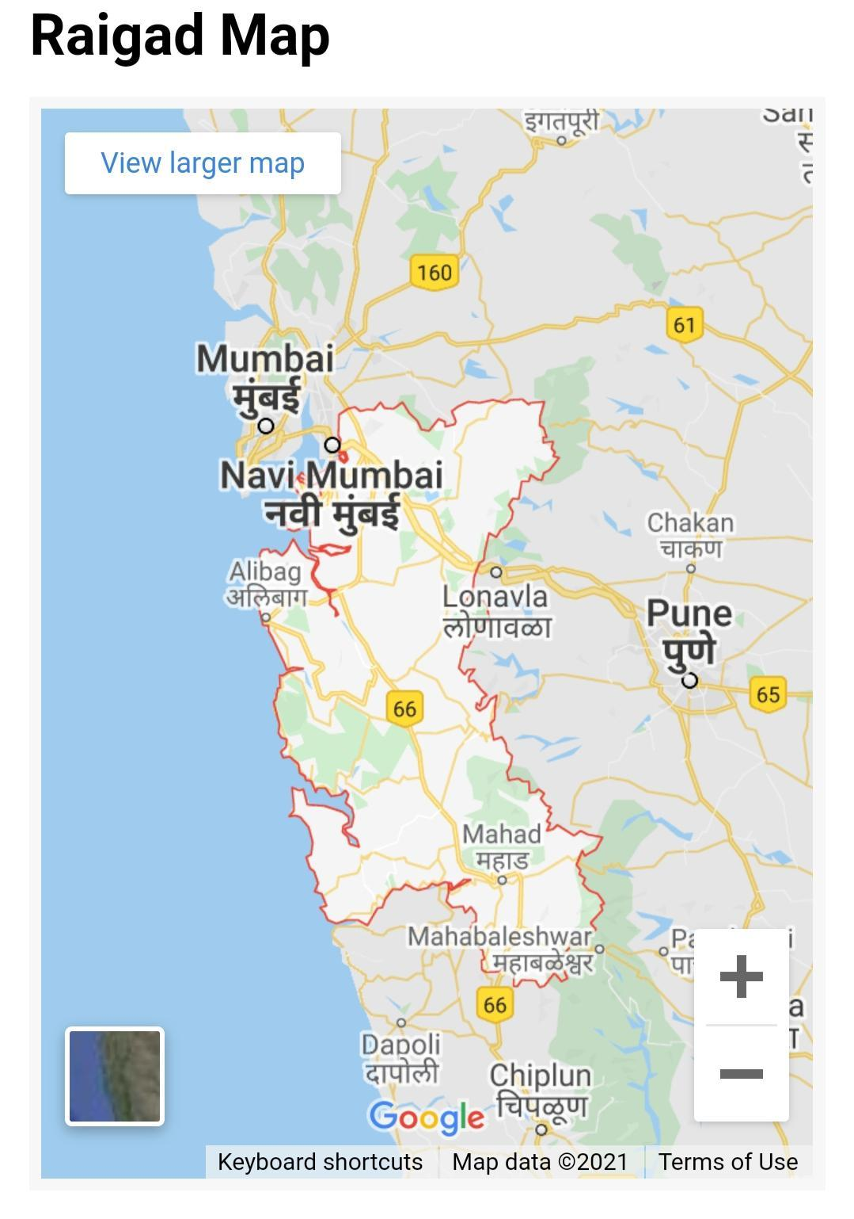

Figure 9: Thane Map²⁴
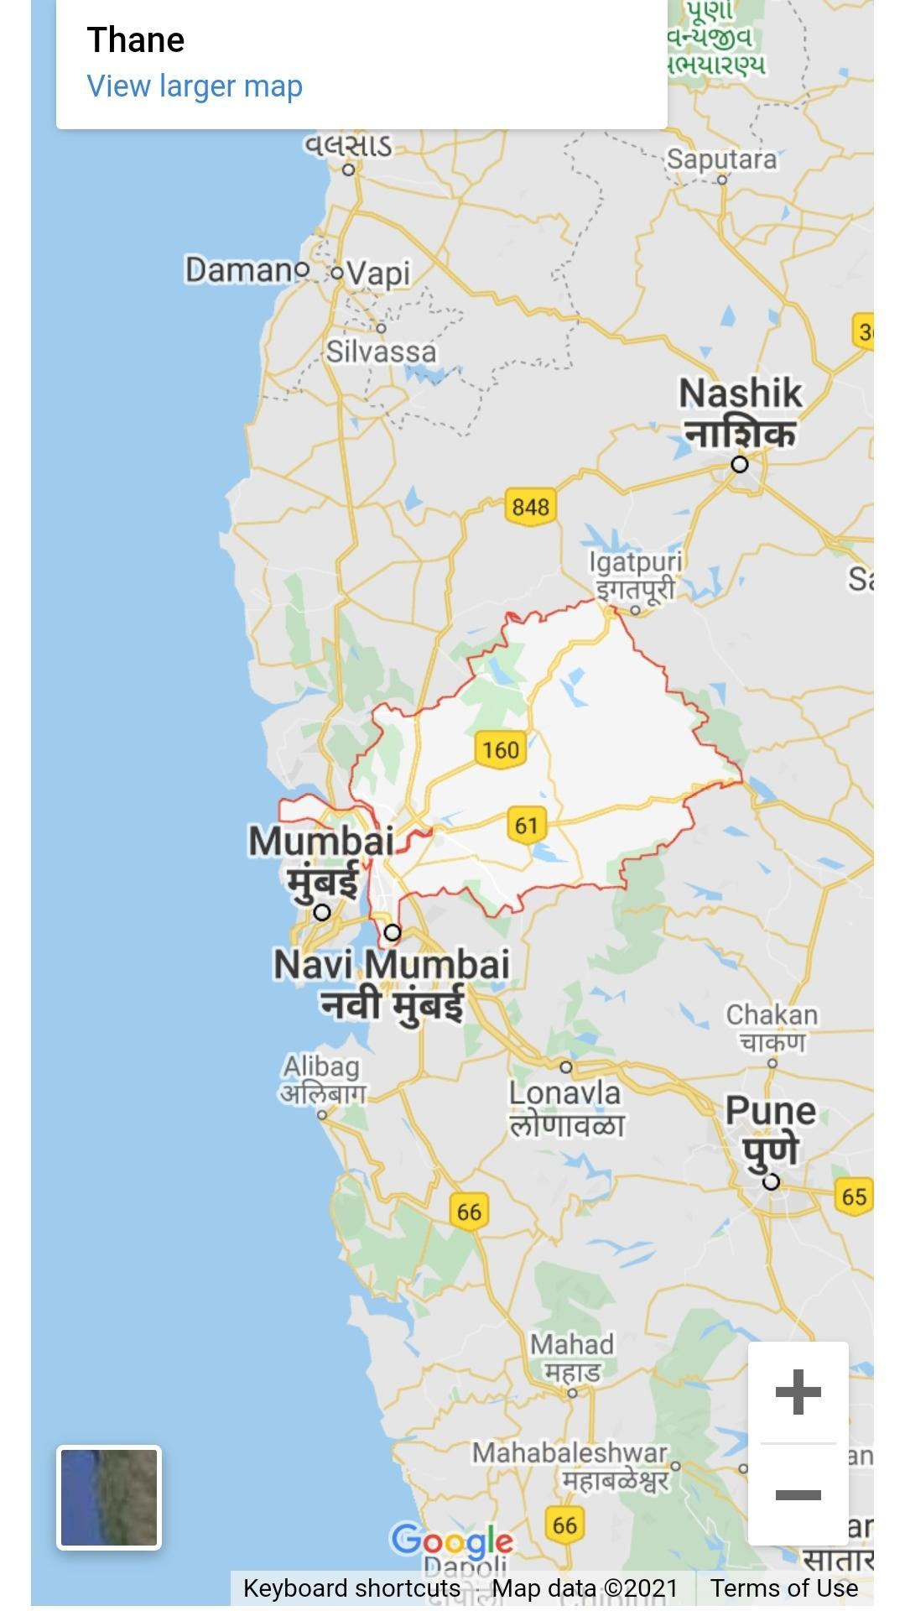
Figure 10: Sindhudurg map²⁷
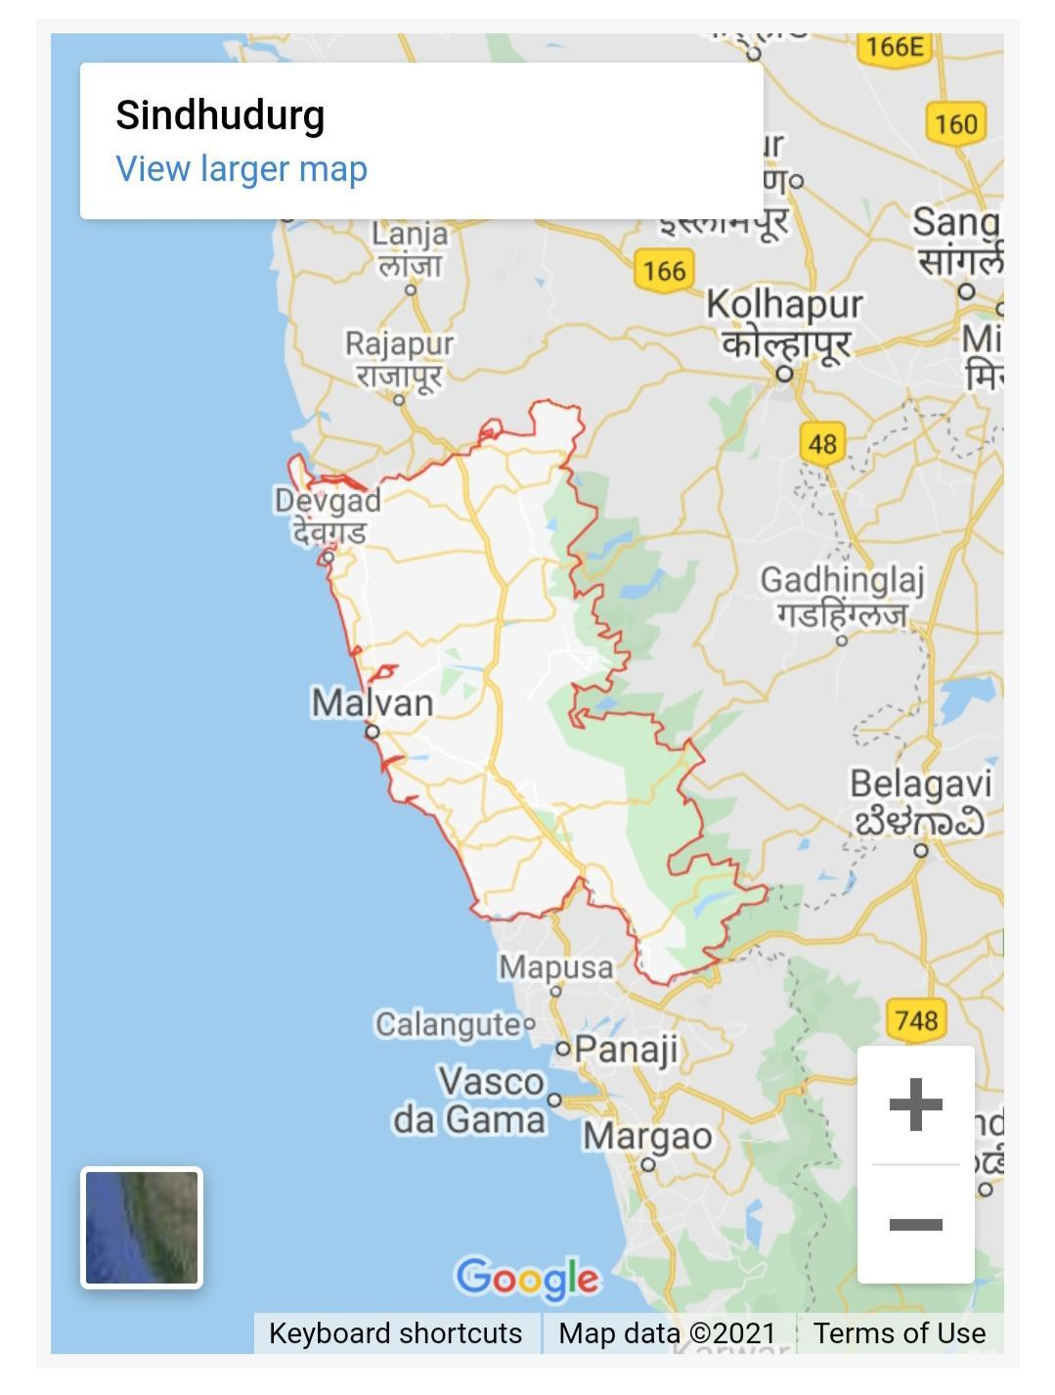
Figure 11: India Rainfall map ²⁸

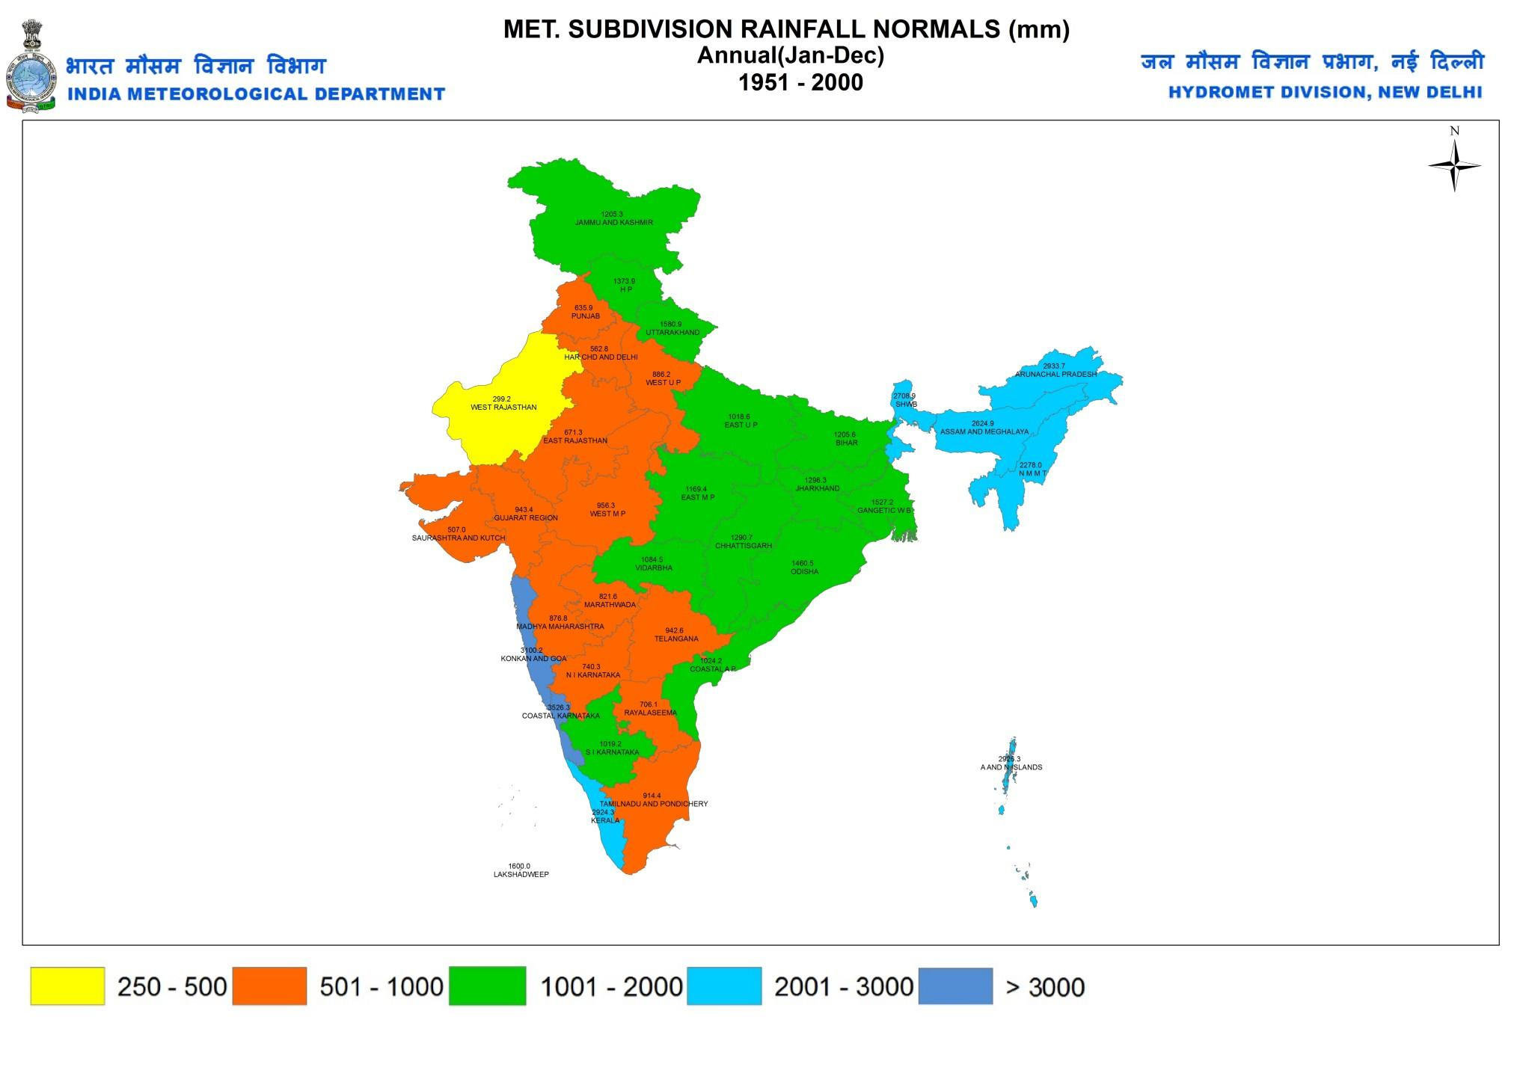

Conflict of interest Nil.

Source of funding Nil.

References-
- Acharya YT. Caraka Saṃhitā by Agnivesha. 4th ed. Varanasi : Chaukhambha Sanskrit Sansthan; 1997; p.276.
- Joshi YG. Charak Saṃhitā, 1sted, Indriyasthana 1/5.Pune:Vaidyamitra Prakashan; 2003; p.765.
- Joshi YG. Charak Saṃhitā,1sted,Indriyasthana 1/5.Pune:Vaidyamitra Prakashan; 2003; p.712.
- Acharya YT. Caraka Saṃhitā by Agnivesha. 4th ed. Varanasi: Chowkhambha Sanskrit Sansthan; 1997; p.653
- Acharya YT. Caraka Saṃhitā by Agnivesha. 4th ed. Varanasi: Chowkhambha Sanskrit Sansthan; 1997; p.654.
- Ambikadatta Shastri.Sushrut Saṃhitā, 11thed, Sutrasthana 35/50. Varanasi: Chaukhamba Sanskrit Sansthan: 1997; p.136.
- Acharya YT. Caraka Saṃhitā by Agnivesha. 4th ed. Varanasi: Chowkhambha Sanskrit Sansthan; 1997; p.654. Ambikadatta Shastri.Sushrut Saṃhitā, 11th ed,Sutrasthana 35/50
- Agnivesha, Charaka, Dridhabala, Charaka Samhita, Kalpa Sthana, Madanakalpa . In: 1/8. 1st ed. Yadavaji Trikamji Acharya., editor. Varanasi: Chaukhambha Surbharathi Prakashana; 2011. p. 653. [Google Scholar].
- Murthy K. R. S.:Astanga Samgraha(A.S.Su.18/31)English translation,ChaukhambhaOrientalia,Varanasi, U.P., India Edition 1997;344.
- https://www.researchgate.net/publication/341070315_Characteristics_of_konkan_Soils_and_their_Potential_for_Carbon_Sequestration.
- S.N. Karlekar ,S.C. Thakurdesai;'Geomorphological Field Guide Book on konkan & GOA COASTS'; 9th international conference on Geomorphology Delhi India 2017; page no. 5.
- http://divcomkonkan.gov.in/Document/en/page/MapGallery.aspx
- http://divcomkonkan.gov.in/Document/en/page/SectorRegion.aspx
- https://mausam.imd.gov.in/imd_latest/contents/rainfallinformation.php?msW
- https://ratnagiri.gov.in/?s=Map.
- https://en.climate-data.org/asia/india/maharashtra/ratnagiri-24258/
- https://ratnagiri.gov.in/geographical-information/
- http://raigadpolice.gov.in/htmldocs/overview.html
- https://en.climate-data.org/asia/india/maharashtra/karjat-997581/
- https://raigad.gov.in/
- https://en.climate-data.org/asia/india/maharashtra/karjat-997581/
- https://en.climate-data.org/asia/india/maharashtra/thane-5006/
- https://thane.nic.in/district-profile-new/
- https://thane.nic.in/?s=Map
- http://cgwb.gov.in/District_Profile/Maharashtra/Sindhudurg.pdf
- https://en.climate-data.org/asia/india/maharashtra/kudal-24211/
- https://sindhudurg.nic.in/?s=Map
- https://mausam.imd.gov.in/imd_latest/contents/rainfallinformation.php#
- https://www.nationalgeographic.org/encyclopedia/koppen-climate-classification-system/.
- Mayur RD, Sandeep VB. Appraisal of Marāṭhawaḍā province of Mahārāṣtra state in co-relation with the concept of Deśa in Āyurvedā. J Ayu Med Sci 2017;2(2):204-8. DOI: 10.5530/jams.2017.2.10

