A Role of Ayurvedic Management in Mutrashmari w.s.r. to Renal Calculi – A Case Study
- Author
  - Hod & Guide Name - Dr. S.B.Jamdhade Sir
  - Assistant professor – Dr.Pradnya S. Jamdhade Mam
  - PG Scholar. – Dr.Prajakta Pravin Dhawadkar
- Department – Kaychikitsa
- College Name – D.M.M.Ayurved College, Yavatamal
- Correspondence Author – Dr. Prajakta Pravin Dhawadkar
Abstract – Mutrashmari is one of the commonest diseases of Mutravaha strotas .The disease Mutrashmari is one among the AshtaMahagada ( 8 fatal conditions) formed in the urinary system . Based on its clinical features,it is compared with urolithiasis .It is a consequence of complex physicochemical processes which involves sequence of events in the formation of any urinary stone.In this case report 50 yrs /male patient visited in OPD Kaychikista with complaint of abdominal pain ( radiating pain from loin to groin ) & burning micturation . The pt had 2 times operated history for renal calculi . He was not willing for 3rd time operation of renal calculi so he came for Ayurvedic treatment . The USG report showed renal calculi . The patient was treated with ayurvedic formulation of churna
,tab & kashaya .This treatment showed magical effect .The stone was expelled out through urine within 1 mnth .It was 18 mm ×9 mm in size .The pt got moderate relief from pain in the abdomen & didn’t experience dysuria .
Key Words – Mutrashmari,Renal calculi, Shaman chikitsa , Ayurvedic formulation.

Introduction-
- Renal stones vary in frequency around the world probably as a consequence of dietary & environmental factors. Renal stone are one of the most common urological problems.Renal stone can occur at any age . Stones that grow in the urinary tract ( recognised as nephrolithiasis or urolithiasis) form when the urine becomes excessively supersaturated concerning a mineral , leading to crystal formation, growth, aggregation & retention with in the kidneys.
- The lifetime prevalence of symptomatic renal calculi is approximately 10% in men ,5% in women & probability of the second stone formation within 5 to 7 yrs is approximately
50%. Worldwide approximately 80% kidney stones are composed of calcium oxalate (CaOx) mixed with calcium phosphate (CaP)
- Mutrashmari is one of the commonest diseases of Mutravaha strotas. Mutrashmari is classified on the basis of , predominance of doshas sign & symptoms. Depending upon the type of ashmari the other symptoms & the nature of pain varies .Acharya Sushruta has mentioned Mutrashmari as one of the AshtaMahagada ,Mahagada means which is dreadful & having potential to disturb the anatomy & physiology of urinary system .It has tendency of recurrence . Acharya Sushruta has explained the formation of Ashmari
in detail including Nidana, samprapti ,purvarupa ,Rupa ,Bheda ,Updrava ,Asadhya lakshana &chikitsa in a most scientific manner.
- Acharya Charak has explained the samprapti of Mutrashmari in Trimarmiyadhyaya of chikitsa sthan.Along with Kapha dosha in Mutravaha strotas vitiated vata dosha lead to Ashmari formation .There is reduction in volume of urine due to saturation of kapha dosha thus causing formation of Ashmari due to nidan sevan ,doshas gets aggrevated along with dushya they cause strotodusti & then disease manifest .

Method :-
Case study- A 50 yrs old male patient visited to our L.K.Ayurved Rugnalay, Yavatmal on 27/06/2022.
The patient presented with complaint of severe pain in left flank region associated with burning micturation , difficulty in urination ,pain radiating to groin region , intermittently.USG abdomen was advised .
History of Present illness :- Before 2 mnths pt was in good state then he started to complain of severe abd pain & it was discovered that the pain was sporadic & colicky .It was present on the rt side of the abdomen which radiated from the loin to groin area, difficulty in urination normally at the start of pricking type of urination often burning micturation.
Past History:- Patient had 2 times operated history for renal calculi.There was no history of diabetes mellitus or HTN . History revealed that his food intake was irregular so recurrence of calculi was present . He was not willing for 3rd time operation of renal calculi . He came for Ayurvedic treatment .
Family History:- no significant history

Rugnaparikshan :-
- Nadi - 76 /min
- Mal. – samyak
- Mutra – Asamyak
- Jivha - alpsam
- Shabda – Prakrut
- Sparsha – samshitoshn
- Prakruti. – vat-kaphaj
- Nidra. -Anidra
- RR. – 19 / min
- Temp – 98.3°F
- BP. - 120/70 mm of Hg
- Urine – Burning & painful micturation
- Stool – Unsatisfactory bowel habits
- P/A - No organanomegally & tenderness elicited in both side of lumbar region & side of renal angle.

Investigation :-
USG Report – Right renomegaly with two small stones (8.9× 7.4.10×8.3 mm) in caliceal system with hydronephrosis due to three small stones (9.3×6.2,6.5×4.6 mm) in right VUJ & lower ureter .
Urinary bladder shows mild mucosal irregular thickening .His blood & urine reports were within normal limits

Samprapti Ghatak :-
Dosha – tridosha ( vatkaphpradhan n)
Dushya – Mutra
Agni - jatarangi mandya
Ama - Jataragni mandya janya
Strotas – Mutravaha strotas
Udbhava sthan – Amashaya & pakvashaya
Sanchara sthan – Siras , amapakvashayagat Mutravaha strotas
Adhisthan – Mutravaha strotas & basti
Vyakta sthan – Mutravaha strotas & basti

Dusri Prakara – sanga

Rogmarga - madhyama
Vyadhi swabhava – Mutra apravruttijanya vicar
Sadhyasadhyatha – kruchhasadhya , shastrasadhya

Material & Methods:- Method :- 1) A Case study
2) Centre – PG Dept of Kaychikitsa L .K. Ayurved Hospital Yavatamal affiliated to DMM Ayurved college Yavatmal

Material :-
Dravya | Matra | Kala | Anupan
1.Hazrul Yahud  Bhasma  +  Punarnava  Mandur  +  Punarnava  Gugulu  +  Pashanbhed  +  punarnava  churna  +  Chandraprabha  Vati | 20 gm  10 gm  10gm  10 gm  40 gm  10 gm | BD | Ushnodak
( 60 pudya ) | (twice a day  1……………..1)
2.cap Unclean |  | TDS | Water
3.Tab Distone |  | TDS | Water
4.cap. panastone |  | TDS | Water
4.Syp Unclean +  Ashmarihar kadha |  | TDS (10ml ) | Water
5.Cap.Conlax |  | OD HS water

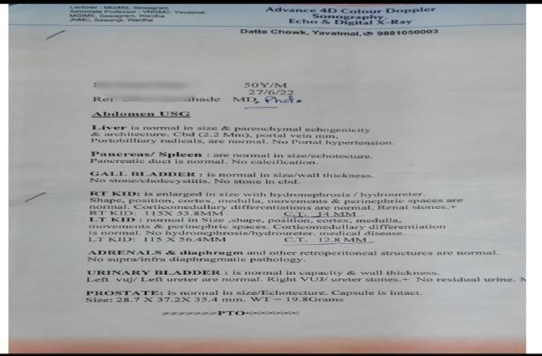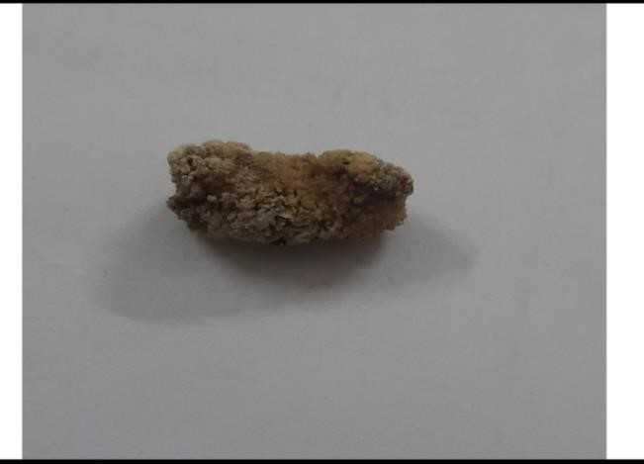

Before treatment (USG Report) After treatment ( no stone in USG report)
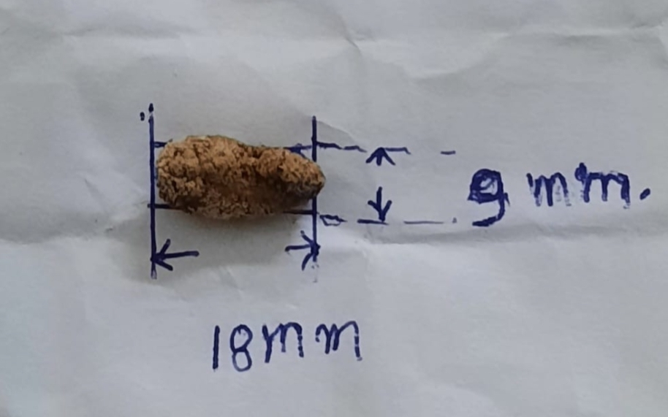

( Stone size )

Result :- In the first follow up,the patient informed the stone was expelled out through urine.It was 18mm×9mm in size .He experienced moderate pain & disturbance in the urine flow on 30 th day .The patient got moderate relief from pain in the abdomen & didn’t experience dysuria.The result revealed that with ayurvedic Shaman Chikitsa renal calculi can be healed & other surgical procedures can be prevented.
Discussion :-- In this case study , the stone was present on UVJ region . UVJregion is nearer to the urethra so the stone was easily expelled out through the urine.The combination of drugs described in the treatment found to be very effective in reducing the symptoms of Mutrashmari,bastishula ,Mutra virechaniya , mutrasangrahaniya & mutrashodhaka.
- In the present case study ,pain is relieved due to the ushna & teekshna guna of drugs has kaphvataghna properties . It acts antagonist to kaphvataja sanghata. In Uclean capsule , chandraprabha (50mg),Hazral Yahud Bhasma (50 mg) ,Tankan bhasma (25 mg), Pashanbhed (100mg) which is used in urinary retention ,dysuria ,renal calculi & burning micturation due to acidic urine .
- Distone capsule in ayurvedic formulation enriched with Pashanbhed, manjistha ,Nagar musta ,Apamarkhar , Elaichi,Revanchini ,Gojiha ,sahadevi ,Hazrul yahud bhasma ,Shudha shilajit .that is a unique ayurvedic blend of herbs & minerals meant for overall kidney , urogenital system wellness & also reduce stone forming substance.
- Chandraprabha Vati is potent anti-inflammatory ayurvedic remedy used for the treatment of diseases of the urinary tract ,kidney , pancreas , thyroid gland ,bones &joints . syp uclean & Ashmarihar kadha helps in breaking the sanghat of Mutrashmari & helps in dissolution & disintegration of stone i.e Ashmarighna properties .

Probable Mode OF Action :- All the medicine are given in the treatment are ushna & tikshna guna has kaphvataghna properties. It acts antagonist to kaphvataj sanghat It helps in breaking the sanghat of Mutrashmari &helps in dissolution & disintegration of stone I e Ashmarighna properties
Conclusion :- After observation of this case study , it can be concluded that the Ayurveda gives better relief to the patient of Mutrashmari . The ayurvedic formulation of churna , tablets & kashaya can be safely & effectively carried out in pts of Mutrashmari with good results .

References :-
1.Davidsons Essential of Medicine ,2 nd Edition ,edited by J . Alastair Innes,with a contribution by Simon maxwell.ch.7/159
2. Sushruta samhita Ashmari chikitsa 7/22 Sushrut samhita with the Nibandh sangraha , commentary of
Shri Dahanacharya & the nyayachadrika Panjika Gayadasacharya on chikitsasthan edited by Vaidya
Yadavji trikamji acharya chaukhamba sanskrut sansthan varanasi edition 2017.P436
3.Shri Gayadasacharya on Nidansthana edited by Vaidya Yadavji trikamji acharya chaukhamba Sanskrut sansthan . Sushrut samhita samprapti ,lakshan ,3rd 4-12 Sushruta samhita with nibandh sangraha commentary of Shri Dahanacharya &Nyayachadrika Panjika varanasi edition 2010.P.277-279
- Finlayson B.physicochemical aspects of urolithiasis . kidney In1978:13:344-360
- Nephrolithiasis – Author :J Stuart Wolf Jr,MD FACS : Chief Editor Bradley Fields Schwartz Do,FACS
- Sharma PV, editor , Trimarmiyadhyaya chikitsa adhyaya In; chatak samhita of agnivesha , chikitsa sthana 8th ed . Varanasi ,India chaukhamba orientalia 2007.p 629
7.Sharma PV editor,Ashamarichikitsa adhyaya Verse 3.In Sushruta samhita, chikitsa sthan Varanasi India : Chaukhamba Surbhabharati prakashan 2013.p -234
8.https:/www.researchgate.net/ publication /349344145-A_case study on management of complex renal calculi_mutrashmari by ayurvedic formulation
9.https:/www.researchgate.net/publication / 349344145-a case study on management of complex renal calculi Mutrashmari by ayurvedic formulation
- https:/www.joinsymed.com/article .asp? ISSN=2320-4419;yr=2019; volume=7 ; issue =3,5page =189; epage =193all last =bhende
- Sharma PV editor Trimarmiyadhyaya chikitsa adhyaya Verse 54,59 In charak samhita of agnivesha chikitsa sthana 8thed . Varanasi India chaukhamba orientalia 2007p 874-5
- Sharma PV editor Ashamarichikitsa adhyaya Verse 40-43 In shushrta Sushruta chikitsa sthana varanasi India chaukhamba orientalia Surbhabharati prakashan 2013 pg no. 42

