TITLE
Nutritional Analysis of Chyawanprash

Suchita Manish Sheth, Associate Professor, Smt. KGMP Ayu College, Mumbai 400 002.

ABSTRACT

Ayurveda a great life science provides many Novel concepts like Rasayan ,Vajikaran .Chyawanprash, is one of the Rasayan, used as antiageing process and is being used since ages, but still the standardization is lacking , The present study is aimed to standardize Chyawanprash for estimation of Nutritional components present in it by sophisticated analytical tools. The study shows that it contains maximum Iron which is, in fact, more than recommended daily allowances and Fat is less than 0.1% and other nutritional componentsas per table 2. This validates the claim that it can be given to patients with heart diseases. Vitamin C present in Raw Amlaki was 447 mg/100 gm, which substantially reduced after processing which was reduced to 7.25 mg/100 gm. Phosphorous detected was 77 gm/100 gm. There was no presence of heavy metals detected. Hence these parameters and the developed methods may be considered as a tool for assistance to the scientific organization and the manufacturers in developing standards for Chwawanprash.

INTRODUCTION
Ayurveda the life of science mainly emphasis on wellbeing by achieving youth, vigour and immunity in body by adopting Routine lifestyle mentioned in Ayurveda and intake of certain food supplements which are known as Rasayana¹.Chyawanprash is one of the Rasayana mentioned along with guduchi etc², which falls under kutipraveshik method for Rasayan intake³⁻⁵ which imparts immunity, strengthens body, anti-ageing⁶, Aphrodiasic⁷⁻¹¹. Chyawanprash is used since ages, but the nutritional value is not estimated till date.

AIM AND OBJECTIVES
- To incorporate sophisticated instruments and methods for achieving purity of Chyawanprash.
- To standardize and analyze the in-process drug with following parameters - Duration, Temperature, pH.
- To assess the result obtained and to validate the claims made.
- To assess nutritional assay for Macro and Micronutrients

MATERIAL AND METHODS 12

Ingredients
Figure 1: Ingredients of Chyawanprash Avaleha (Drugs used for Decoction)

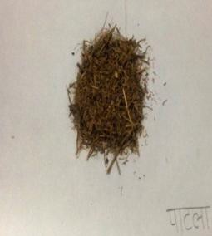 | 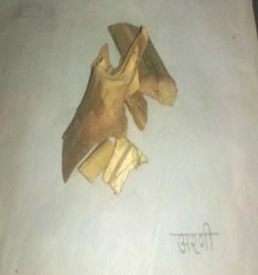 | 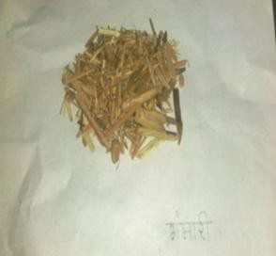
2.1 Patala | 2.2 Arani | 2.3 Gambhari
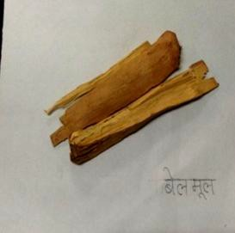 | 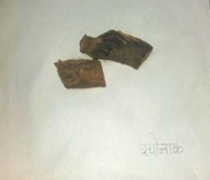 | 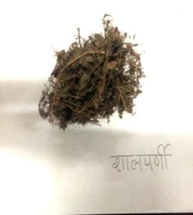
2.4 Bilwa | 2.5 Arani | 2.6 Gambhari
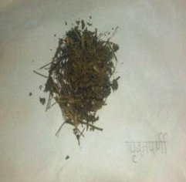 | 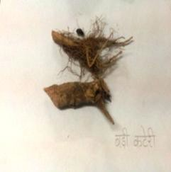 | 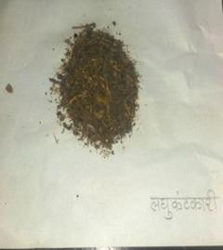
2.7 Mudgaparni | 2.8 Mashaparni | 2.9 Kantakari
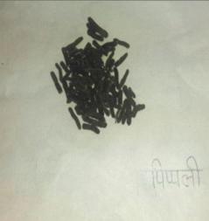 | 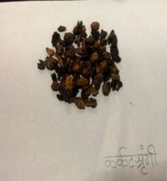 | 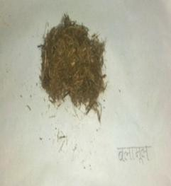
2.10 Pippali | 2.11 Karkatashrungi | 2.12 Bala
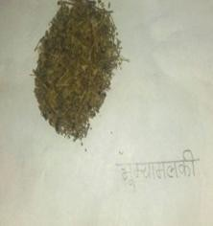 | 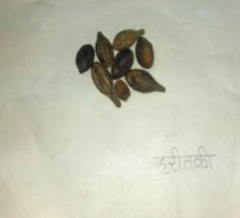 | 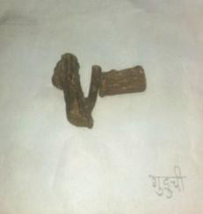
2.13 Bhumyamalaki | 2.14 Haritaki | 2.15 Guduchi
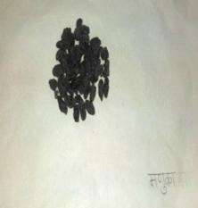 | 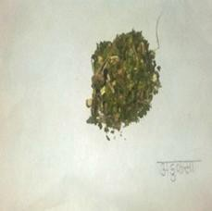 | 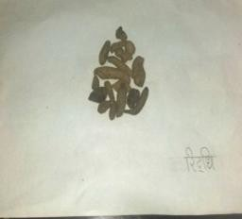
2.16 Draksha | 2.17 Vasa | 2.18 Riddhi
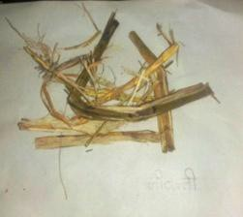 | 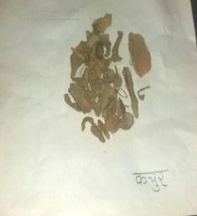 | 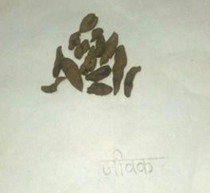
2.19 Jivanti | 2.20 Karchu | 2.21 Jeevak
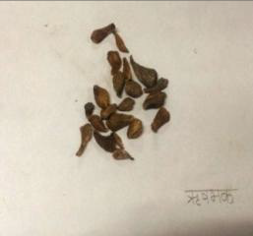 | 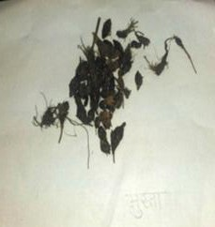 | 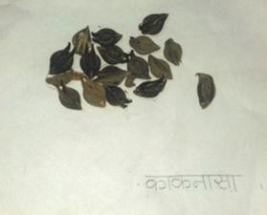
2.22 Rishabhak | 2.23 Musta | 2.24 Kakanasa
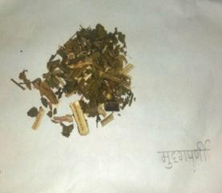 | 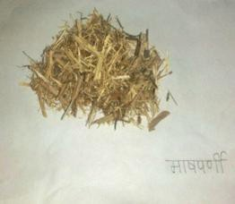 | 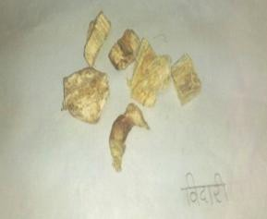
2.25 Mudgaparni | 2.26 Mashaparni | 2.27 Vidari
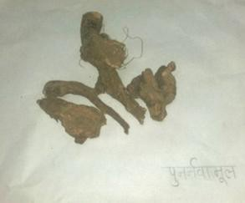 | 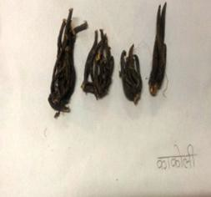 | 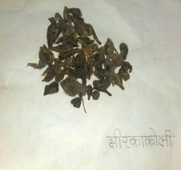
2.28 Punarnava | 2.29 Kakoli | 2.30 Kshir Kakoli
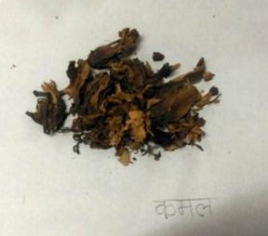 | 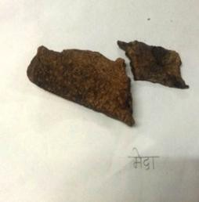 | 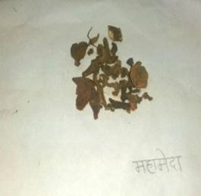
2.31 Kamal | 2.32 Meda | 2.33 Mahameda
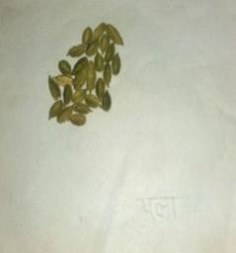 | 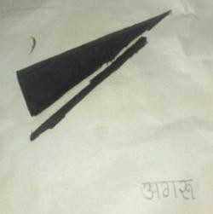
2.34 Ela | 2.35 Agaru

Method of preparation
5 Kg Amala were weighed and washed. Raw drugs (1824 gm) were weighed and soaked in 12 L of water overnight. Next day aamla were tightened in a cotton cloth and were immersed in decoction (as in Dola yantra). Then the decoction was boiled till it reduced 1/8th. Seeds and fibres of cooked aamla were removed and were mashed into pulp. This pulp is then roasted in cow ghee till it leaves oil, at 40°C for about 2-3 hours. Once pulp starts leaving oil, pour decoction and sharkara into it and heat it till avleha consistency is achieved. Finally, powdered prakshep dravyas were added and after cooling madhu was added. The obtained formulation is known as Chyawanprash. Duration for preparation: 4 days, pH: 3-4.

Various stages of preparation | Representative image
Bharjana Sanskara (Amalaki & Goghrita) – Initial Stage | 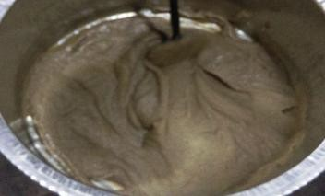
Bharjana Sanskara (Amalaki & Goghrita) – End Stage [Ghee and Kalka get separated] | 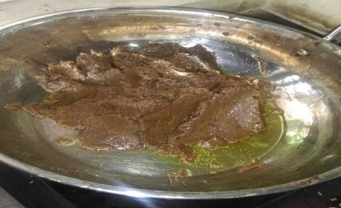
Final Product (Chywanprash Avaleha) | 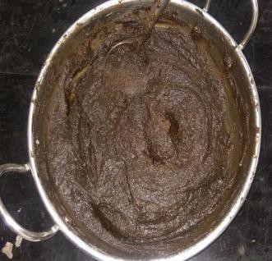

Standardization and Analytical Study:
      - In process standardisation.
      - Finished product- standardisation.

Standardization of raw drugs
The study drugs used were identified and authenticate by pharmacognosy and then subjected to study.

Finished Product Standardisation
Chyawanprash was sent for its nutritional analysis at Microchem Silliker (Navi Mumbai, Ghansoli). Result obtained as following:

Table 1: Results obtained after Nutritional Analysis of Chywanprash
Parameters | Value | Unit of Measures
Moisture | 24.26 | %
Ash | 5.21 | %
Protein | (N×6.25)1.15 | %
Fat | <0.1 | %
Carbohydrates | 69.28 | %
Dietary fibres  (soluble & insoluble) | 12.09 | %
Vitamin A | 22.7 | ug/100g
Vitamin C | 7.25 | mg/100g
Vitamin E | 1.79 | mg/100g
Calcium | 72.22 | mg/100g
Iron | 8.14 | mg/100g
Phosphorous | 76.81 | mg/100g
Magnesium | 36.79 | mg/100 g
Potassium | 30.10 | mg/100 g
Selenium | Below limit of quantification | mg/kg
Mercury | Below limit of quantification | mg/kg
Lead | Below limit of quantification | mg/kg

OBSERVATIONS AND RESULTS

Pharmaceutical study-
Pharmacognostical evaluations shows Dashmool and Ashtavarg which are not genuine still they are being used by traders.
500 g Amala were weighed and washed. Raw drugs were weighed and soaked in 12 L of water overnight. each Amala weighed ~10gm. Then the decoction of 12 L was boiled till it reduced 1/8th i.e. 1.5 L Amala gets softened.
  - pH of decoction: 4.
  - Temperature- Flame while making decoction was: 263°C, decoction: 120°C.
  - The pulp roasted in butteroil till it leaves oil, at 40°C for which duration was about 2-3 hours.
  - Once pulp starts leaving oil pour decoction into it and heat it till avleha consistency is achieved.
  - After that finally powdered prakshep dravyas were added and after cooling madhu was added. Duration for preparation– 4 days pH –3-4

Table 2 Analytical study data of Finished product (Chyawanprash)

Sr. No. | Nutrients analyzed in chayawnprash | Chyawanprash/ 100 gms as per analysis | Nutrients/day as per FDA ranging from children to adult | Dose in per 40 gms of chyawanprash | Deficient
1. | Protein | 1.15% | 50 gm/day (0.6g/Kg/d)  i.e. 10-14% of Calories | 20 gm | 30 gm
2 | Carbohydrate | 69.28 % | 300 gm/day  55% of Calories should come from carb. | 27.712 gm | 272.28 gm
3 | Fat | <0.1% | 65gms/day  35% of Calories should come from Fat.  Saturated/unsaturated - >10%  Poly/monosaturated - >10% | 0.04 gm | 64.96 gm
4 | Vit A | 22.7mcg/100 gm | 500 IU | 30.264 mcg = 9.0792 IU | 490.9 IU
 |  |  | Age 1-8 yrs - 1000-1300 IU
 |  |  | Adult - 3000IU (M) 2300 IU (F)
5 | Vit E | 9 mg/ 100 gm | 30 IU | 7.16 mg = 7160mcg = 10.68 IU | 20.68 IU
 |  |  | Age 1-8 yrs – 13-16 IU
 |  |  | Adult – 33 IU (S), 22 IU(M)
6 | Vit C | 5mg/ 100gm | 60 mg | 29 mg | 31 mg
 |  |  | Age 1 -8 yrs – 25mg
 |  |  | Adult – 90mg (M), 75mg (F)
7 | Calcium | 72.22 mg/100 gm | 1000mg | 300 mg | 700 mg
 |  |  | 700-1000 mg (Children)
Adult – 14yr-1100mg/d
70yr – 1000mg/d
8 | Iron | 8.14 mg/ 100gm | 18 mg | 32.56 mg | More of 14.56 mg
 |  |  | Age 1 -8 yrs – 7-10mg
 |  |  | Adult – 8mg (M), 18mg (F)(19-50 y), 8mg (F)( 51+ y), 27 mg (Pregnant), 9mg (Lactation)
9 | Dietary fibre | 12.09 % | 25gms/day | 4.836 gm | 5 gm
10 | Phosphorus | 76.81mg/ 100gm | 1000mg/day | 30.724 mg | 969.28
 |  |  | Age 1-8 yrs – 460-500mg
 |  |  | Adult – 700mg
11 | Magnesium | 36.79 mg/100 gm | 420 mg/day | 14.716 mg | 405.28s
 |  |  | Age 1-8 yrs – 80-130mg
 |  |  | Adult – 400mg (M) (19-30yr), 420mg (M) (30+), 310mg(F) (19-30 yrs)
12 | Potassium | 302.10 mg/100gm | Age1-8 yrs – 3-3.8mg/day
 |  |  | Adult – 4.7gm/d, 5.1gm/d (Lactation)
 |  |  | Age 1-8 yrs – 80-130mg
13 | Selenium | Below limit of quantification | 55 microgram/day
 |  |  | Age 1 -8 yrs – 22-30mcg/day
 |  |  | Adult – 55mcg/d 70mcg/d (L) 60mcg/d (Preg)
14 | Mercury | Same as above
15 | Lead | 0.48 mg/kg
- Institute of medicine of National Academy of Sciences, Nov 30, 2010. Daily Values from NIH, Food labelling guide, FDA, 2013.

The present research drug in 40 gm of sample contains the following nutritional quantity in comparison to Food drug and admission led Recommended Daily Allowance (RDA).

Chyawanprash taken in an advisable dose will match for protein, Vitamin C, Dietary fibre, Calcium deficit for 100 mg, Abundance of Iron as per RDA. It is deficit in Magnesium and Phosphorous by 375.8 mg and 907.8 mg respectively. Potassium was deficit by 2.7 gm. Selenium and Mercury was below limit of quantification and Lead was 0.48 mg/kg

DISCUSSION
The study entitled nutritional Assay of in Chyawanprash has 3 main sections - Pharmaceutical study, Standardization and analytical study .Pharmaceutical study-Chyawanprash was prepared using standard text sharangdhar.. Before the preparation of Chyawanprash the raw drug was analysed for pharmacognostical evaluation .Finished product was analysed for the presence of nutritional component in it. The chart below enlists the same.

Table 3 -Test report of Nutritional components of Chyawanprash

Sr No | Parameter name | Result | Unit of measurement | Method
1 | Moisture | 24.26 | % | IS: 6287-1985(R 2005)
2 | Ash | 5.21 | % | FSSAI MAN 5
3 | Protein | (NX6.25)1.15 | % | AOAC 2001.11
4 | Fat | <0.1 | % | IS:6287-1985
5 | Carbohydrate | 69.28 | % | AOAC 986.25
6 | Dietary fibre (soluble & insoluble) | 12.09 | % | AOAC 991.43
7 | Vitamin A | 22.7 | µg/100g | AOAC 2001.13
8 | Vitamin C | 7.25 (Finished product)  446.72 (Raw Amla) | mg/100 g | AOAC 2012.22 AOAC967.21
9 | Vitamin E | 1.79 | Mg/100 g | AOAC 997.03
10 | Calcium | 72.22 | Mg/100 g | AOAC 985.35
11 | Iron | 8.14 | Mg/100 g | AOAC 985.35
12 | Phosphorous | 76.81 | mg/100 g | MC/SOP/INS/21
13 | Magnesium | 36.79 | mg/100 g | AOAC 985.35(19th Ed)

Iron present is maximum i.e. more than recommended daily allowances and Fat is less than 0.1%.This validates the claim that it can be given to patients with heart diseases. Vitamin C present in Raw Amlaki was 447 mg/100 gm, which substantially reduced after processing which was reduced to 7.25 mg/100 gm. Phosphorous detected was 77 gm/100 gm. There was no presence of heavy metals detected.

CONCLUSION
The present work was carried out to assay the nutritional value of Chyawanprash. The result obtained as set to develop standard operating process for method of preparation of Chyawanprash and the nutritional assay of the food components were compared with Recommended daily allowance with that of Food drug and administration. The result indicates the presence of nutrient as per Table 3. Method of food component detection was done by using standard AOAC.

Hence these parameters and the developed methods may be considered as a tool for assistance to the scientific organization and the manufacturers in developing standards. The present work is a small step towards development of standard operating process of Chyawanprash a standard assay of nutritional component present in it.

This will also help to produce uniform standard products, which will restore in the faith of the claims made in Ayurvedic systems.

SUMMARY
Chyawanprash sample was prepared in the Laboratory according to the standard text. Pharmacognostical evaluation was done by expert. The data analysis revealed most of the materials are not available, instead their alternative herbs are used (Table 2). Chemical analysis was done using various parameters viz fat, carbohydrate, calcium, iron, listed in Table1. The chemical analysis for the evaluation of nutritional components showed maximum percentage of iron etc, as per Table 1. In-process standardization showed the duration, temperature pH. All these parameters of Table 1, Table 2 and Table 3 together can be used successfully for analysis of Chyawanprash and can be used as a food supplement required per day, will serve as a basis for fixing standardization parameter.

REFERENCES AND SHORT BIBLIOGRAPHY
- Acharya Kashinath Shastri, Charak Samhita; Chaukhamba bharati Academy; Chikitsa Sthana, 19th edition, 1st Chapter, Verse 7, 1993, p.5
- Acharya Parashuram Shastri, Sharangadhara Samhita, first part, Chaukhambha Orientalia Publications, 3rd edition, 4th Chapter, Vers 13, 1983. p. 37
- Acharya Parashuram Shastri, Sharangadhara Samhita, first part, Chaukhambha Orientalia Publications, 3rd edition, 4th Chapter, Vers 13, 1983. p. 37
- Acharya Kashinath Shastri, Charak Samhita; Chaukhamba bharati Academy; Chikitsa Sthana, 19th edition, 1st Chapter, Verse 7, 1993, p.5
- Acharya Kashinath Shastri, Charak Samhita; Chaukhamba bharati Academy; Chikitsa Sthana, 19th edition, 1st Chapter, Verse 16-24, 1993, p.7-9
- Acharya Kashinath Shastri, Charak Samhita; Chaukhamba bharati Academy; Chikitsa Sthana, 19th edition, 1st Chapter, Verse 7, 1993, p. 8-9
- Acharya Kashinath Shastri, Charak Samhita; Chaukhamba bharati Academy; Chikitsa Sthana, 19th edition, 1st Chapter, Verse 7, 1993, p.7
- Acharya Kashinath Shastri, Charak Samhita; Chaukhamba bharati Academy; Chikitsa Sthana, 19th edition, 1st Chapter, Verse 7, 1993, p.6
- Acharya Ambikadutta Shastri, Sushrut Samhita, Chaukhambha Sanskrit sansthana, Chikitsa Sthana, 8th edition, 27th Chapter, Verse 3-5, 1993, p. 120
- Acharya Ambikadutta Shastri, Sushrut Samhita, Chaukhambha Sanskrit sansthana, Chikitsa Sthana, 8th edition, 27th Chapter, Verse 3-5, 1993, p. 121
- Acharya Anna Kunte, Ashtanga Hridayam, Chaukhambha Orientalia Publications, Uttar Tantra, 7th edition, 39th Chapter, Verse 1-2, 1982, p. 907
- Acharya Parashuram Shastri, Sharangadhara Samhita, first part, Chaukhambha Orientalia Publications, 3rd edition, 4th Chapter, Vers 13, 1983. p.

