“Effect of an Ayurvedic Formulation Orally and Purnil Oil locally in the management of Vicharchikaw.s.r. to Eczema” –A case study.
1) Dr.Subhash B Jamdhade¹ 2) Dr.Pravin G Kendre²
Associate Professor P.G Scholar
P.G.Dept Of Kaychikitsa P.G.Dept Of Kaychikitsa
D.M.M.AyurvedCollege,Yavatmal D.M.M AyurvedCollege,Yavatmal

3) Dr. S. K. Jaiswal³
HOD/Professor
P.G.Dept Of Kaychikitsa
D.M.M.AyurvedCollege,Yavatmal

Abstract: Ayurveda is the traditional,ancientindian system of health science. Ayurveda is science of life. Ayurveda is not only curative but also preventive science of life.
Skin is the largest and important organ and outermost covering of the body which is 1st protective barrier but very often it is exposed to many entity which can damage it and cause many skin disorder .
In ayurveda the word Kushta is broad term which cover almost all skin disorder. According to many acharya in kushta due to vitiated dosha the part of the skin become affected and changes its normal colour called Kushta .which have been classifytwo groups
1.Mahakushta 2. Kshudrakushta.
Vicharchika is defined under kshudrakushta. it can be correlate with eczema in modern medicine.Vicharchika is kaphapradhanvyadhiand symptom of vicharchika are Kandu(itching),Shyavata(blackish discolouration),Pidaka(erruption), Bahustrava(disharge), Ruja(pain), Rajyo(marked lining due to thickness of lesion),Rukshata(dryness).
In spite of presence of antibiotic,antihistamines, steroids etc, the skin disorder remains refractory totreatment But Ayurveda is the repository of skin remedies which are therapeutically safe and effectiveness.
In ayurveda there are various drugs formulation mentioned insamhitawhich show significant effect onvicharchika.
Methodolgy: In this case of vicharchikapatient was treated by some Ayurvedic formulation orally and Purnil Oil locally.
Keywords: Vicharchika, Kushta, Eczema, Purnil oil, Ayurvedic Formulation
- Introduction:- Ayurveda is the traditional, ancient Indian Systeam of Healthscience. Ayurveda is “the science of life”. Skin is the largest and important organ and outermost covering of the body which acts as a protectivebarrier. But very often, it is exposed to many entities which candamage it and cause many of the skin disorder. About 10-20% ofthe general practice includes the patients suffering from skindisorder and Eczema accounts for a very large proportion of all the skin diseases.
In Ayurveda, The word Kushta is broad term, which covers almost all skin disorders.According to Astanghrudaya,inkushta due to vitiated dosha thepart of skin becomes affected and changes its normal colour called kushtha. Which have been classified mainly into two groups-(1) Mahakushtha (2) Kshudrakushtha
Vicharchika being one among kshudrakushtha and also a Rasa,Raktaand Mansa dhatupradoshajvikara.
According to Acharya vicharchika is kaphapradhanvyadhiand symptoms of vicharchika are kandu(Itching), shyavavarna(blackish discolouration),pidika(carbuncles),bahustrava(discharge), ruja (pain), rajyo (marked lining due to thickness of lesion ), rukshata(dryness).
Also Many Acharya defined as various dosha responsible forVicharchikavyadhi and defined vicharchika is kaphapradhan,pittapradhan, Kaphavatprdhan Disease.
All the clinical features of vicharchika can be very well correlate toclinical features of Eczema, which is distinctive pattern ofinflammatory response of the skin,Eczema is broad term used for many types of skin inflammations, Itis the skin disorder also called as Dermatitis. It is a pattern ofinflammatory response of the skin which is the resultant of delayedtype of hypersensitivity mediated T lymphocytes in theskin. It clinically manifest by pruritus, eythema, oedema,Papules and Vescicles and oozing in acute stage wheras itching, scaling,drynessandlichenification occur in chronic stage.
Appearance carries a lot of weight in modern world. Patients arevery much concerd about grooming and the way they presentthemselves before other.Both men and women want a looking attractive and fabulous skinright till old age. Any blemish on skin causes lot of psychologicalstress , physical uneasiness. In spite of presence of antibiotic,antihistamines, steroids etc, the skin disorder remains refractory totreatment But Ayurveda is the repository of skin remedies which are therapeutically safe and effectiveness.The prevalence of skin disease in the general population has variedfrom 7.86%to 11.16% in various studies.
Method:- A case report
A 57yr male pt.came to opd of kayachikitsa department of L K Ayurved Hospital yavatmalwith chief c/o
1)PadbhagiTwakvaivarnyata( changes in skin colouration) since 20 yr.
2)kandu(Itching) since 20yr
3)pidika(erruption), since 20yr
4) shyavvarna (blackish discolouration) since 20 yr
5) strava(discharge), on and off
6)ruja (pain), since 20 yr
7)rajyo (marked lining due to thickness
of lesion ),since 20 yr
8)rukshata(dryness), since 20 yr
Pt. having above complaints since 20 yr
Past history:- NO H/O DM/HTN/Any major illness.
History of present illness :- pt. is normal before 20 yr ago then pt. has been sufferd from above symptoms. Pt. was treated by local doctor many times but after stop medication pt. symptoms was aggrevated thenpt.came to L.K.Ayurved Hospital yavatmal for ayurvedic treatment and management.
Rugnaparikshan:-
1.Nadi: 68/min
2.Mala: Asamyak
3.Mutra: samyak
4.Jivha: alpasaam
5.Shabda : prakrut
6.Sparsha : prakrut
7.Druk : praktrut
8.Aakruti:-Madhyam
9.Nidra:- prakrut
10.BP:- 140/86 mmHg
11.Temp:- Afebrile
Material and methods
Method:-
1) A Case Study
2) Centre: P.G Dep. Of kayachikitsa
L.K ayurved hospital yavatmalaffilated to D.M.M Ayurved college yavatmal.
Material :-
Table no.1 Showing material of case study
Sr.no | Dravya | Dose | Duration | Anupan
1 | GandhakRasayan | 250 mg | Twice a Day | Lukewarm water
2 | SuksmaTriphala | 250 mg | Twice a Day | Lukewarm water
3 | Guduchighanvati | 250 mg | Twice a Day | Lukewarm water
4 | Panchsakarchurna | 3gm | H.S | Lukewarm water
5 | Purnil Oil | Local application | Twice a Day

Table no.2Mode of action of formulation used in chikitsa
Sr.no | Dravya | Mode of action/Use
1 | GandhakRasayan | Kandunashak, kushtaghna,Vishaghna, rasayan, vranaghna, Sarvaroghar
2 | SuksmaTriphala | Krumighna,kushtaghna,kshudraroghar,
3 | Guduchighanvati | Rasayan, Balancing Tridoshas,improve immune system and built bodys resistance to infection
4 | Panchsakarchurna | Mruduvirechak, vatanulomak
5 | Purnil Oil | Kushtaghna, twachyakar,kandughna, krumighna

Table no.3 showing changes in affected area before chikitsa and after chikitsa
*Before treatment:-
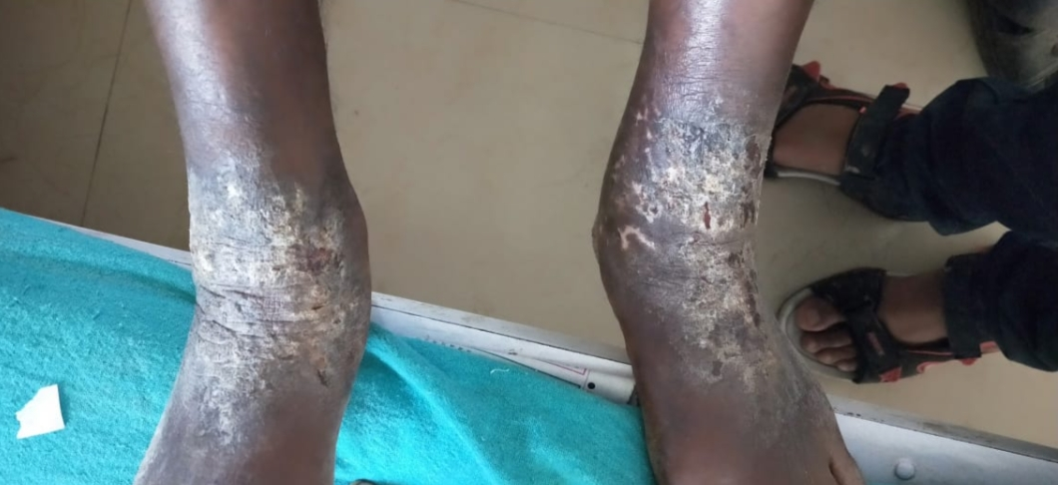
*During treatment :-1.

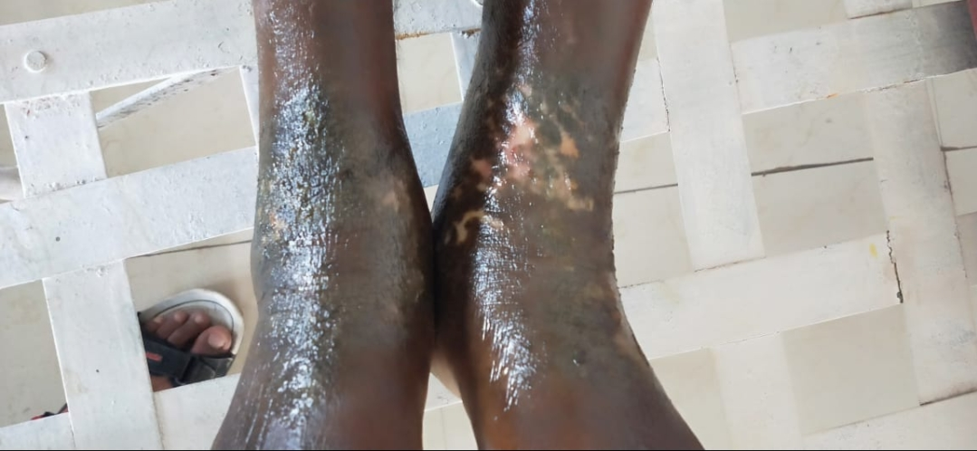

*During treatment :- 2.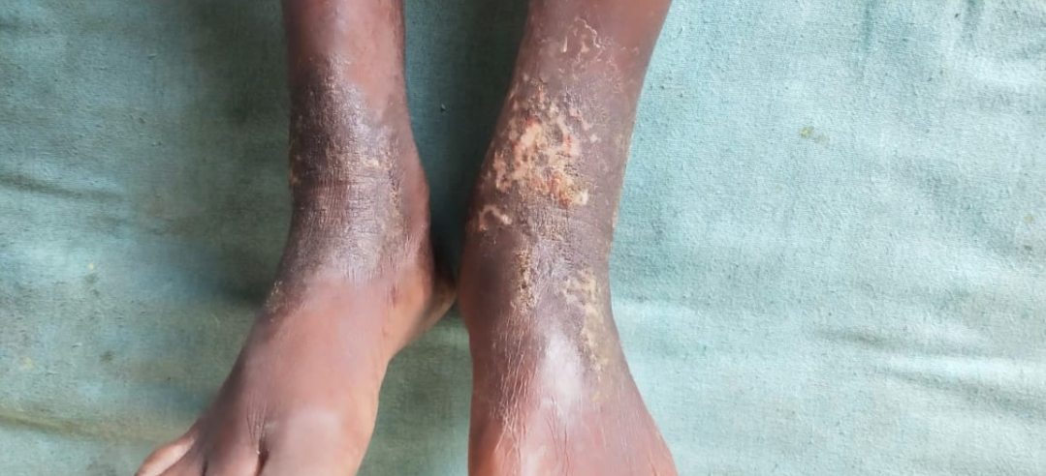

*After tretment:-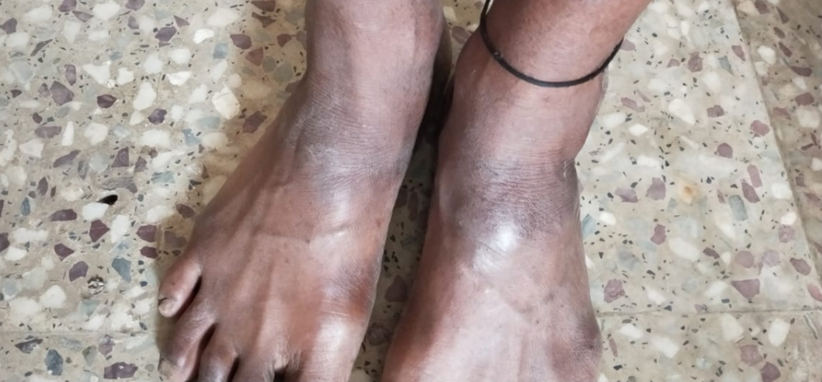

Discussion:-
01)Hetu:-
1)Aahar:- Dadhisevan, mansasevan, Lavan-amla-katupadarthsevan
Madhyapan(drinking), virudhaaahar, vidahiannapan
2) Vihar:-Atishram, aatapsevan,atikrodh,panchkarmaAbhav, Diwaswap
02)SampraptiGhatak:-
1)Dosha:- vat + kapha
2)Dushya:- Rasa, Rakta,Mansa
3)Strotas:-Rasavahastrotas
Raktavahastrotas
Mansavahstrotas
4)Udbhavsthan:- Twacha
5)Vyaktisthan:-Twacha
In this case study the drug used oraly formulation of GandhakRasayan, su.Triphala,GuduchiGhanvati which mostly acts as Kushtaghna, Vranaghna,Twachyakar,Shothaghna,Raktashudhikar, Balancing trishosha and rasayani and localy used purnil oil which also conataint combination of karanj oil, tuvarakoil,bakuchioil,marichoil,neemoil,castor oil which also Kushtaghna, vranaghna, twachyakar,Shothaghna,Raktashudhikar.
Result: In ayurveda there are lots of drug used but in this caseAyurvedic FormulationOrally and Purniloil localyused and it is safe and show significant effect on reduce clinical sign and symptom of vicharchika patient.
Conclusion:- on the basis of above discussion It is concluded that Ayurvedic drug formulation of Gandhakrasayan, su.Triphala,guduchiGhanvati orally and Purnil oil locally is very effective to reduce sign and symptoms of vicharchika patient.
References:-
1) charaksamhita edited by Ravidattatripathi,chaukhambaprakashan Sanskrit pratishthan Delhi, 2007 edition,Nidansthanchap.no.5; shloka no.4 page.no.514
2) charaksamhita edited by Ravidattatripathi,chaukhambaprakashan Sanskrit pratishthan Delhi,2007 edition,chikitsasthanchapter no.7, Shloka no.26 and 30. Page no.185
3) Sushrutsamhita ,edited by Ambikadattashastri,chaukhambaprakashanVaranasi,Reprint 2016,Nidan sthan chapter no .5 shlokano.5 & 13 page.no.320
4) SarthVaghbhat;VaghbhatkrutAstangHruday edited byDr.GaneshkrushnaGarde,ChaukhambhasurbharatiPrakashana,Varanasi;2016 edition;Nidansthan chap.no.14,shlok no.3 pageno.204
5)SarthVaghbhat;VaghbhatkrutAstangHruday edited by Dr.GaneshkrushnaGarde,ChaukhambhasurbharatiPrakashana, Varanasi;2016 edition,Sutrasthan chap.no.1,shlock no.5,page no.02
6) Madhavnidan edited by Ayurvedacharyashri.yadunandnopadhyay,chaukhambaprakashan part 2 ,reprint2009
7) Sharangdharsamhita edited by bramhanandtripathi,chaukhambaprakashan Varanasi 2015,prathamkhanda,(Rogaganana)chapter no7.shloka no.87 page.no.72
8) Berth Jones J.Eczema; lichenification; prurigo and erythroderma.In: Burns T et al; eds.Rook`s textbook of dermatology 8th ed.UK:Blackwell Publishing Ltd; 2010.
09)Davidson`s Principle & Practice of medicine 23rd edition;Elsevierpublication;Chap.no.29 page.no.1244
10)Harsh Mohan textbook of pathology 5th edition; Jaypee brothersmedical publication Ltd Page.no.796
11)Jain, S, Barambhe MS, Jain J, Jajoo UN, Pandey, N.Prevalance ofskin disease in rural central India. A Communication based crosssectional, observational study.J mahatma Gandhi Inst med
sci.2016;21:111-5
12) yogratnakar edited by vaidyaraj,dattoballalborkaryogRatnakaruttar.Rasayanadhikar page.511

