An effect of Pathadya Choorna orally and Sinduradya Tailam topically in the management of Vicharchika WSR to Eczema- A case study.

Dr. Subhash B Jamdhade1 Dr. Kalyani P. Nalkande2

Associate professor P.G. Scholar P. G. Dept. Of Kaychikitsa P.G. Dept.Of Kayachikitsa

D. M. M.Ayurved college, Yavatmal D. M. M .Ayurved college,Yavatmal

3) Dr. S. K. Jaiswal3

HOD/ Professor

P.G. Dept. of kaychikitsa

D.M.M. Ayurved college, Yavatmal

Abstract:-

Skin diseases are occurs all over the world at significant levels. The skin is much more than just a protective layer and protect the body from higher number of antigens which occurs in surrounding environment.

In the ayurvedic text all skin diseases were included under the “Kushtharog” which is classified in two divisions i.e. Mahakushtha and kshudrakushtha.

In ayurveda vicharchika is described under kshudrakushtha. All the clinical features of vicharchika are similar to eczema in modern dermatology.

Eczema which is also known as Atopic dermatitis is characterized by dry itchy skin, which is classified in two phase i.e. acute phase and chronic phase. Modern science is very developed in dermatology but still there is no sure cure of eczema. Most of the time steroids are used as a symptomatic treatment, which can produced serious side effect like osteoporosis, skin cancer etc.

In ayurveda there are many formulations for internal and topical application mentioned by the different Acharays in samhitas, which can shows significant effect on vicharchika.

Methodology:- In this case pathadya choorna administer orally and sinduradya tailam topically given to the patient.

Result:- There is significant effect on clinical signs and symptoms of patient and size of affected area.

Conclusion:- In this case study combine use of pathadya choorna orally and sinduradya tailam topically was very effective in reducing signs, symptoms, and size of affected area of vicharchika. .

Keywords:- Vicharchika, Kushtha, Pathadya choorna, Eczema, sinduradya tailam.

**INTRODUCTION:-**

Skin is the outermost covering of the body, accounting for 16-20% it’s weight, skin forms the integumentary system which acts as a protective barrier between the body and external environment .but very often ,it is exposed to many microbes which can damage it and many cause various skin disorders.

In Ayurveda, all skin disorders describes under the heading of ‘kushtha‘.

“kushnatee iti kushtham”

The disease which destroy the affected part of the skin called kushtha. (cha.chi7\3)

Which have been classified mainly into two groups-

Viz.

Mahakushtha

Kshudrakushtha

च.नि.५/४

Vicharchika being one among kshudrakushtha, is also a rasa, rakta and mansa dhatu pradoshaj vikara. vicharchika is described in many of ayurved text.

**विचर्चिका-**

१)"सकण्डु पिडका श्यावा बहुस्त्रावा विचर्चिका……….|| “च.चि.७/२६,भा.प्र.५४/२७,यो.र

२)"राज्यो अतिकण्ड्वर्तिरुज: सरुक्षा भवन्ति गात्रेषु विचर्चिकायाम् ॥"..........सु.नि.५/१३

३)"सकण्डुपिटीका श्यावा लसीकाढ्या विचर्चिका ॥"..........अ.ह्र्.१४/१८

४)"श्यामलोहित व्रण वेदना स्त्राव पाक वती विचर्चिका ॥..........का.सं Pg.No.116

५)"कण्डुविचर्चीभुवने प्रतीता श्वेतानि सुक्ष्माणि च पाटलानी ॥..........हा.सं.३रे स्थान ३६/१२

६)"पित्तेनोदुम्बरं प्रोक्तं कफान्मण्डलचर्चिके ॥"..........शा.सं७/८७

"कफप्राया विचर्चिका ॥".............च.चि.७/३०

According to charak samhita ,vicharchika is kaphapradhan vyadhi , symptoms of vicharchika are kandu(Itching), shyava varna(blackish discolouration) ,pidika(carbuncles) ,bahu strava(discharge), ruja (pain), rajyo (marked lining due to thickness of lesion ), rukshata(dryness) ,lohit varna(redness of lesion) .

All the clinical features of vicharchika can be very well correlate to clinical features of Eczema, which is distinctive pattern of inflammatory response of the skin, i.e dermatitis according to modern science.

Eczema is broad term used for many types of skin inflammations, usually first symptom of eczema is intense itching, the rash appears later ,and is red in nature has a carbuncles of different sizes ,for this reason ,Eczema is also called as “itch that rashes.”

In some of the people there may be different types of skin inflammations occurred such as chapping (roughness), flaking rupturing of skin and bleeding too.

Even the intensity of eczema differs from one person to another,so the present study research is to treatvicharchika with the oral administration of Pathadya choorna and topical application of Sinduradya tailam .

According to the journal of allergy and clinical immunology , prevalence of current eczema ranged 0.9%in INDIA .

**A CASE REPORT:-**

A 18 years female patient came to OPD of kayachikitsa department of L.K.Ayurvedic hospital, Yavatmal with chief complaints of-

1)Kandu( Itching)

2)Shyava varna(Blackish discolouration)

3)Pidika

4)Bahu strava

5)Ruja (pain)

6)Rajyo(marked lining due to thickness of lesion)

7)Rukshata(dryness)

8)Lohit varna (redness of lesion ) on Right thumb and right elbow joint.

Patient having above complaints since 10 years

N/H/O- HTN & DM

No any H/O major illness.

**HISTORY OF PERSONAL ILLNESS:-**

The patient was normal before 10 years ago

Since then patient has been suffering from kandu, shyav varna, pidika, bahu strava, ruja, rajyo, rukshata and lohit varna on right thumb symptoms get aggravated from 5-6 months.

For Ayurvedic treatment patient came to our hospital L.K. Ayurvedic hospital yavatmal in OPD of kaychikitsa department.

**Rugna parikshan:-**

Nadi(pulse) - 68/min

Mala( stool) - Prakrit

Mutra(urine) -Prakrit

Jivha(tounge) - Alpa sam

Netra(eyes) - shwetabh

Shabd(speech)-Spashta (normal)

Sparsh(skin) - samshitoshna

Akriti - Madhyam

Bala - Madhyam

Raktachaap(B.P) - 110/70 mm of Hg

**MATERIAL AND METHODS:-**

**METHOD:-**

1. A case study.
2. Centre of study:- Postgraduate Department of kaychikitsa, L.K Ayurvedic hospital , Yavatmal affiliated to D.M.M. Ayurved college Yavatmal.

**MATERIAL:-**

Table 1 - showing material of case study.

|  |  |  |  |  |
| --- | --- | --- | --- | --- |
| Sr.No | Dravya | Dose | Matra | Anupana |
| 1 | Pathadya churna | 3gm | Twice a day | Warm water |
| 2 | Sinduradya tailam | - | Twice a day | - |

**DISCUSSION:-**

**Hetu :-**

**1)Aahar –** Virodhi Annapana,

- Snigdha / Guru Ahar,

**- Kshara-amla-lavana-ushna aahar**

**-** Mounsa Sevan (Machali)

**-** Dudha - Duda - Tila - Udida–Mula etc.

**2)Vihar** - Diwaswap

- Ativishranti

- Chinta virhita

**3)Manas - Kama, chinta, Bhay, Krodh, Shok etc.**

**hetu**

**SAMPRAPTI GHATAK:-**

1. Dosha – kapha
2. Dushya – Rasa ,Rakta, mansa
3. Strotas - Rasavaha strotas

Raktavaha strotas

Mansvaha strotas

4)Udbhavsthan – Twaka

5) Adhishthan - Rasa, Rakta, Mansa,

6) Vyaktisthan- Twaka

**TABLE 2-MODE OF ACTION OF FORMULATIONS USED IN CHIKITSA:-**

पाठाद्दं चूर्ण:-

पाठादार्विवन्हिघुणॆष्टा्कटूकाभि

मुत्र युक्तम शक्रयवैश्चोष्णजलश्च।

कुष्ठ पित्वामासमरुकस्याद गुद्किलि।

मेहि शोफ़ि पाण्डूरजिर्नि क्रिमिमान्च्य ॥

वा.भ.चिकित्सा-१९

|  |  |  |  |  |  |  |
| --- | --- | --- | --- | --- | --- | --- |
| Dravya | Latin name | Guna | Rasa | Virya | Vipak | Doshghnata |
| Patha | Cissampelos pareira (menispermaceae) | Laghu tikshna | Tikta | Ushna | Katu | Kaphapittghna |
| Daruharidra | Berberis aristata (berberidaceae) | Laghu ruksha | Tikta kashay | Ushna | Katu | Kaphapittshamak |
| Chitrak | Plumbagi zeylinica  (plumbaginaceae) | Laghu rukshna tikshna | Katu | Ushna | Katu | Kaphavatghna |
| Atasi | Linum usitasissimum  (linaceae) | Guru snigdha pichhil | Madhur tikta | Ushna | Katu | Vatshamak |
| Kutaki | Picrorrhiza kurrora (scrophulariaceae) | Riksha tikshna | Katu | Sheet | Katu | Kaphapittshamak |
| Indrajav | Holarrhena pubescens (apocynaleae) | Laghu ruksha | Tikta kashay | Sheet | Katu | Kaphapittshamak |

सिन्दुराद्द तैलम्:-

"सिन्दुरम् चन्दनम् मासि विडन्ग् रजनिद्वयम्।

प्रियन्गु पद्द्कम् कुष्ठ मंजिष्ठा खदिरम् वचाम्।

जात्यार्क त्रिव्रुत्ता निम्ब्करन्ज् विषमेव् च।

क्रिष्णचित्रकलोध्रच् प्रपुन्नाद्च सन्हरेत्।

श्लक्ष्णपिष्टानि सर्वानि योजयेतैलअमात्रया।

अभ्यन्गेन् प्रयुज्जितम् सर्वकुष्ठविनाशनम्।

पामाविचर्चिका कन्डू विसर्पादिहितम् मतम्।

रक्तपित्तोत्थितान हन्ति रोगानेव् विधान् बहुन्।

सिन्दुराद्दमिदं तैलमश्विभ्यां निर्मित् पुरा॥"

भै. रत्नावलि।कुष्ठधिकार

|  |  |  |  |  |  |  |
| --- | --- | --- | --- | --- | --- | --- |
| Dravya | Latin name | Guna | Rasa | Virya | Vipak | Doshghnata |
| Girisindoor | Red oxide of mercury(Hgo) | Sara  Guru | Katu  tikta | Ushna | Katu | Tridoshshamak |
| Shwet chandan | Santalum album linn.(santalaceae) | Laghu  Ruksha | Tikta  Madhur | Sheet | Katu | Kaphapittaghna |
| Jatamansi | Nordostachys  Jatamansi  (valerianaceae) | Laghu  Snigdha | Tikta  Kashay  madhur | Sheet | Katu | Tridoshahar |
| Vidang | Emblica ribes  (myrsinaceae) | Laghu  ruksha  Tikshna | Katu  Kashay | Ushna | Katu | Kaphavatshamak |
| Haridra | Curcuma longa  (zingiberaceae) | Ruksha  Laghu | Tikta  Katu | Ushna | Katu | Tridoshshamak |
| Daruharidra | Berberis aristata  (berberidaceae) | Laghu  Ruksha | Tikta  Kashay | Ushna | Katu | Kaphapittshamak |
| Priyangu | Callicarpa  Macrophylla  (verbenaceae) | Guru  Ruksha | Tikta  Kashay  Madhur | Sheet | Katu | Tridoshshamak  Vatpittshamak |
| Padhyakam | Prunus cerasoides(rosaceae) | Laghu | Kashay | Sheet | Katu | Kaphapittaghna |
| Kushtha | Saussurea lappa  (compositae) | Laghu  ruksha  Tikshna | Tikta katu madhur | Ushna | Katu | Kaphavatshamak |
| Manjishtha | Rubia cardifolia  (rubiaceae) | Guru ruksha | Tikta kashay madhur | Ushna | Katu | Kaphapittshamak |
| Khadir | Acasia catechu (leguminosae) | Laghu ruksha | Tikta kashay | Sheet | Katu | Kaphapittaghna |
| Vacha | Acorus calamus (araceae) | Laghu tikshna | Katu tikta | Ushna | Katu | Kaphavatshamak |
| Javatri | Myristica malabaricum (myristicaceae) | Laghu tikshna | Tikta katu | Ushna | Katu | Kaphavatshamak |
| Trivritta | Operculina turpethum  (convolvulaceae) | Laghu rukshna tikshna | Tikta katu | Ushna | Katu | Kaphapittaghna |
| Nimb | Azadirectica indica (meliaceae) | Laghu | Tikta kashay | Shaeet | Katu | Kaphapittghana |
| Karanj | Pongamia pinnata (leguminosae) | Laghu tikshna | Tikta katu kashay | Ushna | Katu | Kaphavatshamak |
| Bachnag | Aconitum ferox (ranunculaceae) | Rukshya tikshna laghu vyavayi vikasi | Madhur | Ushna | Madhur | Vatkaphashamak |
| Krishnachitrak | Plumbago zeylanica  (plumbaginaceae) | Laghu ruksha tikshna | Katu | Ushna | Katu | Kaphavatghna |
| Lodhra | Symplocos racemosa  (symplocaceae) | Laghu ruksha | Kashay | Sheet | Katu | Kaphapittshamak |
| Chakramard | Cassia tora (leguminosae) | Laghu ruksha | katu | Ushana | Katu | Kaphavatshamak |

**The patient had started improving during tratment and the symptoms decreased gradually .**

**TABLE 3- SHOWING CHANGES IN AFFECTED AREA DURING CHIKTSA:-**

**BEFORE TREATMENT**

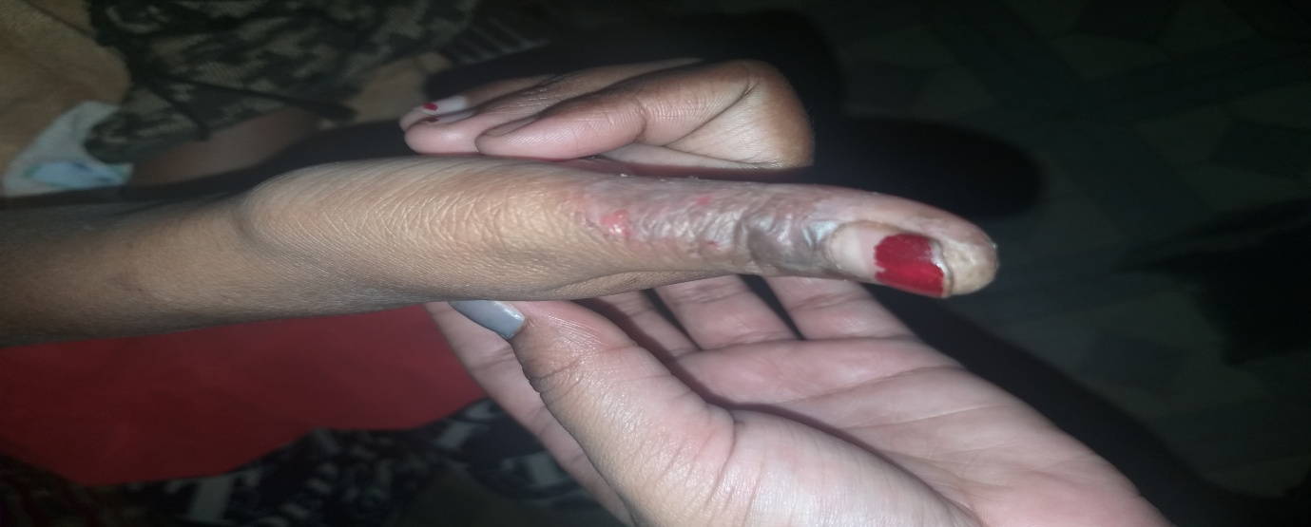

**(Affected Area- Right Thumb)**

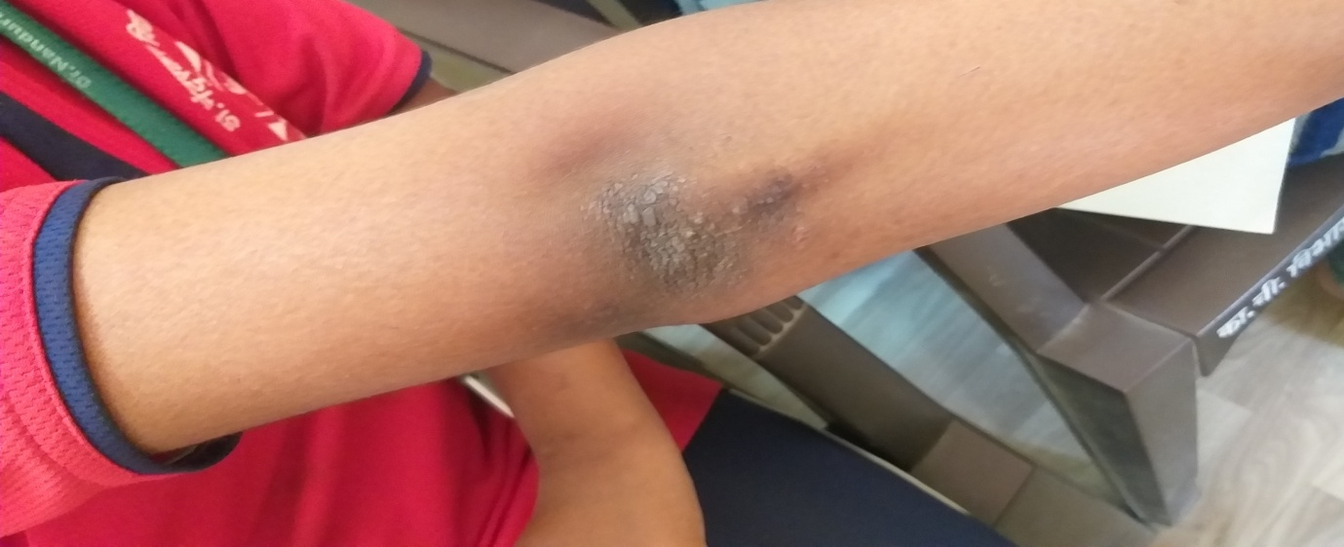

**(Affected Area- Right elbow joint)**

**AFTER TREATMENT**

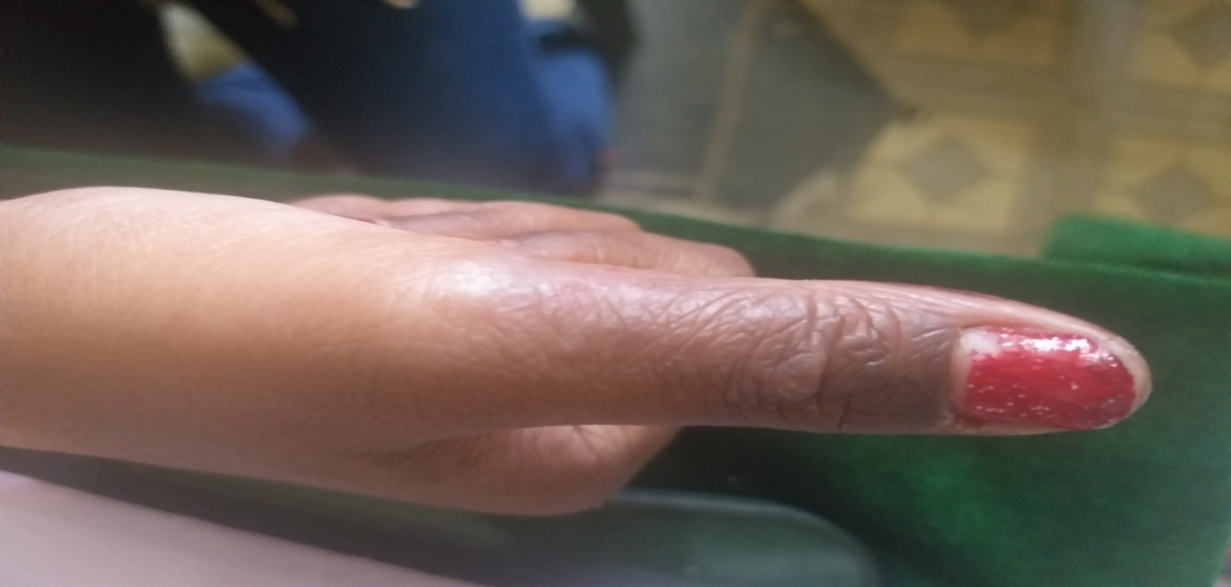

**(Affected Area- Right Thumb)**

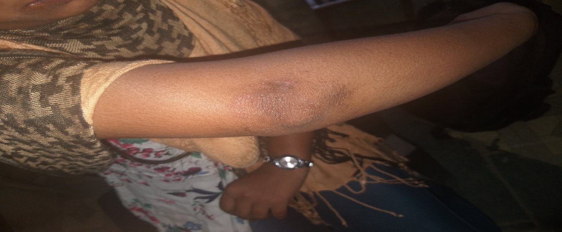

**(Affected Area- Right elbow joint)**

**Discussion :-**

In this case study the drug used Pathadya churna contains dravya which mostly acts as kaphagna and vatashamak which reduced the symptoms like kandu, rukshata, shyavata, rajyo, ruja ,lohit varna etc. And the sindyaradya tailam which also contain kaphavatshamak dravya decreases the kandu( Itching) and shyavata ( blackish discolouration) significantly .

The symptomatology of vicharchika is similar with eczema .Eczema can be defined as a disease in a form of dermatitis or inflammation of the epidermis. The term eczema is broadly applied to a range of persistent skin conditions. There is no sure cure for eczema in modern medical science. The treatment of eczema was discussed here in detail, but they have many side – effects e.g topical corticosteroids have side effects.

So, now the duty of ayurveda is to provide a safe and effective medicine to the world so, present case study is a humble effort to give a medicine from classical ayurvedic preparation .

**Conclusion and result:-**

From above discussion it is concluded that a classical ayurvedic preparation can also be shows significant effect in the skin diseases. A pathadya churna 3gm orally twice a day and sinduradya tailam topically twice a day decreased symptoms of vicharchika with some pathyapathya ( i.e avoid fish intake) without any side effects.

**References:-**

1)Charkacharya:- charak samhita edited by Ravidatta tripathi, chaukhamba prakashan Sanskrit pratishthan Delhi ,2007 edition, chikitsa sthan chapter no7. Shloka no.27 and 30.

2)Sushrut:- sushrut samhita ,edited by Ambikadatta shastri, chaukhamba prakashan Varanasi, Nidan sthan chapter no .5 shloka no 13

3)Madhav nidan edited by Ayurvedacharya shri. yadunandnopadhyay, chaukhamba prakashan part 2 ,reprint 2009

4)**Vagbhatt:-** Ashtanghridayam with viawananoranjini hindi commentary and notes by pandit kashinath shastri edited by indradev tripathi and shrikant tripathi published by chaukhamba prakashan Varanasi first edition 1994,nidan sthan chapter no.14 shloka no.18

Chikitsa sthan chapter no.19 shloka no.18

5)Sharangdhar samhita edited by bramhanand tripathi,chaukhamba prakashan Varanasi 2015,pratham khanda,(Rogaganana)chapter no7.shloka no.87

6)yogratnakar edited by vaidyaraj, datto ballal borkar published by shri.gajanan book depo, pune, part 2 kushthnidan 30 shloka no.23

7)Rasratna samuchhay edited by sanghguptasunu shri. vagbhatacharya virchit,published by shivaji vidyalaya, Kolhapur 1972,uttarardha adhyay.20

8)Ras ratnakar edited by Dr. indradev tripathi and Dr, swaminath mishra published by chaukhamba prakashan .kushthachikitsa shlok no.17 to 18 page no-757

9)Harita samhita:-edited by acharya ramvalamba shastri, prachya prakashan 1st edition 1985,3rd sthan chapter no.36 shlok no.12

10)Kashyapa samhita ,Nepal rajgurana p.hemraj Sharma ,chaukhamba prakashan ,Varanasi 1988 4th edition ,page no.116

11)Bhaishjya ratnavali ,edited by Ayurvedacharya shri. jaydev vidyalankar ,published by motilal banarasidas ,saidmithha bajar,Lahore 4th edition 1644-2001 Kushthadhikar, page no.1303,shlok no.21,143

12)Bhavprakash , shri.hariprasad pandey ,chaukhamba prakashan 1993 5th edition ,chapter no.54,shlok no.27.