Management of Psoriasis by Ayurveda - A Case Study
Rachana Kashyap ¹*, D. V. Kulkarni ²
1. PG Scholar (Dravyaguna)
2. Professor and Head of Department,
Dravyaguna Dept., Government Ayurveda College, Osmanabad, Maharashtra, India. 413501
*Corresponding author: email-rkashyap16@gmail.com
Abstract
Psoriasis is one of the diseases of skin. Skin is an organ which comes in front of everyone’s eye. Every person in the world likes to look beautiful but due to some skin diseases a person has to deal with some situations like lack of confidence. In Ayurveda all skin diseases come under one banner i.e. kushtha. Due to vitiation of tridosha and dhatus like rakta and mansa various types of kushtha are formed. Psoriasis can be related to ekkushtha in Ayurveda by its clinical features. In modern medicine there is no complete treatment of skin diseases but in Ayurveda psoriasis can be healed. We need to explore medication in Ayurveda to fight against such diseases. In this case study a male of 42 years suffering from psoriasis , since 30 years history was cured by shodhana and shaman therapy.
Keywords- Psoriasis, kushtha, skin disease, shodana.
Introduction
Skin is the largest organ of our body. Functions of skin are to provide biologic cover, thermoregulation, identity and beauty. It is an organ, which comes in front of everyone’s eye. So, when a person suffers through a skin disease he lost his confidence to face the people around. The prevalence of skin disease in India is 10 to 12 percent of total population with eczema and psoriasis being the major contributors. The main causes for this disease are pollution, U.V light and global warming, photosensitive skin, smoking, obesity, tobacco consumption, consuming products that increase heat in our body. Psoriasis is one of the major contributors in skin diseases.
Psoriasis is a non-contagious, chronic skin disease that produces plaque of thickened, scaly skin. The dry flakes of silvery –white skin scales result from the excessively rapid proliferation of skin cells. Psoriasis commonly affects the skin of elbows, knees and scalp. According to modern medicine system psoriasis is considered to be an incurable , long term chronic inflammatory skin condition. ^{[1]} Prevalence of psoriasis in India also varies from 0.44 to 2.8 % it is twice more common in males compared to females, most patient are in 3rd and 4th decade. ^{[2]}
According to Ayurveda it can be related to ekkushtha, though all the skin disease can come under heading of the kushtha. Acharya charak has described ekkushtha as one in which there is no sweating, extensively spread and resemble in form of scales of skin. ^{[3]} Sushrut Acharya has explained ekkushtha as disease in which the skin becomes black and pink colour. ^{[4]} As modern medicines treatment of psoriasis contains steroids and these steroids have many side effects on kidney and other organs. So, ayurvedic medicines can act as boon on the treatment of this disease. Sushrut Acharya in his line of treatment for kushtha has explained to give vaman once in every 15 days, virechan once in 30 days and raktamoshan once in 6 months.^{[5]}
Case presentation
A 42 years old male patient came on date- 11/11/2019 with reddish scales over back, scalp, hands and legs. The affected skin had shades of pink and red with large silvery scales on it. He had complains of severe itching over the patches and these patches started from scalp. He had history of about 30years suffering from psoriasis since childhood at the age of 10years started from scalp all these years but had no relief. He had addiction of tobacco since 10 years. And also had complaints of constipation and flatulence.
- Patient name- Nandkumar Swami
- Age- 42 years
- Gender- male
- Occupation- food grocery store
- Opd no- 35327
- Hospital name- Government Ayurvedic hospital Osmanabad
Table 1 General examination
BP | 130/80mmhg
Pulse | 78
Aahara | Oilyfood , tea, tobacco
Vihara | Unhygienic environment
Apetite | modearte
Bowel | Once a day
Micturation | 6-7 times a day
Sleep | Sound

Table 2. Systemic examination
Respiratory Examination | No added sounds trachea centrally placed
Cardiovascular examination | Chest bilaterally symmetrical
Per abdomen examination | Soft,non tender,no organomegaly

Table 3. Dashvidha pariksha
Prakriti | Pitta kapha
Vikriti | Vata kapha Pradhan
Dushya | Rasa ,rakta, mansa, meda
Sara | Madhyam
Samhanan | Madhyam
Satva | Madhyam
Aahara Shakti | Madhyam
Jarana Shakti | Madhyam
Vyayama Shakti | Madhyam
Satmya | Madhyam
Vaya | Madhyam
Praman | Madhyam

On examination
Nadi | Vata pittaja
Mala | Mala badhata
Mutra | Samyaka
Jivha | Saam
Druka | Spashta
Shabda | Spashta
Sparsha | Samshitoshna
Aakriti | Madhyama

Assessment criteria ^{[6]}
Intensity | Absent | Mild | moderate | severe | Very severe
erythema | Score 0 | 1 | 2 | 3 | 4
induration | Score 0 | 1 | 2 | 3 | 4
desquamation | Score 0 | 1 | 2 | 3 | 4

Treatment given
Deepana pachana and anulomana
Patient was given arogyavardhini vati 500mg BD before meal, gandhak rasayan 2 tablet BD and kaishor guggul for pachana and sariva and Manjishtha churna at 6 am morning.
For anulomana 20 ml eranda tail at night with warm water.
Local application-
Washing with below given dravya churna at the time of bathing-
- Aragvadha
- Khadir
- Haritki
- Guduchi
Winsoria oil applied twice daily on patches.
Snehapana
After giving deepana and pachana for 15 days. The symptoms of constipation and flatulence was relieved and therefore, snehapana was started by panchatikta ghrit in morning 20ml and 10 ml before meal in the afternoon with warm water.
Lifestyle and exercise
Patient was told to quit tobacco and a schedule was made by padanshik karma for it. Patient has followed all the intructions. He was advised to do suryanamaskar and jogging at the morning.
Virechana therapy
As per Sushruta Acharya guideline towards kushtha treatment patient was given virechana once a month. For about 3 months patient was given virechana with eranda tail and triphala kwath followed by sansarjan karma.
Raktamoshan
In the month of December patient was taken for raktamoshan. All the investigations like CBC were done previously before raktamoshan. It was done only once. As mentioned earlier sushruta has explained to do raktamoshana once in 6 months.
Internal medicine
- Khadirarishtha- 20ml BD
- Kaishor guggul- 2BD
- Gandhak rasayan -2 BD
- Jatamansi churna- 5gm at night before sleep.
Drug review
Formulations-^{[7]}
Sr. no. | Kalpa | Contents | Rogadhikar | Dose
1. | Arogyavardhini vati | Parad, gandhak, loha bhasma, abhraka bhasma, tamra, triphala, shilajatu etc. | kushtha, jwara vikara, medanashak | 2-6 gunja
2. | Gandhak rasayan | Gandhak, dalchini, tamalpatra, velchi, nagkeshar, gulvel, triphala, suntha, maka. | Kandu, kushtha, vishdosha, atisara, grahnigad, somrog. | ½ - 3 gunja
3. | Kaishor guggul | Triphala, giloy, lohapatra, guggul. | Sarvakushtha, vatrakta, vrana, gulma, pramehapidika, udararoga, mandagni. | 1-1 shan
4. | Khadirarishtha | Khadir, deodaru, bakuchi, daruharidra, triphala, pippali, lavang, dalchini etc. | Mahakushtha, hridroga, krimi, kasa, shwasa, plihodara, sarvakusthanivarana | 10-20ml

Dravya-^{[8]}
Sr. no. | Drug | Latin name | Family | Rasa | Vipaka | Virya | Doshaghanta
1. | Sariva | Hemidesmus indicus | asclepiadaceae | Madhur, tikta | Madhur | Sheeta | Tridoshashamak
2. | Manjishtha | Rubia cordifolia | Rubiaceae | Tikta, Kashaya, madhur | katu | ushna | kaphapittahar
3. | Jatamansi | Nordostyches jatamansi | valerianaceae | Tikta, Kashaya, madhur | katu | Sheeta | Tridoshahar
4. | Aragvadha | Cassia fistula | leguminosae | madhur | madhur | sheeta | Tridoshahar
5. | Khadir | Acacia catechu | leguminosae | Tikta, kashaya | katu | sheeta | Kaphapittahara
6. | Haritki | Terminalia chebula | Combretaceae | Kashaya Pradhan pancharasa,lavana varjit | madhur | ushna | Tridoshahar
7. | Guduchi | Tinospora cordifolia | Menispermaceae | Tikta, kashaya | madhur | ushna | Tridoshahar

Discussion-
Mode of action of Deepana and Pachana- ^{[9]}
Acharya Hemadri explains that pachana does digestion of ama, deepana does separation of dosha from dhatu. While snehana does utkleshana of dosha and swedana brings the dosha from shakha to koshtha.
Mode of action of snehapana ^{[10,11]}
If shodhana is performed without doing snehana, the body will be broken down like a dry wood. Sneha looses the doshas which are adherent to the wall of minute channels. Dalhana explains that to bring the shakhagat doshas into koshtha, snehana is essential. Charaka has given saying that as from oil smeared container, the water can be easily separated without much effort, similarly the kaphadi doshas are easily expelled out from the oleated body.
Mode of action of Virechana^{[12,13,14,15]}
Action of virechana can be divided into 2 ways-
- Systemic – by which it brings down the morbid dosha, particularly pitta from shakha to koshtha.
- Local- which is concerned with the evacuation of these dosha in form of mala from the gut by adhobhaghara property.

Virechan drugs are having ushna, tikshna, sukshma, vyavayee, vikasee properties and adhobhaghar prabhav.
Virechan dravya gets absorbed by its veerya, it reaches to hridaya, then the dasha dhamani and thereafter it reaches to macro and micro channels of the body. i.e. sukshmati sukshma strotas.
Ushna guna has agneya property and hence the dosha sanghata is liquefied. Hence it facilitates movement of morbid doshas towards koshtha. Due to vyavayee guna these drugs spread quickly through the body and starts their action before its digestion. Vikasi guna of drugs causes loosening of the bond between dosha and dhatu causing dhatu shaithilya.
From all the above properties doshas are driven to koshtha. These drugs consist of prithvi and jala mahabhutas which are heavy in nature and adhobhaghar prabhav which helps in expulsion of dosha from adhobhaga (anal route).
Mode of action of Raktamokshana
In raktamokshana dushita rakta along with vitiated doshas are removed. Due to removal of dushit rakta quality of rakta gets improved. Vitiation of rakta dhatu leads to many twak vikara (skin diseases), raktamoshana helps in removing dushita rakta from twacha and twacha gets nourished with shuddha rakta which will subside all types of kushtha.
Internal medication-
Arogyavardhini vati and gandhaka rasayana due to their ushna, laghu and ruksha guna enhances the digestive capacity and metabolic activity of the cells and facilitates the easy digestion. Sariva and Manjishtha have rakta prasadan property due to which the purify the blood . Kaishor Guggul also works by purifiying the impure blood.

Before treatment

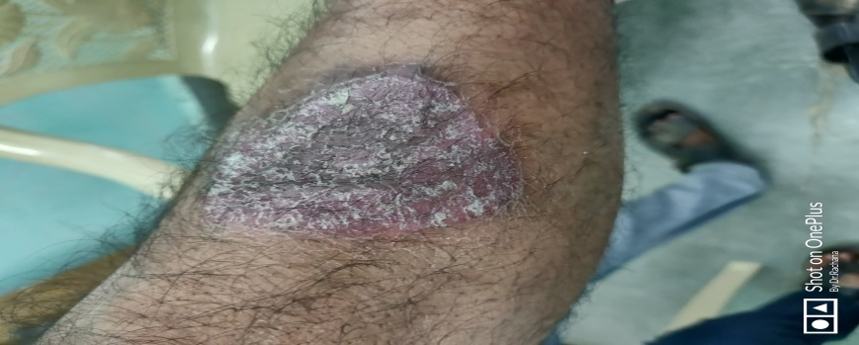
After 5 months of treatment
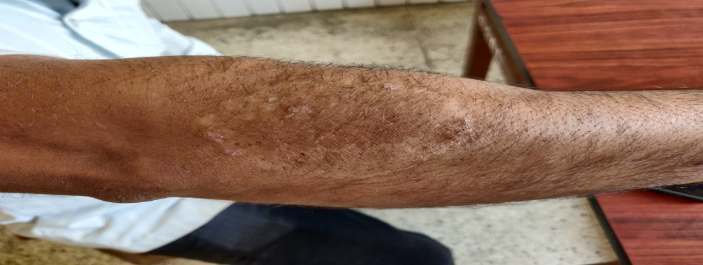
Before treatment
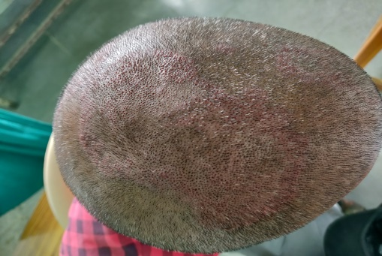
After 3 months

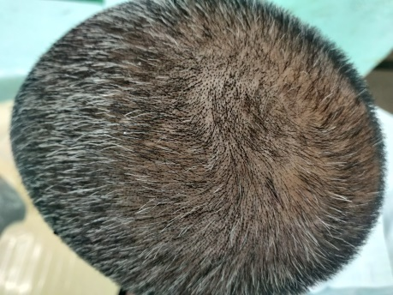
Before treatment

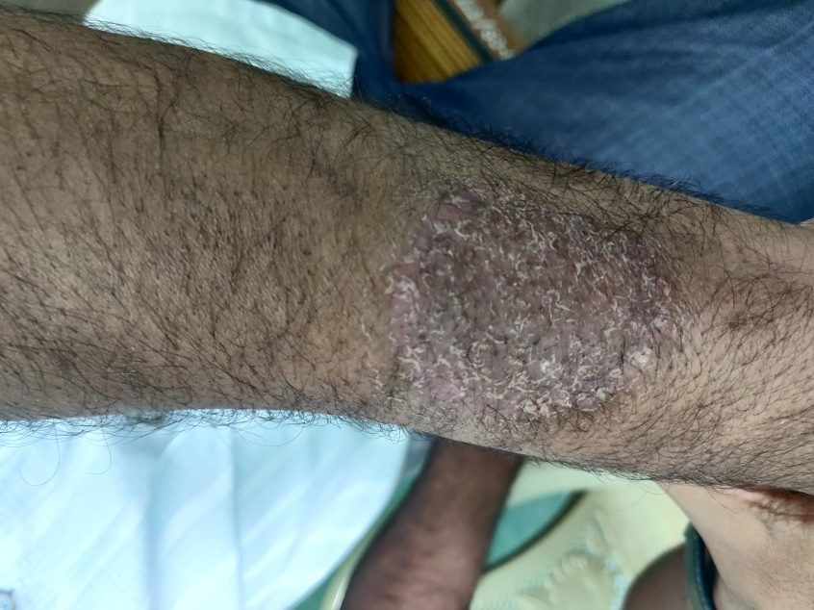
After 5 months
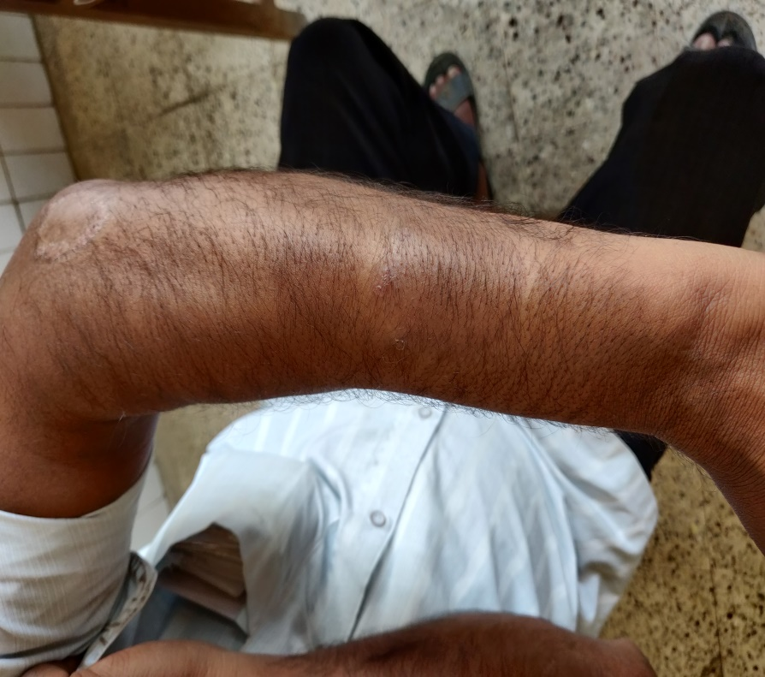
Healing chart
Time | Before treatment | After 2 months | After 5 months
Score | - Erythema- 3  - Enduration-3  - Desquamation-3 | - Erythema -2  - Enduration-2  - Desquamation-2 | - Erythema-0  - Enduration-0  - Desquamation-0

Symptom of itching was also relieved to 100%.
Conclusion
As we know that in the present era bad eating habbits and consumption of junk food stuffs is a daily routine phenomenon for people. Due to these items the blood gets impure and gives birth to certain skin diseases. For treating such patients it is necessary to stop intake of such food stuffs and bad hobbits. And after that comes the elimination of doshas from body by doing panchakarma with internal medication. Skin diseases are also related to manas (mind) therefore yogabhyasa like suryanamaskar and various pranayama are found to be very helpful to relieve the mind from anxiety and stress. Modern science has no such line of treatment in curing the patient of psoriasis like skin diseases and hence Ayurveda comes out to be relieving way for diseases like psoriasis.
References
- https://www.medicinenet.com>article.
- Sunil D, Savita Y, psoriasis in India: prevalence and pattern, indian journal of dermatology, venerology and leprology, 2010 ;vol-76;(6);595-601.
- Agnivesha, charak Samhita, editor and English translator , prof.p.v.sharma, reprint 2008, chaukhamba ayurved pratisthan, Varanasi (India) chikitsasthan 7/21 p-127.
- Sushrut Samhita, edited with ‘sushutavimarshini’ hindi commentary by dr. anantaram sharma, reprint 2012, chaukhamba surbharti, Varanasi (India) nidansthan 5/9 p-495.
- Sushrut Samhita, ambikadatt shastri, reprint 2015, chaukhamba Sanskrit sansthan, Varanasi, chikitsasthan 9/43 ,p-67.
- https://dermnetnz.org
- Gangadharshastri gopalrao gune, ayurvediya aushadhigunadharmashastra, reprint-2011, pg -208,636,270.
- Prof. p.v. sharma, dravyaguna-vijyana VOL- 2, reprint-2012, chaukhamba bharti academy, p-31,170,680,674,798,800.
- Ashtang hridayam , shri vagbhata, edited with ‘nirmal hindi commentary’, by Dr brahmanand tripathi, reprinted 2013, chaukhamba Sanskrit pratisthan delhi (India), a.h.sutrasthan13/29 p-189.
- Sushruta, sushruta Samhita with nibandha sangraha commentary, choukhamba Sanskrit series 2002. Chikitsasthan 33/46.
- Agnivesha, charaka Samhita with ayurved dipika commentary, choukhamba Sanskrit series, Varanasi;1994, sutra siddhi sthana 6/11, p-704.
- Dr vasant patil, virechana karma ,principles and practice of panchakarma, chapter 12, edition 5, new delhi, chaukhamba publications, 2015, p-403.
- Dr brahmanand tripathi, madan kalpa adhyay, charak Samhita of agnivesh, kalpasthan , vol-(2), chapter1, verse no. 5, edition 6, Varanasi, chaukhamba surabharti prakashan ,1999, p- 1072.
- Prof. K.R.Srikanthamurthy, vaman virechan sadhyopadrava chikitsa, illustrated sushrut Samhita, chikitsasthan, vol-2, chapter 33, verse no. 33, reprint edition, Varanasi, chaukhamba orientalia, 2010, page 307.
- Dr bramhanand tripathi, aatreya bhadrakapyeey adhyay, charak Samhita of agnivesh, sutrasthan, volume 1, chapter 26, verse no. 70, edition 6, Varanasi, chaukhamba surabharti prakashan, 1999, pg-490.

