Role of Virechan & Shaman Chikitsa in the management of Eka Kushtha with special reference to Plaque Psoriasis – a Case Study
Vd. Akshaya Sitaram Wagh^{1,} Vd. Anaya Pathrikar², Vd.Nitin Kamat³.
- PG Scholar, Department of Kayachikitsa
- H.O.D., Department of Kayachikitsa
- Honorary Physician, Department of Kayachikitsa
APM’s Ayurveda Mahavidyalaya, Sion, Mumbai - 22
*Corresponding Author: Email- akshayawagh37@gmail.com; Ph: 9619019880
Abstract:
Among the various skin disorders Psoriasis has prime importance & has raised challenges for medical fraternity. Psoriasis is a multifactorial, Autoimmune, chronic, relapsing, inflammatory skin disease affecting 1-2% of general population. Effective therapeutic agents (e.g. - PUVA) for the treatment of Psoriasis in contemporary medicine may have long-term toxic side effects like Melanoma (Skin CA), Nausea, Hepatotoxicity, etc. which makes Ayurvedic medications a good choice because it overcomes the said limitations. Psoriasis is commonly correlated with Ekakushtha which is one among the Kshudra Kushtha having Vata-Kaphaj predominance. According to, Ayurvedic management of Kushtha prime importance is given to repeated “Shodhan” procedure. Hence present study highlights, case study of Eka-Kushtha treated with combined shaman & Shodhan Chikitsa i.e. Virechan. Here an effort was made to treat a 20 years old male patient having classical signs & symptoms of Eka-Kushtha since 1 year. As the principle of treatment of all types of Kushtha is Shodhan along with shaman drugs. In this study initially Shaman Chikitsa is given followed by Shodhan i.e. Virechan.
Keywords: Psoriasis, Kushtha, Shodhan, shaman, Virechan, PASI.
Introduction:
Kushtha is a Vyadhi which disfigures the skin¹. Kushtha is bahudoshavastha janya Vyadhi having Tridosha involvement with Dushya which is termed as “Saptako Dravya Sangraha²” (Tridosha + Twak+ Rakta+ Mamsa + Ambu). Even though kushta is considered as a disease of Bahya roga marg³, the initiation of pathogenesis is from the Koshta. In Ayurvedic classics all skin disorders are categorized under broad heading “Kushtha” which is again divided into 7 Mahakushtha and 11 Kshudrakushtha⁴. Eka-Kushtha is one among the Kshudrakushtha presenting with Aswedan, Mahavastu, Matsyashakalopam & having Vata Kaphaj predominance⁵. The signs and symptoms of Eka-Kushtha in Ayurveda are similar to that of chronic plaque psoriasis.
Psoriasis is among the widest spread chronic, non-infectious, relapsing inflammatory skin disease having unknown etiology, characterized by well-defined dry scaly erythamatous patches and covered with adherent silvery white scales. Its prevalence rate is 1- 2% of world population⁶. Modern medical science treats psoriasis with PUVA and corticosteroids having serious untoward effects if used long term. Psoriasis can be correlated with Eka-Kushtha due to resemblance in their symptoms.

CASE REPORT-
Chief Complaints: - A 20 yr old male patient came in OPD of Kayachikitsa Dept. with following chief complaints- Reddish circular patches over bilateral upper limb & lower limb, abdominal region, lower back region associate with severe itching since 1 year, it got aggravated since 5-6 months.
History of Present Illness: - Patient was normal before 1 year, since then patient had above mentioned complaints since 1 year, it got aggravated since 5-6 months. He is 1st year engineering student by occupation hence unintentionally faulty diet is consumed by the patient. For this he took treatment from different allopathic doctors but he didn’t get any relief, hence came in our OPD for further management. Patient is having habit of taking milkshake at the time of breakfast, curd at the time of Lunch & fish on every Sunday along with night awakening.
General Examination: - (Table no.1)
- Nadi- 80/min | - Mutra- Prakrut
- Akruti- Madhaym | - Weight- 66kg
- Mala- Vibandha | - Jivha- Saam
- BP- 130/80 | - Bala- Madhyam
Examination of Skin: - (Table no.2)
Sr.No | Inspection of Lesion | Description
1) | Site of Lesion:- | - Upper limbs, Lower limbs & Trunk ( both front & back area)
2) | Morphology:-  a) Nature of Lesion: | Macule & plaque ( with erythamatous base)
2) | b) Shape | Circular
2) | c) Color | Shiny red
3) | Distribution:- | - Exposed parts ( both hand & leg)  - both flexor & extensor surface  -Sweating part (Abdominal + Lower back area)
4) | Configuration:- | Scattered & annular
5) | Other:- Itching | Severe
5) | Burning | Moderate
5) | Chronicity | Chronic (since 1 year)
6) | Clinical signs:-  -Auspitz Sign | Positive
6) | -Koebners Phenomenon | Negative
6) | -Candle Grease Sign | Positive
7) | PASI Score | 33
Aims & Objects:
- To evaluate Efficacy of Virechan in the management of Eka-Kushtha.
- To evaluate combined effect of Shodhan (Virechan) & Shaman Chikitsa in the patient suffering from Eka- Kushtha.
Methods: A) Type of Study: - Simple random single case study
B) Centre of Study: - Sion Ayurvedic Hospital (Kayachikitsa OPD)
Material: (Treatment) – (1) Shaman Chikitsa: - (Table no. 3)
Sr.No. | Dravya | Matra | Kala |  | Anupana
1) | Arogyavardhini Vati | 500mg | 1-1-1 | Adhobhakta | Koshna jala
2) | Gandhak Rasayan | 250mg | 1-1-1 | Adhobhakta | Koshna jala
3) | Muktadi Vati | 500mg | 1-0-1 | Adhobhakta | Koshna jala
4) | Yashtimadhu Tail | 100ml | Local Application over affected site thrice a day
2) Shodhan Chikitsa: - (Table no.4)
Date  28/12/18 to 30/12/18 | Day 1st to 3rd | A) Dipan-Pachan:- (for 3 days) | Observation
Date  28/12/18 to 30/12/18 | Day 1st to 3rd | Aampachak Vati- 500mg, Thrice a day, Abhakta  Along with Koshna jala. | Samyak Kshudha pravrutti, Sharir Laghavata
 | Day 4th to 7th | B) Abhyantar Snehapan:- (for 4 days)  As per Koshtha Parikshana “Panchatikta Ghruta” is selected & started from 50ml | Samyak snigdha lakshana:-  Twak mardavta & Snigdha Varcha
1/1/2019 to 4/1/2019 | 4th Day to 7th Day | 4th Day - 50ml, 5th Day - 100ml  6th Day - 150ml, 7th Day - 200ml | Samyak snigdha lakshana:-  Twak mardavta & Snigdha Varcha
5/1/2019 | 8th Day | Adhastaad Sneha Darshan (morning 8:00am) | Hrullas & Aruchi
5/1/2019 & 6/1/2019 | 8th & 9th Day | C) Snehan-Swedan:-  Snehan with – Yashtimadhu tail  Swedan- Peti Sweda | Samyak swinna lakshana were observed
7/1/2019 | 10th Day | D) Virechan: 2 tabs. Of Abhayadi Modak + 40ml of Eranda tail – on empty stomach ( 10:00am )  Followed by Sanasrjan Krama. | Total No. of veg- 08 P- 80/min BP- 130/80
Virechan Chart:-
Time | Episode | Pulse | BP | Swarup
10:45 am | 1 | 68/min | 130/70 mmhg | Loose stool
11:30 am | 1 | 56/min | 150/80 mmhg | Loose stool
12:30 pm | 1 | 60/min | 110/70 mmhg | Sticky loose stool
01:45 pm | 1 | 58/min | 140/80 mmhg | Sticky loose stool
02:30 pm | 1 | 66/min | 130/80 mmhg | Watery stool
03:00 pm | 2 | 70/min | 120/70 mmhg | Watery stool
3:30 | 1 | 60/min | 110/80mmhg | Oily yellowish loose stool
Observation: (Table no.4) [Criteria of Assessment]:-
Subjective  Parameters | Gradations
Subjective  Parameters | 0 | 1 |  | 2 |  | 3
Matsyashakalopam  (Scaling) | No scaling | Mild scaling by rubbing/by itching |  | Moderate scaling by rubbing/by itching |  | Severe scaling by rubbing / by itching
Dryness (Rukshata) | No line on scrubbing by nail | Faint line on scrubbing |  | Dryness leading to itching |  | Excessive dryness leading to crack & bleeding
Itching (Kandu) | No itching | Mild itching |  | Itching distracting subjects attention |  | Intolerable Itching disturbing sleep
Discoloration (Arunatwa) | No discoloration | Faint or near to normal skin |  | Blanching with red color |  | Red color
Objective Parameter | Gradations
Objective Parameter | 0 |  | 1 |  | 2 |  | 3
Auspitz sign | No bleeding |  | Mild bleeding |  | Moderate bleeding |  | Severe bleeding
Candle Grease sign | No scales |  | Mild scales |  | Moderate scales |  | Severe scales
PASI Score:-
 | PASI Score (Before Rx) |  |  |  | PASI Score (After Rx)
 | Head | Upper L. | Trunk | Lower L. | Head | Upper L. | Trunk | Lower L.
Erythema | 2 | 3 | 3 | 3 | 1 | 1 | 1 | 1
Indurations | 1 | 2 | 2 | 2 | 0 | 0 | 1 | 1
Scaling | 2 | 2 | 2 | 2 | 0 | 0 | 1 | 0
Total | 5 | 7 | 7 | 7 | 1 | 1 | 3 | 2
 | 50.1 | 70.2 | 70.3 | 70.4 | 10.1 | 10.2 | 30.3 | 20.4
 | = 0.5 | =1.4 | =2.1 | =2.8 | =0.1 | =0.2 | =0.9 | =0.8
Area Score | 3 | 5 | 5 | 5 | 1 | 1 | 2 | 2
 | 30.5 | 51.4 | 52.1 | 52.8 | 10.1 | 10.2 | 20.9 | 20.8
 | = 1.5 | =7 | =10.5 | =14 | =0.1 | =0.2 | =1.8 | =1.6
 | 1.5+7+10.5+14 = 33 |  |  |  | 0.1+0.2+1.8+1.6 = 3.7
Final Score | 33 |  |  |  | 3.7
Result: - (Table No.7)
Signs & Symptoms | Result
Signs & Symptoms | Before Treatment | After Treatment | % of Relief
A) Subjective Parameter
1) Matsyashakalopam (Scaling) | 3 | 1 | 66.65%
2) Rukshata (Dryness) | 3 | 1 | 66.65%
3) Arunatwa (Discoloration) | 3 | 1 | 66.65%
4) Kandu ( Itching) | 3 | 0 | 100%
B) Objective Parameter
5) Auspitz Sign | 2 | 1 | 50%
6) Candle Grease Test | 2 | 0 | 100%
7) PASI Score | 33 | 3.7 | 88.78%

DISCUSSION: - probable modes of action of treatment given to the patient are as follows-
A) Shaman Chikitsa
1)Arogyavardhini  Vati | Most of the drugs are katu, tikta, kashaya rasatmak as well as Laghu, Ruksha gunatmak which act on vitiated Kapha Dosha & Eka-Kushtha is Kapha predominant Vyadhi so Arogyavardhini Vati works as Doshapratyanika Chikitsa. Kutaki, Nimba act as Kushthaghna i.e. Vyadhipratyanika Chikitsa and Krimihara property⁷
2) Gandhak Rasayan | Gandhak is only Rasa-Aushadhi in this Vati which is, Kushthaghna, vishaghna, jantughna and yogavahi in nature. Chaturjat (tvaka, ela, patra, keshar) is Pittashamak – acts on tikshna and Ushna guna of pitta. Guduchi is rasayani, pittodrekanashak, dahanashak. Amalaki is pittaghna, Rasayan. Bibhitaki is vranaghna, stambhaka, kaphaghna. Bhringaraj is Vatashamak⁸.
3) Muktadi Vati | As in present case study pitta dosha is predominant hence Muktadi vati is selected and most of the drug from this kalpa is highly Pittashamak and Dahaghna.
4) Yashtimadhu Tail | Due to its Varnya, snigdha and Pittashamak properties it’s selected for local application
B) Shodhan Chikitsa
a) Abhyantar Snehapan | Ghruta is Vata pitta har & by its samskara it also acts as kaphahara & Kushta is raktapradoshaj .Ghruta act as pittahara & raktashodhaka⁹.
b) Snehan & Swedan | In vishrama kala abhyanga and Swedan helps in bringing shakhagata doshas to Koshta from where they can be easily expelled out, By Vruddhi (increasing) Vishyandana (dissolving) Paka (digesting) Srotomukha vishodhana (cleaning the orifice of Srotas) &Vayu nigrahana the morbid doshas may be brought back from Srotas to koshta^{6,10}.
c) Virechak Yoga: - (Abhayadi Modak + Eranda Tail) | - It consists of Haritaki, Amalaki, Pippali, Pippalimula, Maricha, Twak, Sunthi, Danti, Vidanga, Musta, Trivrutta, Madhu & Sharkara. Among them Haritaki & Amalaki is Anulomak, Danti is tikshna virechak, Trivrutta is Sukha Virechak. Pippali is pitta virechak and Maricha has Pramathi guna along with Kaphashamak & Vatanuloman¹¹. Eranda Tail is snigdha virechak, adhobhaghar, Kruminissarak.
d) Virechan: | Drugs carry out the therapeutic purgation due to their Prabhav (potency). As these drugs are having Jala and Pruthvi Mahabhuta dominancy, they have a natural tendency to go downward and thus they can help in induction of purgation¹².

CONCLUSION:-
The present study reveals that, After Virechan there was significant reduction in Itching, Erythema, Dryness & scaling. The skin lesions of the patient was calculated by PASI score before starting the treatment was found to be 33 which decreased to 3.7 at the end of treatment. This case report showed that combined effect of Shaman & Shodhan Chikitsa resulted in great improvement in overall condition of the patient.
After Treatment
Before Treatment
After Treatment
Before Treatment
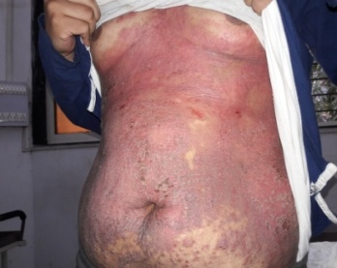 | 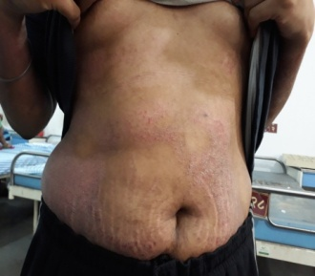 |  | 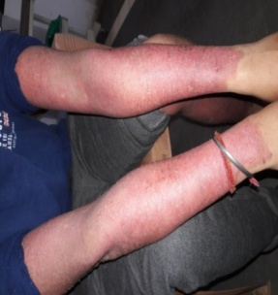 | 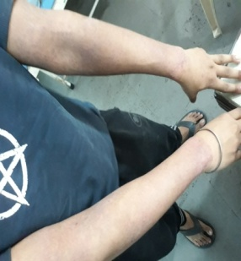
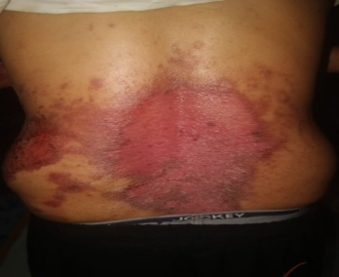 | 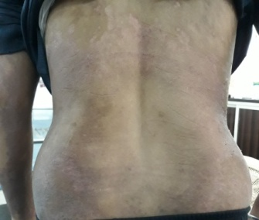 |  | 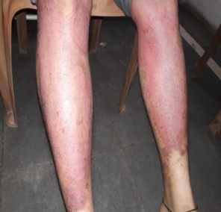 | 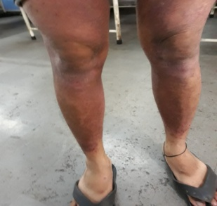
References:-
- Sarth Vagbhat of Maharshi Vagbhat Edited by Dr.Ganesh K. Garde, Chaukhamba Surbharati Prakashan, Varanasi, reprinted in 2012, Nidana sthan -14/24. p. 206.
- Charka Samhita of Agnivesha Edited by Dr. Ravidatta Tripathi, Chaukhamba Sanskrit Pratishthan Delhi, reprinted in 2012, Chikitsa sthan- 7/9. p.182.
- Sarth Vagbhat of Maharshi Vagbhat Edited by Dr.Ganesh K. Garde, Chaukhamba Surbharati Prakashan, Varanasi, reprinted in 2012, sutra sthan -13/24. p. 206.
- Charka Samhita of Agnivesha Edited by Dr. Ravidatta Tripathi, Chaukhamba Sanskrit Pratishthan Delhi, reprinted in 2012, Chikitsa sthan- 7/13. p.182.
- Charka Samhita of Agnivesha Edited by Dr. Ravidatta Tripathi, Chaukhamba Sanskrit Pratishthan Delhi, reprinted in 2012, Chikitsa sthan- 7/21. p.184.
- Smith CH, Barker JN. “Psoriasis and its management, BMJ.2006 Aug 19; 333(7564):380-4.
- Vd. Gangadharshastri Gune, Ayurvediya Aushadhi gunadharma shastra, Reprint- 2011, Kalpa no -10. p.208.
- Vd. Gangadharshastri Gune, Ayurvediya Aushadhi gunadharma shastra, Reprint- 2011, Kalpa no -30. p.270.
- Sarth Vagbhat of Maharshi Vagbhat Edited by Dr.Ganesh K.Garde, Chaukhamba Surbharati Prakashan, Varanasi, reprinted in 2012, sutra sthan -13/18. p. 61.
- Sushruta, Sushruta Samhita with Nibandha Sangraha commentary of Dalhana and Nyayachandrika panjika commentary on sutra sthana of Gayadasacharya,edited by Yadavjitrikamji,Varanasi: chaukhamba Sanskrit sansthan;2014.p.520
- Aacharya shri Radhakrushna Parashar, editor, (3rd Ed.). Sharangdhar Samhita of Sharangdhar, Uttarkhanda, Virechan Kalpana: Chapter27, Verse34. Varanasi: Baidyanath Ayurveda Bhavan, Nagpur, 1984; 482.
- Charka Samhita of Agnivesha Edited by Dr. Ravidatta Tripathi, Chaukhamba Sanskrit Pratishthan Delhi, reprinted in 2012, Kalpa sthan- 1/5. p.80.

