Rehabilitation in Falij(paralysis) with Dalak(massage) and Riyazat(exercise)

Dr. Aliya Parveen^{1*}, Dr. Mohd Saqlain²

1. Assistant Prof., Department of Community Medicine, Rajputana Unani Medical College, hospital and research centre, Jaipur, Rajasthan
2. Assistant Prof., Department of Kulliyat, Rajputana Unani Medical College, hospital and research centre, Jaipur, Rajasthan

Abstract
Falij in Unani system of medicine is been used for weakness of muscles or Hemiplegia. Unani scholars, adverted ahtebaas(obstruction) in the pathway of roohe muharrika(motor pnuema) & roohe hassassa(sensory pneuma) being the pathology behind Falij. The obstruction may be due to sudda(obstruction in brain vessels),inflammation or injury of nerves, change in the temperament of organ or excess of baroodat (cold)& ratoobat (wet).In Unani system of medicine regimens like dalak,riyazat,hammam,cupping etc. have shown their great effect in the management of Falij and prevention from permanent disabilities. Out of all Unani regimens,dalk & riyazat both help in dissolving the fuzlat(waste),liquefies ratoobat,produces hararat, increases the blood circulation in the affected part, relieves pain and strengthen the muscles. Unani physicians advised to use hot oils like roghane qust,surkh,nawein,arand etc. for Dalk to stimulate the innate heat. Dalk also strengthen ligaments, relieves stress, increase the atrophied muscles mass, and hence improves the sensory impairments. Whereas Riyazat along with strengthening the muscles also strengthens the nerves, tendons, improves the flexibility& integrity of joints. It reduces the spasticity of muscles, improves postural control & balancing, and hence improves the motor impairments. This article will help to understand the readers, how paralyzed muscles respond to Dalk and Riyazat and how we can use these regimens in the patients of hemiplegia or other paralyzed persons to make their life better.

Key words: Falij, Dalk,Riyazat

*Corresponding author email: aliyaprvn@gmail.com

Inroduction
Falij(paralysis) is an Arabic word means to halve, therefore can be used for hemiplegia where the body longitudinally get paralyzed sparing head and neck. Some of the Unani scholars used Falij for isterkha(weakness of muscles).So,it can be said that Falij covers paralysis of single muscles to paraplegia to apoplexy.The core pathology behind Falij is cited to ahtebaas(obstruction) in the pathway of roohe muharrika(motor pnuema) & roohe hassassa(sensory pneuma).^{1,2,3}
Census 2011(India) has revealed that 5,436,604 persons are paralysed due to different causes, which ultimately lead to physical, psychological, social & economical burden on the community.⁴Keeping in mind the burden of disease, there is an urge to take steps to combat the prevailing situation. Before coming to the management of the Falij, let’s understand what actually it is.
Aetiology-

Grouped into two categories-
- Causes leading to obstruction in the path of Roohe hassasa (sensory pneuma) and Roohe muharrika(motor pneuma) preventing their penetration into the organs. This obstruction may be due to sudda or atheroma in the vessels, or rupture of any blood vessel, inflammation or injury of nerves.
- Causes making the organs non-responsive to Roohe hassaas and muharrika i.e. Sue mijaz or intemperament. This intemperament may be due to abnormally excessive heat, cold, dryness or moist.^{2,5,6}

Effect of Riyazat(exercise/ rehabilitation) in Falij(paralysis)⁷
Ibne Sina defined Riyazat as a sequence of voluntary and continuous movements of the body which produces rapid and deep respiration. ^{8,9}
Therapeutic exercise is the systematic and planned performance of movement of body, specific postures, or physical activities intended to provide a patient to prevent impairments, enhance physical functions, and reduce health related risk factors and to provide feeling of well being
Broadly Riyazat is classified into two cateogaries-
- Riyazate Haqeeqi/Kulli / Whole body exercise e.g. Brisk walking
- Riyazate Juziya /Specific body part or organ’s exercise e.g. singing to improve lung capacity.
Typs of exercises advised in Falij(Paralysis)¹⁰
In case of paralysis,exercise (Riyazat) is advised to maintain the tone of the muscles. So, the type of exercise/riyazat depends on the site of affected muscles.
For facial palsy- Riyazate Mutarakhiya (Exercise in which movements are weak and slow)
For upper limbs paralysis- Riyazate Motadil (average strenuous exercise)
For lower limbs paralysis-Riyazate Hasheesha (fast and strenuous exercise)

Effect of Dalk in Falij (paralysis)
Dalak (Massage) is a therapeutic technique or systematic manipulation of body tissues with the hands. It involves working and acting on the body with gentle pressure by using expertise hands sometimes with fingers, elbows, knees, forearm, feet, or with a massage device.¹¹
Type of Dalk advised in Falij(Paralysis)¹²
- Sulb kaseer (hard and prolonged massage) with Roghan-e-qust(Saussurea lappa), nardeen(Nardostachys jatamansi), kaknaj(Withania coagulans),badam(Amygdalus communis),balsan(Commiphora opobalsamum) prepared with jundbedastar(Castoreum), farfiyoon(Euphorbia resinifera ) etc. for the duration of 20 minutes
Understanding why Dalk & Riyazat is advised to paralyzed muscles in Unani System of Medicine-
What is atrophy of muscles??
When muscles are no longer activated to perform work, muscle’s protein breakdown (proteolysis). When proteolysis becomes greater than protein synthesis, muscle’s mass decreases which is known as atrophy of muscles. Increased proteolysis leads to altered muscles composition causing accumulation of fat and decalcification.¹³
Mechanobiology

Mechanobiology is an emerging field of science at the interface of biology and engineering that focuses on how physical forces and changes in the mechanical properties of cells and tissues contribute to development, cell differentiation, physiology, and disease.¹⁴ The use of mechanotherapies in regenerative rehabilitation activate specific biological responses in musculoskeletal tissues to enhance the integration, healing, and restorative capacity of implanted cells, tissues, or synthetic scaffolds.

How mechanobiology effect paralyzed muscles ^{15,16}

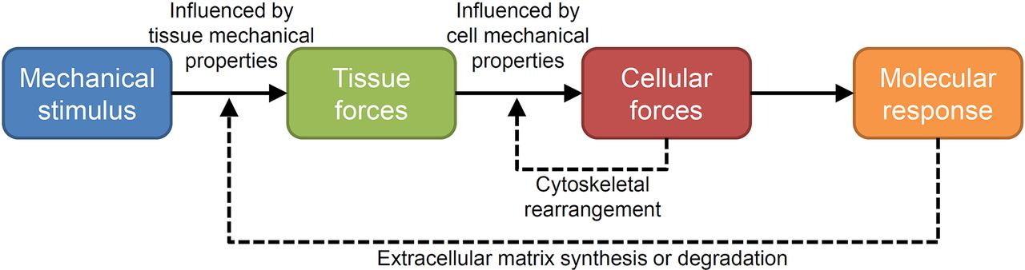

Fig. 1 Molecular response to mechanical stimuli¹⁵

Mechanical forces direct cellular activities to induce tissue adaptation. Extrinsically and intrinsically generated mechanical forces load musculoskeletal tissues, with the characteristics of the resultant tissue forces being dependent on the ability of the tissue to resist those forces. Tissue forces are transmitted to the micromechanical environment of resident cells, with cellular mechanical properties influencing the characteristics of the cellular forces. Cells can modify their micromechanical environment via cytoskeleton rearrangement, which feeds back to alter cellular sensitivity to incoming forces. When cellular forces are sufficient, the cell initiates a molecular response, which ultimately alters synthesis or degradation of the extracellular matrix. The later alters tissue mechanical properties, which feeds back to influence tissue forces.

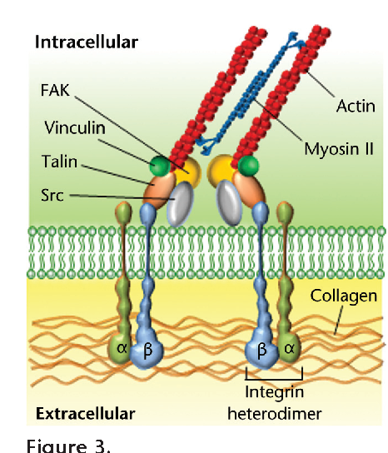

Fig. 2 Activation of biochemical signaling pathways in response to mechanical force¹⁵

Forces are transmitted at the matrix/cell membrane interface where specialized complexes called focal adhesions form. Integrins span the plasma membrane, uniting the extracellular matrix with the internal actin cytoskeleton. Linker proteins, such as vinculin and talin, reinforce the structural integrity of the adhesion complex, and associated signaling effectors, including focal adhesion kinase (FAK) and Src, activate biochemical signaling pathways in response to force.(Fig. 2)

A variety of extracellular receptors activate an overlapping network of mechanosensitive pathways-
- Musculoskeletal cells can sense incoming mechanical signals using a diverse group of transmembrane mechanosensitive proteins (mechanosensors).The mechanical stimulation of these proteins can lead to changes in their affinity to binding partners or ion conductivity.
- Mechanical stimulation of the mechanosensors and alteration in their binding capacity or ion conductivity converts the mechanical signal into a biochemical signal (biochemical coupling) triggering intracellular signaling cascades which results in the activation of select transcription factors.The transcription factors translocate to the nucleus and modulate the expression of a panel of mechanosensitive genes, which determines the functional response of the cell to a mechanical stimulus.As a result of which the atrophied muscles regain ttheir strength sue to mechanical stimulus.(Fig. 3)

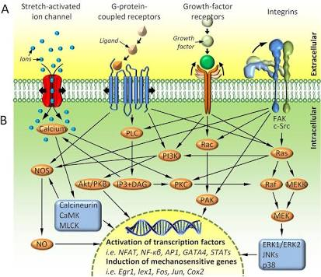

Fig. 3 Activation of mechanosensitive pathways in response to mechanical force¹⁵

Conclusion
Burden of paralyzed patients is increasing on the community day by day. Most of the time people unable to reach to the hospitals in time to get proper treatment and sometimes, the most proper medication do not yield a good result in time. Post traumatic effect usually left people physically socially mentally and financially handicapped. To combat with the situation and to make victim’s life easier, rehabilitation is considered to be the only option. Earlier the efficacy of physiotherapy was doubtful. But nowadays, mechanobiology helped us to understand that how the mechanotransduction effect the muscle’s biology. The transformation of a mechanical stimulus into a chemical signal or the resulting cellular signaling cascade after an external mechanical deformation of tissue. The cytoskeleton consists of numerous mechanosensitive structures, such as stretch-activated ion channels and focal adhesion complexes. Activation of these structures can cause depolarization, can change the sensitivity of surface receptors to their substrates, and can serve as a major source of signal transduction within and between cells. This mechanotransduction ultimately can lead to the transmission of signals throughout the cell, altering protein expression. These researches have shown that various loads applied to muscle tissue can trigger distinct signaling cascades that lead to adaptive cellular responses. The atrophied and paralyzed muscles respond to these mechanical stimuli, which make a number of rehabilitation techniques successful.
In Unani system of medicine, Dalk and Riyazat have been proposed thousands of years ago for the management of Falij(paralysis).The efficacy of these regimens also been proved practically several years ago but still it took years to proved it scientifically. Keeping in mind the benefits of Dalk & Riyazat and how it affects the paralyzed muscles, modifications and development of advance therapeutic techniques are still the need of hour. The advance techniques in the regimens(Dalk & Riyazat) so developed, should be practiced regularly to make Falij(paralyzed)patients more independent in their lives, so that they can lead a physical, social, mental and vocational stable life.

References
1.Ibn S. Al Qanoon Fil Tib. (Urdu translated by Kantoori GH). Vol. I & 3, part I. New Delhi, Idara Kitabul Shifa, 2007:120-126, 211-212.
2. Jurjani I. Zakheera KS. (Urdu translation by Khan HH). Vol. 2 & 3 Part 6th. Lucknow, Munshi Naval Kishore, 1903: 76-83.
3.Md Tanwir,Izharul Hasan, WaseemAhmad,Aisha Perveen, Shaista Perveen.Falij (Hemiplegia) and their understanding in the past: Unani concept. International Journal Of Herbal Medicine.2013; 1 (4): 63-66
4. Office of the Registrar General & Census Commissioner, India. CENSUS OF INDIA 2011 [Online];2013 December. Available from: http://www.censusindia.gov.in
5. Haji A. Efficacy of Massage with Roghan Seer in Motor Recovery in Falije Nisfi [dissertation]. Dept. of Moalajat (Medicine), National Institute of Unani Medicine (NIUM), Rajiv Gandhi UniversityHealth Sciences (RGUHS), Bangalore, Karnataka, India, 2009. 8.
6. Ahmad A. Evaluation of efficacy of Tanqia and Tadeel in motor recovery of Falij Nisfi [dissertation]. Dept. of Moalajat (Medicine), National Institute of Unani Medicine (NIUM), Rajiv Gandhi University of Health Sciences (RGUHS), Bangalore, Karnataka, India, 2012.
7. Mohammad Aslam,Azizur Rahman, Rafique Khan, Imtiyaz Ahmad, Md Izhar Alam. Riyazat (exercise) in The Perspective of Unani System of Medicine and its Importance in Life - A Review. Am. J. PharmTech Res. 2015; 5(3)
8. Rushd AWI. Kitab-ul-Kulliyat. New Delhi: CCRUM; YNM.
9. Majoosi AIA. Kamilus Sana'ah. Vol-I. New Delhi: CCRUM; 2010.
10. Ibn Sina A.A.H.A. Kulliyat Qanoon. New Delhi: Ejaz Publishing House; 2006.
11.Anonymous.Dalak (Massage or Friction).National Health Portal of India. [Online];2016.Available from:https://www.nhp.gov.in/dalak-massage-or-friction_mtl
12. Tanwir M.A, Ansari A.H, Aisha P,Anzar M. A.Dalk (Therapeutic Massage) & Their Indication for Musculoskeletal Disorder in Unani Medicine. International Journal of Advanced Ayurveda, Yoga, Unani, Siddha and Homeopathy 2013; 2(1):59-70,
13. David R, Dolbow, Ashraf S. Gorgey. Effects of Use and Disuse on Non-paralyzed and Paralyzed Skeletal Muscles. Aging and Disease . 2016 Jan; 7(1): 68–80
14.Jacobs, Christopher R. Huang, Hayden Kwon, Ronald Y. Introduction to Cell Mechanics and Mechanobiology. Garland Science. 2012 .
15. William R. Thompson, Alexander Scott, M. Terry Loghmani, Samuel R. Ward, Stuart J. Warde.Understanding Mechanobiology: Physical Therapists as a Force in Mechanotherapy and Musculoskeletal Regenerative Rehabilitation. Phys Ther. 2016 Apr; 96(4): 560–569.
16. Christine Waters-Banker, Esther E. Dupont-Versteegden, Patrick H. Kitzman,Timothy A. Butterfield. Investigating the Mechanisms of Massage Efficacy: The Role of Mechanical Immunomodulation. J Athl Train. 2014 Mar-Apr; 49(2): 266–273.

