Efficacy of Kshara taila with Kasisa bhasma in management of Mole (Mashaka) –A case study

ABSTRACT
Mole are common skin growth which appears as small, dark brown spots; caused by cluster of pigmented melanocytes. In Sushruta Mashaka is described among Ksudra roga as hard, painless, black and elevated eruption on the body (skin) resembling the masha pulse in shape. Mashaka can be compared with mole in modern science. Moles can be removed surgically, but Kshara are superior to the Shastra and Anushastra; due to its Tridoshaghna properties to perform Chedana, Bhedana and Lekhana. A 28 years male came with complain of mole over right side of forehead (supraorbital area) since birth, which was gradually increasing in size. It was planned to remove mole with local application of paste consisting Kasisa bhasma in Kashar taila. This case was successfully treated as after 8 days, lesion was healed up with no any complain of bleeding, burning, pain or infection of wound.
Keywords: Mole, Mashaka, Kshara taila, Kasisa bhasma

INTRODUCTION
Mole are common skin growth which appears as small, dark brown spots; caused by cluster of pigmented melanocytes. Melanocytes migrate from the neural crest to the basal epidermis during embryogenesis. When Melanocytes aggregates in the dermis or at the dermo- epidermal junction, they are called naevus cells ⁽¹⁾. Mole can be a flat or raised based on their presence in the skin layer. The medical term for the moles are pigmented nevi or melanocytic nevi. They are usually present since birth. Although many of these may appears later in life; also they appear solitary or in clusters at any part of body. They may have different colours may be brown, black, and even bluish sometimes. It's common for an average adult to have 10 to 40 moles ⁽²⁾. Moles may even appear and disappear with hormonal changes like pregnancy or puberty. Many people naturally grow more moles on their skin with exposure to sunlight, but they do not cause any harm.
In Sushruta, Mashaka is described among Ksudra roga as hard, painless, black and elevated eruption on the body (skin) resembling the masha pulse in shape, caused by the aggravation of vayu. ⁽³⁾ Similarly, according to Vagbhata; black, pains, sprouts on the skin, resembling tila (sesame seed) are known as Tilakalaka and those which are elevated are known as Mashaka. ⁽⁴⁾
Mashaka can be compared with mole in modern science.
Moles can be removed surgically as fairly a minor procedures. Fading or lightening creams, bleaches, freezing, or other chemicals usually do not play any role in treating moles. Moles and skin tags can easily be removed with the laser treatment also ⁽⁵⁾
Here a case of 28 years old male patient came complaining of a blackish brown coloured growth present over right side of his forehead (supraorbital region) since birth which gradually increases in size. As he was concern due to aesthetic issue, so removal of mole was planned. In contemporary medicine, various treatments of this condition are available but no promising management is updated till date. Keeping this in mind the patient was advised to undergo removal of mole with paste of Kshara taila with Kasisa bhasma.

A CASE REPORTS
A 28 years male came with complain of mass over right side of forehead (supraorbital area) since birth .It was gradually increasing in size.
There was no history of swelling, fever, pain; with no any aggravating factors. Patient was not having history of diabetes, hypertensive or any chronic disease. There was no family history of carcinoma.
On local examination mass was non tender, soft in consistency, immovable, irregular margin, was of about 1 cm in size and brown in colour.
On the basis of clinical examination it was diagnosed as Mashaka (mole).

MATERIAL AND METHODS
Kshara taila, Kasisa bhasma

INVESTIGATIONS
Routine investigations Hb %, TLC, DLC, ESR, RBS, HIV, HBsAg, Urine–Routine/Microscopic were done. All investigations were within normal limits.

TREATMENT PLAN
The treatment regimen was planned to remove elevated mole by local application of paste made by mixture of Kshara Taila with Kasisa bhasma.

PROCEDURE
Patient was educated about the whole procedure and his written informed consent was taken. Tetanus toxoid prophylaxis was given.
The paste was prepared by mixing Kasisa bhasma in Kshara taila till the consistency that it would be applied on the mole like a cream.
Patient was advised to apply this paste only upon area of mole twice a day for 30 minutes and then wash it with water.

RESULT
Significant improvement was observed in treatment of elevated Mole. After 8 days lesion was healed up with no any complain of bleeding, burning, pain or infection of wound. No any side effect or complication was observed during and after treatment.

DISCUSSION
Kshara is an alkaline Ayurvedic preparation useful as the substitute of surgical instruments. It is milder procedure than surgery. It is the superior most among the sharp and subsidiary instrument because it can perform activities like excision, incision and scraping.
Kshara taila has property to coagulate protein, also have sclerosing effect which ceases oozing of blood. Hence there was no chance of bleeding during and after Kshara taila application. The chance of infection is least due to the sustained action of the anti-microbial property of Kshara. It also acts as a fibrolytic agent which inhibits the growth of bacteria.⁽⁶⁾
Kasisa is considered as Ferrous sulphate (chemical formula: FeSO4.7H2O), also known by other names as Iron sulphate, Green Vitriol, and Iron Vitriol. It has the action of Sankochaka (astringent), Shvitraghna (anti-vitiligo), Vatamayahara (pacify Vata disorders), Krimighna (deworming agent /antibacterial), Kusthaghna (cures skin disorders), Ashmarighna (removes calculi), Savarnakara (promotes complexion), Vranaghna (wound healer).⁽⁷⁾
It do not need local anaesthesia, even no Pathya-Apathya, Ahara-Vihar, no regular follow up were needed. Complications are negligible.

CONCLUSION:
With this case it can be concluded that, this treatment is effective procedure which was a conducive, day care procedure, which could be done by patient himself and is very cost effective. It can be developed for cosmetic purposes also. Study on large sample size is needed to establish the effect of Kshara taila with Kasisa bhasma in elevated mole. Compilation of case reports and comparative clinical studies are needed to standardize the treatment protocol and catalogue outcome measures.

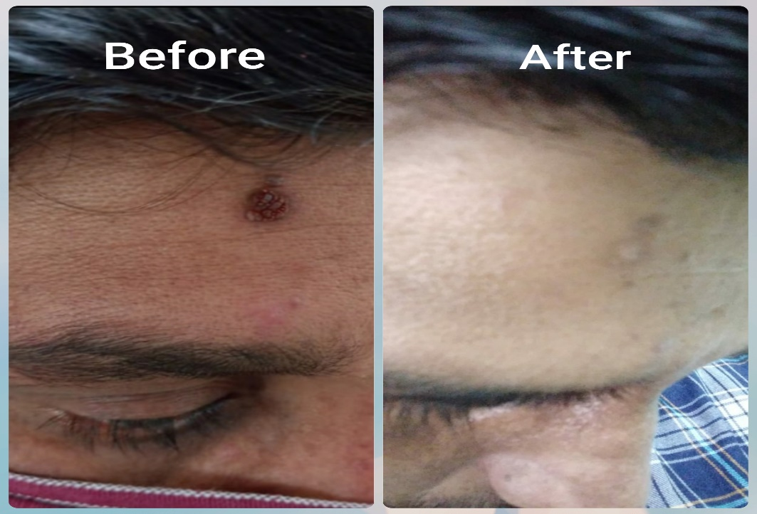

REFERENCES
1. Bailey and love, Bailey and love’s Short practice of surgery, Skin and subcutaneous tissue, CRC Press Tayor and Francis Group,2018.Pp599
2. Health E, Disease H, Disease L, Management P, Conditions S et al. Moles, Freckles, Skin Tags, and More [Internet]. WebMD. 2020 [cited 8 June 2020]. Available from: https://www.webmd.com/skin-problems-and-treatments/ guide/moles-freckles-skin-tags#2
3. Dr.Anant Ram Sharma,Sushrut Samhita of Maharsi Sushrut vol II chikitsasthana 20/23, ChaukhambaSurbharatiPrakasan,Vanarasi:2017.Pp331
4. Prof. K.R. Shrikanta Murthy,Vagbhata’s Astanga Hrdayam, English Traslation Vol III Uttarstyana 31/25b-25a, Chowkhamba Krishnadasa Academy, Vanarasi,6th Edition 2012 (reprint),Pp 295
5. Skin moles treatment: what are your options for mole removal [Internet]. Skin Vision. 2020 [cited 8 June 2020]. Available from: https://www.skinvision.com/articles/skin-moles- treatment-what-are-your-options-for-mole-removal/
6. Kumara, A. A. J. P., Jayaratne, D. L., and Anthony, D. J. 2016. “Antibacterial Activity of Pratisaraniya Ksharaa (Achyranthes aspera) in the Management of the Fistula in Ano.” International Journal of Ayurvedic and Herbal Medicine 6 (3): 2220-8.
7. https://www.researchgate.net/publication/312041468_Pharmaceutico-therapeutic_vistas_of_Kasisa_green_vitriol_in_Ayurveda

