Role of Raktmokshana (Siravedh) & Shaman Chikitsa in Vicharchika - A Case Study
Vd. Amol V. Mungale^{1*} , Vd. Suryaprakash K. Jaiswal²
- PG scholar, Department of Kayachikitsa, DMM Ayurved College, Yavatmal 445001 Contact No.9545998766 , Email- amolmungale31@gmail.com
2. Professor & HOD, Department of Kayachikitsa, DMM Ayurved College, Yavatmal 445001 Contact No. 9822126706 , Email- Skjaiswal01@gmail.com
*Corresponding Author
Vd. Amol V. Mungale
PG scholar, Department of Kayachikitsa, DMM Ayurved College, Yavatmal 445001 Contact No.9545998766 , Email- amolmungale31@gmail.com

Abstract :-
In ayurvedic texts, all skin diseases are classified under Mahakushtha and Kshudrakushtha. Vicharchika is a type of Kshudrakushtha. It can be correlated with eczema according to modern science. Eczema is characterised by dry itchy skin with areas of poorly demarcated scales. In acute phase eczema may be vesicular and oozing. In chronic phase, it may become hyperpigmented and lichenified. Modern dermatology employs systemic and local administration of steroids for the management of eczema. Despite an initial response, maintenance therapies with small doses of systemic and topical glucocorticoids usually produce hazardous ill effects. So attempt has been made to treat eczema by Ayurvedic medicine. Ayurveda focuses on underlying etiopathogenesis and treats the root cause of the disease. The present study has been done to evaluate the efficacy of Shodhana i.e.Raktamokshan(siravedha) and Shaman Chikitsa in Vicharchika.

Introduction :-
Most of the skin diseases devloped from abnormal functioning of the agni, defective dietary habits like Smoking, alcobol, psycological stress and causing life style related skin diseases. Vicharchika is one of the disease mentioned in ancient science among kushtha.^{[1]}
Kushtha has been classified in mainly two groups, Mahakushtha and Kshudrakushtha. ^{[2,3]}
Vicharchika being one among Khudra kushtha. All Kushthas having tridosha origin.^{[4]} Hence it Can be explained in similar manner i.e. Kapha is responsible for Kandu, Pitta is for strava and shyava indicate the presence of vata.
The existing treatment in modern science for eczema consist of reassurance, elimination of predisposing cause and palatative. It is also said that there is no specific medication for eczema ^{[5]}.
Though few drugs give symptomatic relief only . Modern deomatology employs systemic and local administration of steroid for the management of eczema^{[6]}. Despite of Initial response, maintenance therapies with small doses of systemic and topical glucocorticoids usually produce hazardous effect ^{[7]}.
Ayurveda focuses on underlying etiopathogenesis and treats the root cause of disease.
The main focus of treatment in Ayurveda for Vicharchika is Shodhan (Raktamokshan)^{[8]} .
The present work has been undertaken to check the efficacy of Shodhan (Raktamokshan) and Shaman Chikitsa in Vicharchika^{[9]}.

Case report:-
A 56 yrs old male patient came in OPD with complaints of Kandu(itching), Shyava varna ( blackish discolouration), Rukshata(dryness), Strava( discharge), Lohita varna( redness) and Ruja at the dorsum of both hands. Initially it was started in the form of small vesicles associated with itching, later on developed pidaka , strava and reddish lesions. After some days, itching was gradually increased with dryness. Patient received some oral steroids, antifungal and anti inflammatory drugs from local dermatologist but he didn’t get relief. So he came in Kayachikitsa OPD.
General Examination:-

General condition of patient was fair, Vitals were normal. Local and systemic examination revealed no abnormality.
Bowels - Abnormal.
Micturition - Normal,
Appetite - good.
BP- 110/80 mmHg
PR- 76/min
Routine blood investigations were done and was normal Skin examination.

Ashtavidha Pariksha:

Nadi – 72/min, Madhyam, Pittavataj Mala – Malavastambha
Mutra –Samyak Jivha – saam
Shabda – Prakrit Sparsha – Snigdha
Druk – Prakrit Aakriti – Madhyam
Kshudha – Kshudhamandya Nidra – Samyak

Material and methods:-
Table 1: Showing Treatment schedule

Date | Treatment
06-08-20 | - Siravedha has been done  - Hingwashtak churna 2gms + Ajamodadi churna 2gms BD before meal with lukewarm water.  - Panchasakar churna 2gms with lukewarm water at bedtime.  - Arogyavardhini vati 1BD  - Raktapachak Kadha 20ml BD  - Cutis oil for LA
21-08-20 | - Siravedha 2nd sitting  - Cap. Panchatikta Ghrit Guggul 500mg 1 BD  - Sukshma Triphala 1 BD  - Cap. Epderm 1 BD  - Mahamanjishthadi Kadha 15ml Bd  - Aragvadha kapila vati 1 with lukewarm water at bed time.
05-09-20 | - Rasayan vati 1 BD  - Chopchinyadi Churna 2gms BD

Table2 : Gradation of symptoms / subjective parameters of Vicharchika^{[10]}.

Sr.No. | Parameters | Grade 0 | Grade 1 | Grade 2 | Grade 3
1 | Kandu(itching) | Absent | Tolerable | Tolerable but doesn’t disturb sleep | disturb sleep
2 | Shyava varna ( blackish discolouration) | Normal | Slightly black | Dark patches | Dark spot with variation
3 | Pidika | Absent | One or two | More than two | All over the body
4 | Rukshata(dryness) | Absent | Dryness wth rough skin | Dryness wth scaling | Dryness wth Cracks
5 | Strava( discharge) | No Discharge | Occasional discharge with itching | Occasional oozing without itching | Excessive oozing making cloth wet
6 | Lohita varna( redness) | Normal skin | Slightly red | Reddish patches | Dark Red patches
7 | Ruja | No pain | Mild pain | Moderate pain | Severe pain

Table 3: Showing results before treatment and after treatment
Sr. No. | Parameters | BT | AT
1 | Kandu (itching) | 2 | 0
2 | Shyava varna (blackish discolouration) | 3 | 1
3 | Pidika | 2 | 0
4 | Rukshata(dryness) | 2 | 0
5 | Strava ( discharge) | 3 | 0
6 | Lohita varna ( redness) | 2 | 0
7 | Ruja | 2 | 0

Discussion:-
Vicharchika is a type of Kshudrakushtha and is generally caused due to the vitiation of vata, kapha and rakta having Rukshta, Strava, shyava varna, Strava . In this case, The patient was treated for the period of 30 days. Treatment was planned in 2 phases.
- Raktamokshan (Siravedha)
- Shaman Chikitsa
Prescribed medications with their action are shown below:
- Arogyavardhini Vati- ^{[11]}

Aamdoshanashak, Hepatoprotective, Vata and Kaphanashak, Kushthaghna. It has as anti-inflammatory. It has Bhedan and Malashuddhikar property because of Kutaki.

- Raktapachak Kadha-

It contains Patol, Sariva,Musta, Patha, Kutaki. It corrects the Rakta Dhatvagni. It is Raktashodhak and Kushthaghna.

- Panchatikta Ghrit Guggul-^{[12]}.

It is kushthagna. It helps in pacification of tridosha.It has anti inflammatory, anti pruritic and carminative properties.

- Mahamanjishthadi Kwath-^{[13]}.

Varnya, Kaphapittashamak, Shothahar, Kushthaghna, Vranaropak, Raktashodhak, Dahashaman

- Sukshma Triphala-

It contains Kajjali and Triphala. It is Kaphashamak. It has Rechan property.

- Cutis oil-
It is vata kaphashamak. It has raktashodhak and Kandunashak properties. It reduces dryness, itching and scaling.

7. Raktmokshan ( Siravedh)- ^{[14]}.
Vicharchika is included under Siravedha Arha vyadhi. In each and every disease, Shodhan is mentioned which includes Siravedha. In Vicharchika , there is vitiation of Rasa, Rakta and Mans Dhatu and Siravedha is indicated in all these vitiated Dushyas.In Vicharchika, there is excess dushti of all doshas which can be eliminated easily by Siravedha. Siravedha produces Indriya prasadan and Dhatu Sthirata, hence Rakta Dhatu Dushti and Rasa Dushti in Vicharchika is reduced and Twakindriya is nourished. In present case, 2 sittings of Siravedha at the interval of 15 days has been done, along with it, Shaman Chikitsa is given to the patient. The action of the prescrfibed medication were discussed above.

Conclusion:
In the contemporary view of Vicharchika, it can be included in Eczema. Long period of treatment in the form of suppressive and symptomatic (topical and systemic) are necessary in both therapies. In Ayurveda, Kushtha and kshudrakushtha are broad concept with pointed principle of management. All aspect of treatment also describe in Vicharchika eg. Pathya and Apathya. Various drugs for systemic and local purpose in many form of drugs preparation eg. Vati, lepas, Rasayan preparations, oil, Kwath. In present case study, patient has been treated with Shodhan and Shamana Chikitsa and got 95% result. So it can be concluded that Ayurvedic management will be an effective and acceptable in treatment of Vicharchika.

Study Photograph :-

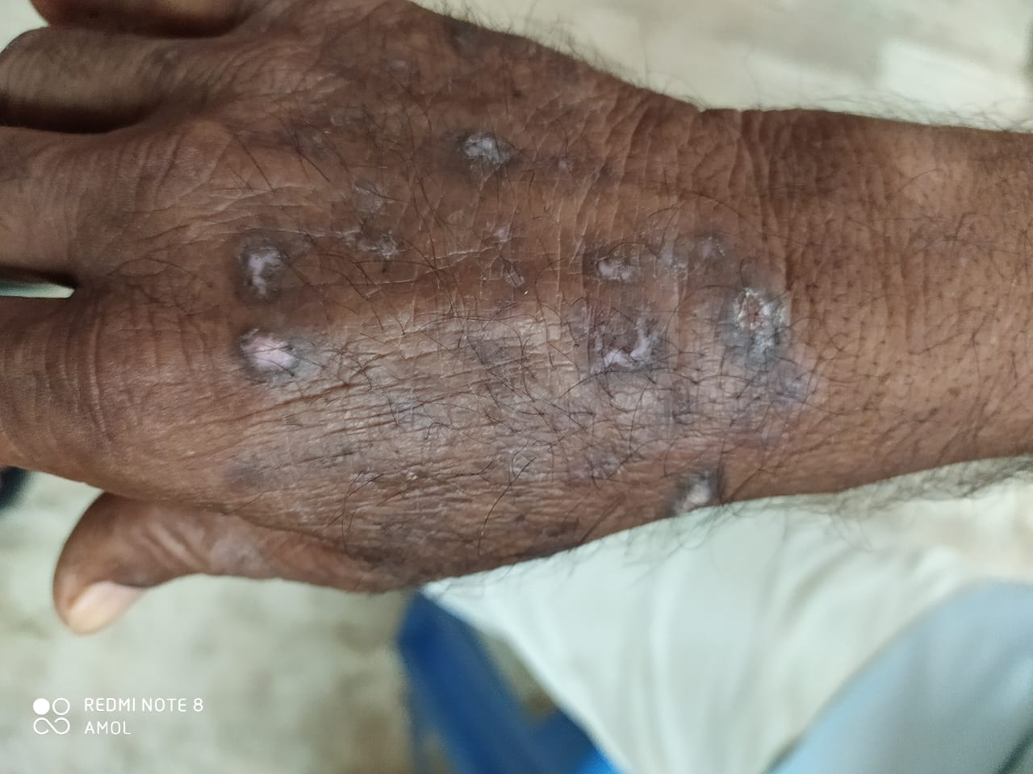
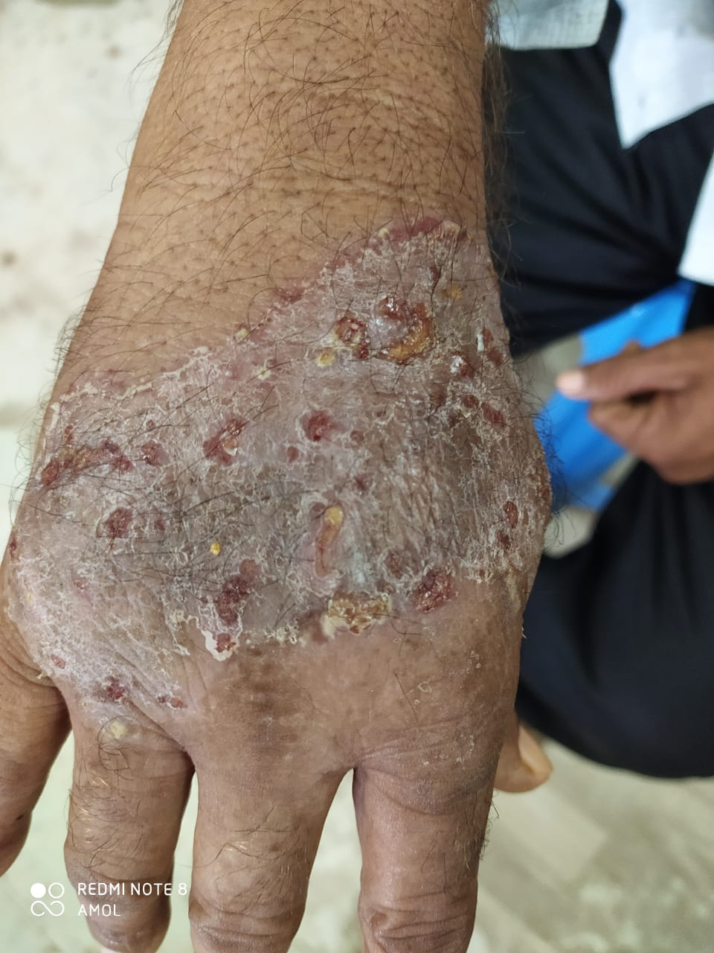

After
Before

References :-
- Vd. Bramhanand Tripathi , Charak Samhita Vol II, Kushtachikitsa ch. 7 shlok 13 Chaukhamba sanskrit prakashan varanasi reprint 2011, pg no. 302.
- Charak samhita edited by Ravidatta tripathi, Chaukhamba Sanskrit prakashan Varanasi ,2007 edition,Nidan sthan chap.no.5; shloka no.4 pg no. 514
- Sushrut samhita ,edited by Ambikadatta shastri, Chaukhamba prakashan Varanasi,Reprint 2016,Nidan sthan chapter no .5 shloka no.5 & 13. Pg no. 320
- Charak samhita,edited by Bramhanand tripathi,Chaukhamba prakashan Varanasi 2015,edition chikistasthan chapter no.7 shlok 31 pg no. 18
- Kay AB. Allergy and allergic diseases. First of two parts. N Engle J Med 2001; 344(1): pg 30-37.
- Johansson SG, Hourihane JO, Bousquet J, Bruijnzeel Koomen C, Dreborg S, haahtela T et al. A revised nomenclature for allergy. An EAACI position statement from the EAACI nomenclature task force Allergy 2001; 56(9):813-824.
- Cooper KD. Atopic dermatitis: recent trends in pathogenesis and therapy. J invest Dermatol 1994; 102(1):128-137.
- Sushruta Samhita with Nibandhasangraha of dalhanacharya and Nyayachandrika Panchika of Gayadasa. Yadava T. Shareera Sthana.7 Varanasi Chaukhambha Surabharati Prakashana; 2004..383, 379p.
- IJAPR/december 2020/ vol 8 / Issue 12 Management of vicharchika by shaman Chikitsa Md. Tanzil Ansari, Sukumar ghosh.
- On Dermnet Nz-Hanifin JM, ThurstonM, Cherry R, Tofte SJ, The eczema area and severiety index(EASI) assessment of reliability in atopic dermatitis.
11. Mishra S, editor. Rasaratnasamuchhaya, Reprint ed. Varanasi: Chaukhamba orientaliaorientalia; 2017, p 446.

12 . Jain A Gupta VB, Chemisty and Pharmacological profile of Guggula A review Indian Journal Of Traditional Knowledge 2006 5(4) 47883 .

13. IJAPR/december 2020/ vol 8 / Issue 12 Management of Vicharchika by shaman Chikitsa . Md. Tanzil Ansari, Sukumar ghosh.
14. www.wjpr.net/ wjpr/ vol 6/ issue 8 /2017, Gupta et. al pg.957.

