Introduction
According to Ayurveda Rakta is one of the seven tissues of the human body. . Acharya sushruta mentioned blood [Rakta] as life^{[1]}. It is essential life-giving tissue in the liquid form. It enhances the tone and complexion of body. It also nourishes Mansa dhatu. Yakruta and pleeha are upattisthana of Rakta.
Blood is a body fluid in humans and other animals that transports necessary substances like nutrients and oxygen to cells and carryout metabolic waste products away from those cells.^{[2]}
Blood disorders are very prone in India as more than 30% people are below poverty line. Blood disorders are related to change in quality as well as quantity of blood. Blood vitiation seen in Skin diseases. Change in viscosity of blood seen in conditions like pulmonary embolism, DVT, strokes and heart attacks. Anemia is condition where there is decrease in quantity of blood. If there is excessive blood flow in conditions like hemorrhagic disorders, RTA, post-operative surgical care. In most cases, we should be able to control bleeding but in severe cases, however, uncontrolled or severe bleeding can contribute to shock, circulatory failure, damage to tissues and major organs and sometimes death.
The fourth chapter of Charaka samhita is related with fifty various groups. In each group 10 herbs are included having common action. Shonita sthapaka mahakashaya is pronounced for action related with restoring normalcy of blood ^{[3]}. According to some Acharya, shonitasthapana means to stop excessive blood flow.^{[4]} Shonita sthapaka mahakashaya is very specific and only mahakashaya in which only 5 medines of herbal origin like Madhuka, Rudhira, mochrasa, Lodhra, Priyangu, one metallic compound Gairika, one jantav dravya Madhu and two byproducts Sharkara and Laaja and Mrutkapala. Shonitasthapaka gana included different properties like Raktashodhana [haemostatic], Raktastambhana [ blood coagulation], Raktavilayaka [blood thinning], Raktavardhana [ haemopoitic]. Rakta and pitta dosha are same in nature, so Rakta is mainly vitiated by pitta dosha. Thus, dravyas included in Shonitasthapaka gana have pittashamaka properties.

Aim
To evaluate the pharmacological action of Shonita-Sthapana gana.
Objectives
1] To study the pharmacognosy of drugs of Shonitasthapana mahakashaya.
2] To assess the activity of drugs of Shonitasthapana mahakashaya with respect to Ayuervedic as well as modern aspect.
Materials and methods
Literary review of Shonitasthapaka mahakashaya narrated from Charaka samhita. Study of dravyas included in Shonitasthapaka gana done from various nighantu and research articles.
Shonitasthapaka mahakashaya contains 10 dravyas as follows –
- Madhu [honey]
- Madhuka [Glycyrrhiza glabra Linn.]
- Rudhira [Crocus sativa Linn.]
- Mocharasaa [Resin of Salmalia malabarica Schott & Endl.]
- Mrutkapala [Erthen pot pieces]
- Lodhra [Symplocos racemosa Roxb.]
- Gairika [Ferrum haematite]
- Priyangu [callicarpa macrophylla Vahl.]
- Sharkara [Sugar]
- Laaja [Fried paddy]

SHONITASTHAPAKA DRAVYAS -
- Madhu

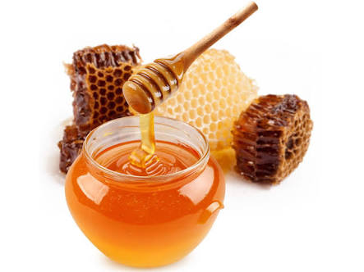
Fig.1 Madhu[honey]
Madhu is sweet, delicious and pleasant type of Jantav dravya. Its rasa is Madhura,kashaya, katu vipaka and sheeta veerya. Laghu, ruksha, vishad, sukshma are guna of Madhu dravya. It pacifies all three Doshas, having Vrana Shodhana, Sandhana, Ropana and Krimihara property.^{[6]} It is mentioned in shonita-sthapana Mahakashaya as well as in Sandhaniya Mahakashaya.^{[7]} According to Charaka samhita Madhu pacifies Rakta, pitta and kapha dosha.^{[8]} Madhu act as a yogawahi dravya it means when it uses with other medicine then it capture properties of that medicine.^{[9]}
In Charaka chikitsa 4th adhyaya, Madhu is said to be use with paravat shakuta churna in case of “grathit Rakta dushti”.^{[10]}
Natural honey contains phospholipase and melittin. Madhu shows Anti-thrombotic action. It means Madhu helps to increase blood clotting time and showed the inhibitory effect on platelet aggregation & blood coagulation^{[11]}.

- Madhuka
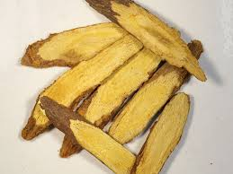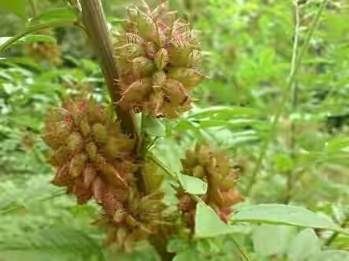
Fig.2 Root of liquorice Fig.3 Madhuka plant

Latin name of Madhuka [ liquorice] is Glycyrrhiza glabra Linn. It is also known as ‘sweet root’. It has Madhura rasa, Madhura vipaka, sheeta veerya and guru, snigdha guna. Due to above properties it alleviates vata dosha and pitta dosha as well and acts as a Raktaprasadaka dravya. Madhuka dravya mentioned in sandhaniya, kandughna and varnya gana in Charaka samhita. Liquorice is included under jeevaniya gana which is mainly act on Rakta dhatu^{[12]}. In Charaka samhita Madhuka dravya is mentioned in treatment of adhoga Raktapitta^{[13].}
Glycyrrhizin, a main constituent of Madhuka dravya, is a plant based inhibitor of thrombin. It prolongs thrombin and fibrinogen clotting time^{[14]}. Thus, increases plasma re-calcification duration and inhibits platelet aggregation and shows anticoagulant activity^{[15]}. Liquorice acts on circulatory system as enhance the blood flow, building red blood cells. It is used as blood purifier & haemopoitic.
It prevents also deposition of plaque on the walls of blood vessels^{[16]}. Mulethi also minimizes immune allergic reactions as well as that auto immune complications^{[17]}.
It is beneficial in bleeding stomach ulcers caused by aspirin. A recent study from Iranian researchers used aspirin coated with licorice and found that it helped protect against ulcers induced by aspirin, reducing the size and number of ulcers^{[18]}.

- Rudhira
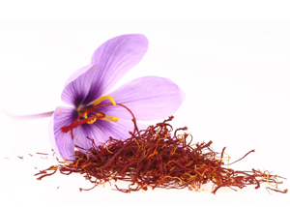
Fig.4 crocus sativus Linn.

It is a ‘Gall’ of Crocus satus Linn. Plant. Rakta, asruk, Shonita are synonyms of Rudhira dravya. Rudhira has katu- tikta rasa. only dravya in Shonitasthapaka mahakashaya having ushna veerya. Rudhira pacifies all three doshas. It is proven for its vranavishodhan [Anti-inflammatory] property. It improves skin complexion and act as blood purifier.
Rudhira dravya is very useful in acne and pimple prone skin and thus, reduces pigmentation over skin. Naveed Akhtar concluded that A cream formulation containing Crocus sativus extract has significant depigmentation & anti-erythema effects on human skin due to apparently reduced melanin & erythema levels in the skin^{[19]}. Two clinical trials had established antipruritic & complexion promotion effects of saffron^{[20]}.
Rudhir is a cardio tonic, cardio protective and anti-atherosclerotic effects help in lowering blood cholesterol and triglycerides. It keeps the blood pressure under control^{[21]}.
For this purpose take 50 mg. of saffron dissolved in 100 ml. of milk was administered twice a day to human subjects, and the significant decrease in lipoprotein oxidation susceptibility in patients with coronary artery disease [CAD] indicates the potential of saffron as an antioxidant as it contain Carotenoids, phenolics, & flavonoids^{[22]}.

- Mocharasa
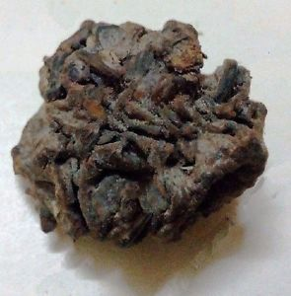

Fig.5. Mocharasa[Resin of Salmalia malabarica Schott & Endl.]

This dravya is nothing but the resin of Shalmali plant [exudate]. Mocharasa posseses kashaya rasa, sheeta veerya. So, it helps to stop bleeding. It shows Grahee and balya properties. It decreses Kapha- pitta doshas. In Ayurvedic samhitas Mocharasa is mentiones in treatment of Rakta-pradara, Rakta-pitta, Raktatisara.
Tannic acid and Gallic acid are main constituents present in Mocharasa which act as a astringents. Mocharasa is haemostatic agent due to its raspanchaka & chemical constituent Tannin. It is used in many bleeding problems such as menorrhagia, metrorrhagia, excessive menstrual bleeding of various aetiology, haemorroids, haemoptysis of pulmonary tuberculosis and influenza, malaena, diarrhea and dysentery^{[23]}.

- Mrutkapala

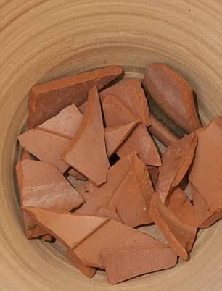
Fig.6 Mrutkapala [Erthen pot pieces]
In Charaka samhita Mrutkapala is indicated in Raktapitta with Atarushaka, Priyangu, Lodhra, Madhu kwath^{[24]}. And Mrutkapala with Madhuka & Madhu is mentioned as ‘ Raktasangrahanam param’^{[25]} [best haemostatic agent]. Why Mrutkapala[ Erthen pot pieces] has been added in the Shonita-sthapana mahakashaya is still not resolved.

- Lodhra

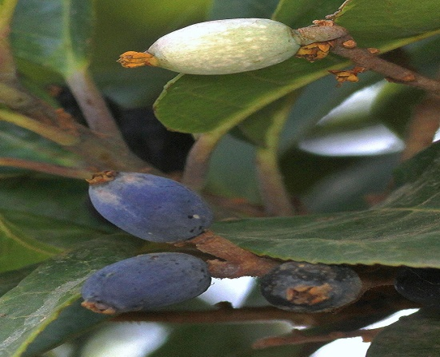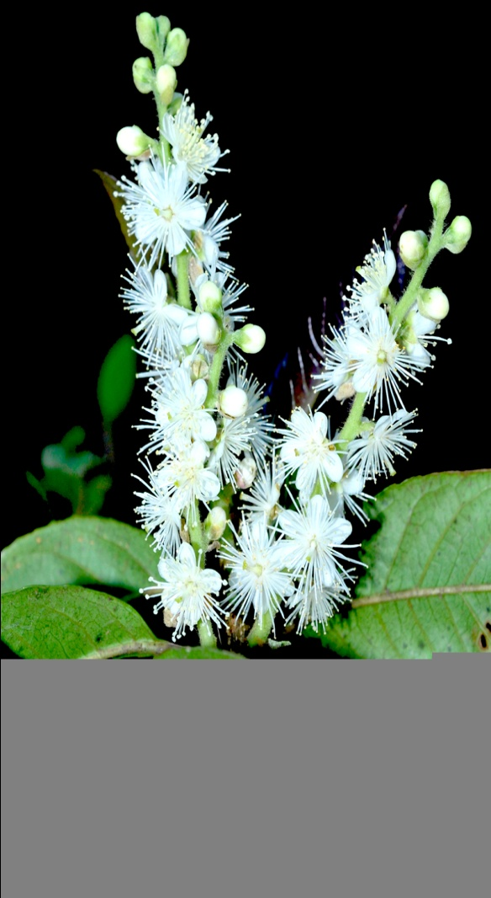

Fig. 7 Lodhra [Symplocos racemosa Roxb.] fig.8 Lodhra [Symplocos racemosa Roxb.]

Latin name of Lodhra is symplocos racemosa Roxb. Main part used is Stem bark. Lodhra having kashaya – tikta rasa and sheeta veerya. Due to its rasapanchaka it shows ‘Raktastambhaka’ and ‘Raktasangrahaneeya’ activity.
In Charaka chikitsasthan 30 th adhyaya, bark of Lodhra is mentioned in treatment of Rakta-pradar^{[26]}. External application of Lodhra powder act as Haemostatic^{[27]}.
Lodhra dravya contains loturine which is alkaloid and proven for astringent property. Lodhra with jaharmohra pishti or with nagkeshar and pravalabhasma with tandulodaka anupana is very useful in uterine complaints like DUB, menstrual disorders like menorrhagia.
From the result of the study on Lodhra, it was found that drug S. Racemosa at a dose level at 25 µl/100gm body weight in albino rabbits showed a significant decrease in whole blood coagulation time, prothrombin time and fibrinolytic activity. The auther concluded that S. Racemosa posseses significant anti-hemorrhagic potential.^{[28]} Hand book of Medicinal Plants[S.K. Bhattacharjee] mentioned that Lodhra is used to treat excessive bleeding during menstruation. The decoction prepared from bark is given 50-60 ml to treat diarrhea, uterine bleeding disorders[DUB] , bleeding piles as well as epitaxis because decoction constricts smaller blood vessels & controls bleeding.^{[28]}
- Gairika
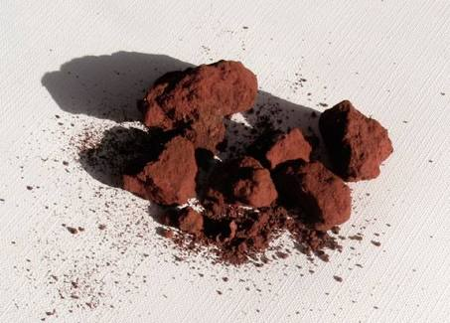
Fig.9 Gairika [Ferrum haematite]

Lohita, Raktapashana, Raktadhatu are synonyms of Gairika dravya which is only metallic compound added in Shonitasthapaka mahakashaya. It has kashaya- Madhura rasa, Madhura vipaka and sheeta veerya. Gairika is indicated in Raktapitta, Arsha, Raktapradara. It shows Raktapittashamaka activity.
Shuddha Gairika is an astringent and haematinic. It increases hemoglobin level because rich sources of iron. Gairika was found to be effective in controlling heavy menstrual blood flow & in improving general condition. It is also concluded that single drug Geru can effectively be used for controlling bleeding instead of combination of multiple drugs or hormonal treatment by its astringent & styptic properties.^{[29]} Shuddha Gairika is also used in treatment of Netra roga, Raktapitta, hikka, vamana, vata vikara, Rakta pradara, kandū, Jwara, daha and Udara roga.

- Priyangu

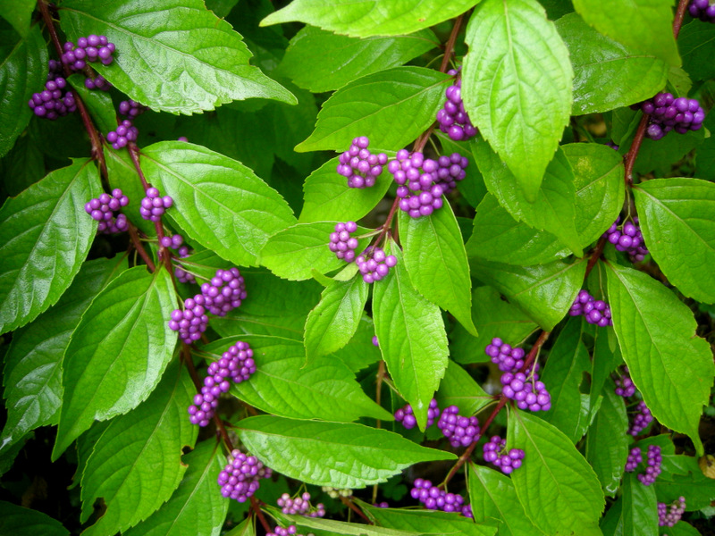
Fig.10. Priyangu [callicarpa macrophylla Vahl.]

Latin name of Priyangu dravya is Callicarpa macrophylla. It has Tikta, Kashaya, Madhura Rasa that alleviates Pitta dosha and Katu Vipaka, Sheeta veerya. There are two varities, one is Priyangu and second is Gandh-Priyangu. Both varities used as Raktapittashamaka.
According to priya-nighantu and Charaka samhita [cha.su. 25] Priyangu is best medicine for Raktapitta roga. Priyangu also mentioned in Raktatisara chikitsa by Acharya Charaka.^{[30]}
Khare CP & et.al concluded that Callycarpa macrophylla is mainly used to “Purify the blood” & to treat skin diseases.^{[31]} In animal experiments, Callicarpa macrophylla showed the effect of promoting blood coagulation by increasing Platelet count, Vasoconstiction.^{[32]}

- Sharkara

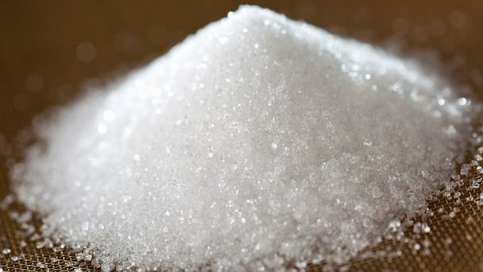
Fig.11. Sharkara [Sugar]

Sharkara having Madhura rasa, Madhura vipaka, sheeta veerya. Due to Rasapanchaka it act as a ‘Raktapittaprashamaka’ according to Charaka and Dhanvantari nighantu. In Rajnighantu Sharkara is mentioned as ‘ Raktadoshahara’. As Sharkara is proven for its Anticoagulant and anti-thrombotic activity, it shows ‘Vranaropaka karya’.^{[33]}

- Laaja

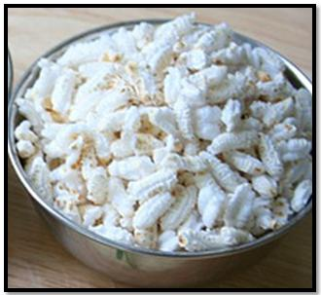
Fig.12 Laaja [Fried paddy]

Laaja shows pittashamaka activity by its Madhura- Kashaya rasa and Sheeta veerya.
Laaja indirectly helps in Raktavardhana [increasing quatity of blood].^{[34]} Laaja also mentioned as Pathya aahara in Raktapitta, chardi, atisara & grahani vikara by various Acharyas in ayurvedic samhitas.

Table no. 1- Rasa-veerya-vipaka of Shonitasthapaka dravyas
Sr. No. | Dravya Name | Rasa | Vipaka | Veerya
1. | Madhu | Madhura, Kashaya | Katu | Sheeta
2. | Madhuka | Madhura | Madhura | Sheeta
3. | Rudhira | Katu, Tikta | Katu | Ushna
4. | Mocharasa | Kashaya | Katu | Sheeta
5. | Mrutkapala | - | - | -
6. | Lodhra | Kashaya, Tikta | Katu | Sheeta
7. | Gairika | Kashaya, Madhura | Madhura | Sheeta
8. | Priyangu | Tikta, Kashaya, Madhura | Katu | Sheeta
9. | Sharkara | Madhura | Madhura | Sheeta
10. | Laaja | Madhura, Kashaya | Madhura | Sheeta

Table no. 2 Panchamahabhautika sanghatana of shonitasthapaka gana dravya.
Sr. No. | Dravya Name | Panchamahabhautika sanghatana
1. | Madhu | Prithvi, Jala, Vayu
2. | Madhuka | Prithvi, Jala
3. | Rudhira | Vayu, Teja, akasha
4. | Mocharasa | Prithvi, Vayu
5. | Mrutkapala | Prithvi, Jala, Vayu
6. | Lodhra | Prithvi, Vayu, Akasha
7. | Gairika | Prithvi, Vayu , Jala
8. | Priyangu | Vayu, Prithvi, Jala, Akasha,
9. | Sharkara | Prithvi, Jala
10. | Laaja | Prithvi, Vayu, Akasha

Discussion
Shonitasthapaka dravyas mainly posseses kashaya and Madhura rasa, katu or Madhura vipaka and sheeta veerya [except Rudhira dravya].
Kashaya rasa has vayaviya and parthiva mahabhuta sanghatana. Due to this mahabhuta sanghatana, they possesses sthira, guru, sanghatakara and ruksha guna. So, sthambhana and shoshana karma can be seen. It can be relate with vasoconstriction action. That means, they stimulates prothrombin net formation and trapping of platelets at the site of injury. Thus shows platelet aggregation and reduces bleeding.
e.g. lodhra, mocharasa, gairika, mrutkapala.
Tikta rasa dravya are best Agnideepak and Aampachaka. They possesses Vayu and aakasha mahabhuta. Due to vishada guna(cleansing action), they shows saptadhatu shodhana and dosha-pachana activity and thus, Raktashodhana activity.
e.g. priyangu, rudhira
Dravyas like Madhuka and sharkara shows Raktavilayaka action. This action can be seen due to Jala mahabhuta’s drava guna and kledana as well as vishyadana property.
Some dravya works by their katu vipaka. So they have prominence of Teja mahabuta and shows raktavilayaka property by sukshma as well as ushna guna.
e.g. madhu.
Laaja dravya is mentioned as Pathya aahara in samhitas. It has prominence of pruthvi, aapa and Vayu mahabuta. So, they are best in preenana, dhatuposhana and dhatuvardhana karma. So, it helps to increase the quantity of blood ( raktavardhana action) and gives laghavata (lightness) to body.

Conclusion
There are two main causes of bleeding, first is agantuka & second is dosha prakop. Rakta and Pitta dosha both are same in nature so Rakta is vitiated mainly by Pitta thus shonitsthapana drugs have pittashamaka properties. They removes derangement of vitiated shonita [Rakta] and bring back it to normal state. So, according to different conditions of Raktavikara [disorders related to blood], we can categorize Shonitasthapaka dravyas in treatment.
- Raktavardhana – Laaja
- Raktastambhana - Lodhra, Mocharasa, Gairika, Mrutkapala
- Raktavilayaka – Madhu, Madhuka, Sharkara.
- Raktashodhan – Priyangu, Rudhira

Blood being one among the seven tissues, has its significant role in regulating the function of vital organs and to give life to individuals. Without proper amount of blood and regular functions of blood the body cannot remain healthy. The dravya possessing the quality to arrest bleeding are called Raktaskandana dravya. In addition the herbs referred here have Raktavardhana and Raktaprasadan action also. So in total Shonitasthapana gana contribute qualitative and quantitative regulation or normalization functions.

References
- Kaviraj Dr. Ambikadatta Shastri, Sushruta Samhita [Hindi Translation], [Varanasi; Chaukhamba Sanskrit sansthan. Reprinted 2005], Vol 1. Sutrasthana Chapter no.14, verse no 44, pg 56

- “Definition of Blood” word finder MERRIAM- WEBSTER’S unabridged dictionary.

- Acharya Vidyadhar Shukla &Prof.RavidattaTripathi, Charaka Samhita [Hindi Translation,Dehli; Chaukhamba Sanskrit Pratishthan. Reprinted 2005, Sutrasthana, Chapter 4, Verse no.8, Vol 1, pg.71

- Kaviraj Dr. Ambikadatta Shastri, Sushruta Samhita [Hindi Translation],[Varanasi; [Varanasi; Chaukhamba Sanskrit sansthan. Reprinted 2005], Vol 1. Chikitsasthana Chapter no.1, verse no 48, pg 7

- Acharya Vidyadhar Shukla &Prof.RavidattaTripathi. Charaka Samhita [Hindi Translation]. [Delhi; Chaukhamba Sanskrit Pratishthan. Reprinted 2005], Vol 1, Sutrasthana, Chapter 4, verse no18, pg 77

- Murthy K.R.S, editor. Sutra Sthana, 15. reprint. Vol. 1. Varanasi: Choukhamba Krishnadas Academy; 2005. Vagbhat's Ashtanga Hridayam.

- Bulusu Sitaram. Madhu Varga. 1st edition. Vol. 1. Varanasi: Choukhambha Orientalia; 2006. Bhavaprakash of Bhavmishra; p. 550.

- Acharya Vidyadhara Shukla &Prof.RavidattaTripathi. Charaka Samhita [Hindi Translation]. [Delhi; Chaukhamba Sanskrit Pratishthan. Reprinted 2009], Vol 1, Sutrasthana, chapter 27, verse no 245, pg.no. 413.

- Acharya Vidyadhar Shukla &Prof.RavidattaTripathi. Charaka Samhita [Hindi Translation]. [Delhi; Chaukhamba Sanskrit Pratishthan. Reprinted 2009], Vol 1, Sutrasthana, chapter 27, verse no 249, pg.no. 414.

- Acharya Vidyadhar Shukla &Prof.RavidattaTripathi. Charaka Samhita Marathi translation by Vaidya vijay Shankar kale, Chaukhamba Sanskrit Pratishthan. Printed 2014, vol.2, chikitsasthan, chapter 4,verse no.72,pg no.130.

- Ahmed A,Khan RA, Saeed SA, Ahmed S, Imran I. ‘Effect of natural honey on human platelets and blood coagulation proteins.’ Pak J Pharm Sci.2011Jul;24[3]:389-97.

- Acharya Vidyadhar Shukla &Prof.RavidattaTripathi. Charaka Samhita [Hindi Translation]. [Delhi; Chaukhamba Sanskrit Pratishthan. Reprinted 2009], Vol 1, Sutrasthana, chapter 4, verse no 8[1], pg.no. 71.

- Acharya Vidyadhar Shukla &Prof.RavidattaTripathi. Charaka Samhita Marathi translation by Vaidya vijay Shankar kale, Chaukhamba Sanskrit Pratishthan. Printed 2014, vol.2, chikitsasthan, chapter 4, verse no.60, pg no.129.

- Mauricio I, Francischett B, Monterio RQ, Guimaraeas JA. “Identification of Glycyrrhizin as thrombin inhibitor”, Biochim Biophys Res Commun 1997; 235:259-263.

- Mendes-Silva W, Assafim M, Ruta B, Monteiro RQ, Guimaraes JA, Zingali RB et al. “Antithrombotic effect of Glycyrrhizin, a plant-derived thrombin inhibitor” Thromb Res 2003; 112:93-98]

- Yamama S. Alwash*,A. Razzak A.Latif *and Nisreen J.Al-Bayati, “Effect of liquorice extract on lipid profile in hypercholestermic male rabbits. QMJ Vol.7 no.12.

- Xiao-Lan Li, Ai-Guo Zhou, and Wei-Jun Chen,” Antioxidant Status and Immune Activity of Glycyrrhizin in Allergic Rhinitis Mice” Int J Mol Sci. 2011; 12[2]: 905–916.Published online 2011 Jan 26. doi: 10.3390/ijms12020905.

- Dehpour AR, Zolfaghari ME, Samadian T, Vahedi Y. The protective effect of liquorice components and their derivatives against gastric ulcer induced by aspirin in rats. J Pharm Pharmacol. 1994 Feb;46[2]:148-9. doi: 10.1111/j.2042-7158.1994.tb03760.x. PMID: 8021806

- Naveed Akhtar. “Skin Depigmentation Activity Of Crocus sativus Extract Cream” Trop J Pharm Res. Nov.2014; 13[1]: 1803

- Moshiri M, Vahabzadeh M, Hosseinzadeh H. “CLINICAL APPLICATIONS OF SAFFRON [Crocus sativus] & ITS CONSTITUENTS : A REVEIW.” AM J CLIN DERMATOL.2008; 9:15-31

- Bhat JV, Broker R. Riboflavin and thiamine content of saffron. Crocus sativus Linn. Nature. 1953; 172: 544. [PubMed].

- Verma SK, Bordia A. Antioxidant property of saffron in man. Indian J Med Sci. 1998; 52: 205–7. [PubMed].

- Krishchandra chunekar; Bhaoprakash nighantu; pg.no. 62 Varanasi: Choukhamba sansthan.

- Acharya Vidyadhar Shukla &Prof.RavidattaTripathi. Charaka Samhita Marathi translation by Vaidya vijay Shankar kale, Chaukhamba Sanskrit Pratishthan. Printed 2014, vol.2, chikitsasthan, chapter 4, verse no.66, pg no.130.

- Acharya Vidyadhar Shukla &Prof.RavidattaTripathi. Charaka Samhita Marathi translation by Vaidya vijay Shankar kale, Chaukhamba Sanskrit Pratishthan. Printed 2014, vol.2, chikitsasthan, chapter 19, verse no.82, pg no.470.

- Acharya Vidyadhar Shukla &Prof.RavidattaTripathi. Charaka Samhita Marathi translation by Vaidya vijay Shankar kale, Chaukhamba Sanskrit Pratishthan. Printed 2014, vol.2, chikitsasthan, chapter 30, verse no.227, pg no.765.

- Kaviraj Dr. Ambikadatta Shastri, Sushruta Samhita [Hindi Translation], [Varanasi; Chaukhamba Sanskrit sansthan. Reprinted 2014], Vol 1. Sutrasthana Chapter no.14, verse no 36, pg 71.

- Deepti Singh Chalia. “Anti haemorrhagic Activity of Homeopathic Drug, Symplocos racemosa: An Experimental Approach.” Revisisting the past: Reveiw of central Council for research in Homoeopathy Quarterly Bulletin’.1995. vol,17[1-4]

- Tabassum Kotagasti. ‘Efficacy of Geru [Red ochre] incontroling the bleeding in patients of Adolscent menorrhagia.’ Korean Journal Publishing Service,TANG.2015.May,5[2]:12-14

- Acharya Vidyadhar Shukla &Prof.RavidattaTripathi. Charaka Samhita Marathi translation by Vaidya vijay Shankar kale, Chaukhamba Sanskrit Pratishthan. Printed 2014, vol.2, chikitsasthan, chapter 19, verse no.83, pg no.470.

- Khare CP, editor. Indian Herbal Remedies: Rational Western Therapy, Ayurvedic & OtherTraditional Usage, Botony. New York: Springer-Verlag; 2004

- Callicarpa, Callicarpa macrophylla2014-2016. [cited on: 5 aug 2016]
Available on – http://www.et97.com>msubveiw122594-122594.htm.

- Souza RO, Assreuy AM. “Purified polysaccharides of Geoffroea spinosa barks have anticoagulant & antithrombotic activities Devoid of haemorrhagic risks” Epub 2015 feb 12

- Dr. M. M. Paprikar , “Compilation of blood purifying [shonitasthapan] drugs mentioned in Charaka Samhita in Blood disorders.” Bharati Vidyapeeth college of Ayurved, Pune [M.S.] India. 2008

- Dr. D. V. Kulkarni, Dr. P. A. Khaire, “A review of medicinal plants selected from Charakaokta Shonitasthapan Mahakashyaya.” International Journal of Recent and Futuristic Ayurveda Science A Peer-reviewed journal ISSN : 2456-3862, IJRFAS 03 [2017] 027-034.

- Dr. Nidhi mishra, dr. Prakash singh rajput, “Evaluation of shonitsthapan mahakashaya.” WJPR Volume 6, issue 3, 334-341. Review article issn 2277– 7105.

