ROLE OF PANCHVALKALA KWATHA DHAWANA KARMA IN THE MANAGEMENT OF NON-HEALING VARICOSE ULCER – A CASE STUDY
Vd. Umesh S. Mohite ¹ and Vd. Mukund D. Magare ²
¹ PG Scholar, final year, Kayachikitsa, R. A. Podar Medical (Ayu) College, Worli, Mumbai 18.
² M.D. Kayachikitsa, Associate Professor, Kayachikitsa Department, R. A. Podar Medical (Ayu) College, Worli, Mumbai 18.

ABSTRACT
Venous ulcers (varicose ulcers or stasis ulcers) are the wounds occurring due to inappropriate functioning of venous valves, commonly of legs. It is most common and serious chronic venous insufficiency complication. The overall incidence rate is 0.76% in men and 1.42% in women. When venous valve gets damaged, it prevents the backflow of blood, which causes pressure in the vein that leads to hypertension, which stretches the veins resulting in ulcer formation. If not treated properly, the ulcers may get infected leading to cellulitis or gangrene and eventually may need amputation of the part of limb.
In Ayurvedic prospective, varicose ulcers can be correlated with ‘Siragata Dushta Vrana’. Acharya Sushruta has advocated the Shashthi upakrama ¹ (60 procedures) for treating the dushta vrana, among which Dhawana/ Parishek² become third upakrama/procedure that means parishek procedure is included in first top 3 procedures and is useful in infected and non-healing wounds.
Patients with varicose ulcers was advised to take ‘Sukshma Triphala’ internally and ‘Panchavalkala Kwatha Dhawana’ over lower limb daily twice a day followed by cleaning and dressing of wound which proved very effective and the ulcer healed completely in 30 days.
Keywords – Varicose ulcer, Siragata dushta vrana, Shashti upkrama, Parishek

INTRODUCTION
Varicose ulcers are wounds occurring due to improper functioning of venous valve, usually of the legs.³ Damaged venous valves prevent the backflow of blood and causes pressure in the veins. Hence an arterial pressure reduces significantly than venous and therefore, blood is not pumped as effectively into area.⁴ Without cleaning and regular dressing, the ulcers can spread quickly. Venous ulcers can be very painful and may limit mobility and quality of life. The longer the duration of venous ulcers, more is the damage to skin and greater the difficulty in healing. The annual prevalence of venous leg ulcer among the elderly is 1.69%. The overall incidence rate is 0.76% in men and 1.42% in women.⁵ The etiological factors include increased intravenous pressure, secondary to deep vein thrombosis, chronic constipation, long standing occupation etc. The pathogenesis starts with persistently increased intravenous pressure which damages the venous walls and result in stretching, loss of elasticity, hyperlipodermatic sclerosis and finally ulcer formation. Confirmation of diagnosis is done by ultrasound scanning of the lower limb venous system.
If varicose ulcer is not treated properly or left untreated then, wound infection causing increased pain, swelling, redness and pus, loss of morbidity and even severe complications like osteomyelitis, septicemia or malignancy etc. may occur.
In Ayurvedic perspectives, we can co-relate varicose ulcers with siragat dushta vrana. Sushruta has described wound management in a most scientific way and given 60 upakrama (procedure’s) to treat wound/ vrana among these third one upakrama is parishek/ Dhawana which is very effective in infected wounds and varicose ulcers.

CASE REPORT
A 46 years old male patient presented to a M. A. Podar Ayurvedic hospital, Worli, Mumbai, Maharashtra, with complaints of reddish ulcer above lateral malleolus of the right leg for more than 6 weeks, associated with pricking pain, burning sensation around the ulcers, edema and blackish discoloration over the right lower limb for the last 4 years. the patient was suffering from varicose vein and 2 years back, he developed varicose ulcers on the lateral aspect of ankle joint above the lateral malleolus and patient was treated with jaloukavacharan and some herbal medicines for the same but not cure completely. Patient was addicted to tobacco and alcohol for last 10 years, but had stopped since 4 months. He was habituated to standing for long time for his job i.e., about 7 to 8 hours for the last 10 years. There is a history of hypertension since 1 year, there is no evidence of Diabetes, Asthma, Tuberculosis or any major illness. Similarly, there was no history of previous surgery in past.

EXAMINATION ON DAY 1ST
On examination, a reddish large ulcer and many small oval ulcers with sloping edges were found. along with this mild serous discharge around lateral malleolus of the right leg. The large ulcer measured 5.5 cm in length, 3.5 cm in width and 1.5 cm in depth with two to three small ulcers without granulation of tissue. The patient also had swelling and blackish discoloration around right ankle joint and feet with tenderness around the ulcer. Varicosity on calf region of the lower limb tested positive for Trendelenburg test and also Pulse test was present which was suggestive of varicose ulcer features.
On the basis of symptoms such as ativivrutta vrana (spreading nature), utsanna (elevated margins), rakta varna (reddish), strava (secretion), daha (burning sensation) and shopha (swelling) present in patient, he was diagnosed as having dushta vrana with pittapradhana tridodhajanya. Informed consent was obtained from the patient for case study.

MATERIAL AND METHODS
- After the assessment, Panchavalkala kwatha ⁶ was prepared with Panchavalkala bharad and water, then kwatha was filtered with fine sieve.
- With warm Panchvalkala kwatha first 10 minutes avagahan karma was done at that site.
- Then with warm kwatha Dhawan of ulcers done regularly for 20 minutes twice a day i.e., is morning and evening for 30 days.
- After that cleaning of wound done with normal saline.
- Patient was advised to take sukshma triphala vati 500mg BD internally and was advised for constant leg elevation for maximum time.

OBSERVATION
The patient was assessed for following lakshanas (symptoms)-

Sr. no. | Lakshanas/ Symptoms | Before treatment | After 15 days of treatment | After treatment
1 | Size | 5.5*3.5*1.5 cm | 3.5*3*1 cm | -
2 | Smell | Foul smell ++ | - | -
3 | Discharge | ++++ | ++ | -
4 | Hyperpigmentation | ++++ | ++ | -
5 | Epithelization | + | + | -
6 | Granulation tissue | + | - | -
7 | Edges – fibrosed, slopping | ++ | + | -

RESULT
With Panchvalkal kwatha Dhawan and adjuvant sukshma triphala internally the varicose ulcer healed completely within 30 days i.e, patient was cured from non-healing ulcer. The image during, between and after treatment supports the statement mentioned.
Before treatment | After 15 days of treatment | After treatment
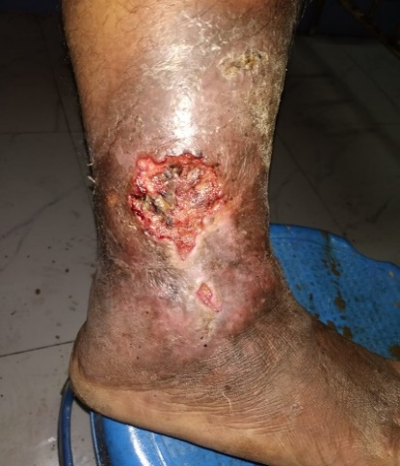 | 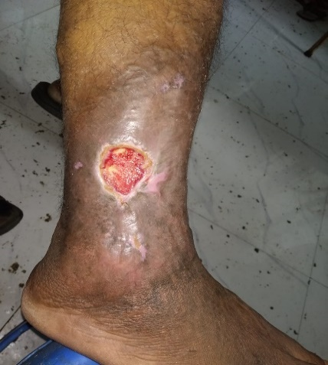 | 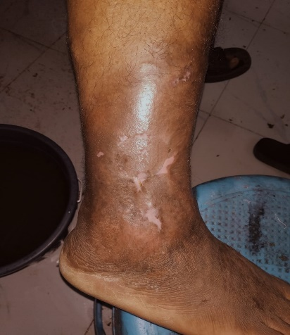

PROBABLE MECHANISM OF ACTION OF PANCHAVALKALA KWATH DHAWAN KARMA –
This herbal mixture is composed of following five astringent herbs-
- Nyagrodha (Ficus benghalensis)
- Udumbara (Ficus glomerata)
- Ashvattha (Ficus pedigiosa)
- Parisha (Thespesia populanea)
- Plaksha (Ficus lacor)

Panchavalkala possess astringent property which is responsible for wound contraction and increased rate of epithelialization in the granulation formation and scar remolding phase. Panchvalkala have both Shodhana and Ropana properties which promotes wound healing. It is also having kledaghna property which removes vikruta kleda from the dushta vrana which is the main cause for the varicose ulcer. Panchvalkala kwatha also shows raktashuddhikar and vranaropana property which is helpful for wound healing process.
It can be concluded that anti- microbial, anti- inflammatory and wound healing property of panchvalkala is useful in the management of chronic non healing wound. Along with this sukshma triphala vati (Triphala and kajjali) 500mg internally was given which is having kledagna, lekhaniya,jantughna and Yogavahi property. Due to yogavahitva and anti-microbial property of kajjali wound healing process is promoted rapidly with no any complications.

CONCLUSION
With Panchavalkala kwath Dhawan and sukshma triphala the non- healing varicose ulcer completely healed within 30 days. On the basis of this study Panchavalkala kwatha dhavan proved its efficiency as wound healing property by its antimicrobial, anti-inflammatory, free radical scavenging activity with clinical results of early wound healing. None of complications like severe bleeding, wound infection or hypersensivity were observed during the therapy. Though treating non healing ‘Varicose Ulcer’ is difficult task ,we have managed to treat it with Panchavalkala kwatha Dhawana along with sukshma triphala internally.
REFERENCES –

- Dr. Anant Ram Sharma, Varanasi; Choukhamba Surbharati Prakashana; Susruta Samhita chikitsa sthan 1/8; volume 2; pg. no.154
- Dr. Anant Ram Sharma, Varanasi; Choukhamba Surbharati Prakashana; Susruta Samhita chikitsa sthan; volume 2; pg. no.157.
- Venous ulcer. [Last accessed 0n 2013 March 21]. Available from: http://www.en.wikipedia.org/wiki/Venous_ulcer.
- Das S. 1st ed. Disease of veins edition published by S. Das publication 13, old mayors’ court Calcutta; A concise textbook of surgery.
- Margolis, Bilker W, Santanna j, Baumgarten M. Venous leg ulcer: Incidence and prevalence in the elderly. J Am Acad Dermatol. 2002:46:381-6. [Pub med].
- Dr. Anant Ram Sharma, Varanasi; Choukhamba Surbharati Prakashana; Susruta Samhita; pg. no. 291.

