  I J – R I M | AYURLINE | e-ISSN: 2456-4435  July- Sept. 2021  Vol. 05th Issue:3rd
International Journal of Research in Indian Medicine

The role of dviharidradi taila locally in the managment of mukhadushika w.s.r.to acne vulgaris –a case study
Dr. Sneha Z. Borutkar, Dr. Mamta S.Jaiswal, Dr. Suryaprakash K. Jaiswal

PG Scholar
Guide & Assistant Professor
HOD,
Dept. of Kayachiktsa, DMM Ayurved Mahavidyalaya, Yavatmal.

ABSTRACT-
Acne vulgaris is a common chronic disease involving blockage and /or inflammation of pilosebaceous units.Acne can presents as noninflammatory lesions ,inflammatory lesions,or a mixture of both ,affecting mostly the face but also the back and chest.Typical features of the condition include blackheads or whiteheads,pimples,oily skin and possible scarring .It primary affects skin with a relatively high number of oil glands,including the face ,upper part of the chest and back.The resulting appearance can lead to anxiety ,reduced selfesteem and in extreme cases depression . It is the commonest dilemma associated with complexion and smoothness of skin .sometimes leading to major skin problem, which is characterized by macula, papulo, pustular eruption on the skin especially on the face.A both male and female gender of adolescent age group is commonly affected
Genetics is the primary cause of acne in 80%of cases.The role of diet and cigarette smoking in the condition is unclear and neither cleanliness nor exposure to sunlight appears to play a part.In both sexes ,harmones called androgens appears to be part of the underlying mechanism,by causing increased production of sebum.
In Ayurvedic prospective Acne Vulgaris can be correlated with Mukhadushika .Mukhadushika is explained by Aacharya Sushruta under kshudra rogas and is considered as swatantra vyadhi in the ayurvedic literature .It is characterizes by shalmali kantaka sadrusha pidika on face . Mukhadushika is also called as Tarunya pitika. Tarunya pitika word itself says that it is pittikopatti in taurnya awastha due to some hormonal changes,up to limit it is normal but in excess it Becomes a reason for depression in a person. In modern Era, physicans came across so many patients suffering from the disease ,mukhadushika .The prevalence of mukhadushika increasing day by day due to their fast lifestyle ,consumption of food ,constipation,late night sleep,fast food ,cold drinks leads to imbalance in doshas which in turns affects body as well as mind.

Keywords – Mukhadushika ,Ksudraroga,Dviharidradi Taila ,Acne Vulgaris

INTRODUCTION-
Mukhadushika is a type of kshudraroga described in Ayurvedic classics. The classical symptoms of mukhadushika described in Ayurveda resembles with modern disease Acne Vulgaris . Acne vulgaris is a common chronic disease involving blockage and /or inflammation of pilosebaceous units.Acne can presents as noninflammatory lesions ,inflammatory lesions,or a mixture of both ,affecting mostly the face but also the back and chest.Typical features of the condition include blackheads or whiteheads,pimples,oily skin and possible scarring .It primary affects skin with a relatively high number of oil glands,including the face ,upper part of the chest and back.The resulting appearance can lead to anxiety ,reduced selfesteem and in extreme cases depression . It is the commonest dilemma associated with complexion and smoothness of skin .sometimes leading to major skin problem, which is characterized by macula, papulo, pustular eruption on the skin especially on the face.A both male and female gender of adolescent age group is commonly affected.Allopathy treatments includes for all forms of acne as topical retinoids and benzyl peroxide ,orally antibiotics ,steroids ,oral isotretinoin.but these allopathy medicine does not treat permanently and also shows severe side effects. Using the Ayurveda is safe and better option in the long run .Dviharidradi Taila is described in the Ayurvedic classical text bhaishjya ratnavali under the kshudra rogadhikara. Describing the properties of this oil ,it is said that applying dviharidradi taila on the face every day removes piplav,tilakalaka,nilika ,vyanga and mukhadushika .Dviharidra taila contains 14 herbal drugs.These include Haridra , Daruharidra ,Yashtimadhu ,Kaliyak kashta, Raktachandan, Prapondarik , Manjishta,padma, Padmak, Kumkum ,Kapittha,Tinduk , Plaksha And Vata . The effect of these substances is Varnya,Kandughna, Ropana ,Shothahara,Vranaropana,Stambhana ,Raktashodhana etc. Dviharidradi taila is use in a case of mukhadushika was successfully treated.Marked improvement was observed in sign and symptoms after treatment .No any complications was found during treatment.
AIM- To evaluate the effect of Dviharidradi Taila locally in Mukhadushika for 45 days.
OBJECTIVE – To study the effect of Dviharidradi Taila in Mukhadushika.

CASE REPORT-
A 21 years old college going female student presented to a L.K.Ayurvedic hospital,Yavatmal , Maharashtra ,with complaints of
1.Mukhavaivarnya (Discolouration )
2. Pidaka
3.Strava (Discharge)
4. Kandu (Itching)
5.Ruja(Pain)
On right cheek ,left cheek ,forehead, nose and chin.
Patient having above complaints since 1 years.The patient was alright before 1 year.Gradually Pimples started coming on forehead,both cheeks and nose. associated with Strava , Kandu & Ruja.While taking history her menstrual cycle was normal.she had chronic constipation and she used number of allopathy creams and lotions and soaps for the treatment of pimples in the past but did not get satisfactory results and for further management she came L.K.Ayurved Rugnalaya.
N/H/O – HTN,DM,Thyroid
No any H/O major illness

EXAMINATION ON DAY 1
On examination , 5mm and 2mm size pimples present with pinkish discolouration along with thick pus discharge (on & off). The large Pidaka measured 5mm on right cheek and forehead.The patient also had Itching and Pain . On the basis of symptoms such as Shalmali kantakvat pidaka, Ruja(Pain),Pustules ,Number of pidaka, Pus filled boils,Strava from lesions(discharge), Mukhavaivarnya (Discolorations) ,Kandui(Itching) present in patient ,she was diagnosed as having mukhadushika .Informed consent was obtained from the patient for case study.
Rugna Parikshana –
Nadi -82/ min
Mala (Stool)- Malabaddhata
Mutra(Urine) - Prakrut
Jivha (Tounge)- Saam(Coated)
Netra(Eyes)- Shwetabh
Shabdha(Speech)- Spashta
Sparsha(Skin)- Samshitoshna
Aakriti- krush
Bala - Alpa bala
Raktachaap- 110/60 mmhg

MATERIALS AND METHODS METHODS
METHOD
1.Case Study.
2.Center of study -Postgraduate Department of kayachikitsa ,L.K.Ayurved Hospital ,Yavatmal affiliated to D.M.M.Ayurved college Yavatmal.

MATERIAL
Treatment plan
Table 1 –Showing materials of case study
Sr.no | Dravya | Dose | Matra
1 | Dviharidradi taila | Local application as per area | Twice a day

OBSERVATION –
The patient was assessed for following lakshanas (Symptoms)
Sr.no | Lakshanas/Symptoms | Before Treatment | After 15days of Treatment | After 45 days of Treatment
1. | Mukhavaivarnya(Discoloration) | +++++ | ++ | -
2. | Kandu(Itching) | +++ | - | -
3. | Daha(Burning Sensation) | +++ | - | -
4. | Strav(Discharge) | ++++ | + | -
5. | Ruja(Pain) | +++++ | - | -
6. | Pitika | +++++ | ++ | -
7. | Aakar | 5mm,2mm | - | -
DISCUSSION –
Hetu-

SR.NO | AHARAJ | VIHARAJ | MANSIKA | VAYA
1 | Upavasa | Malabaddhata | Krodha | Tarunaavastha/  Yuvanavstha
2 | Abhishyandi | Chardi  Vegavarodha | Chinta | Tarunaavastha/  Yuvanavstha
3 | Atikatu | Ratrijagarana | Shoka | Tarunaavastha/  Yuvanavstha
4 | Atitikta | Panchakarma apachara | Kshobha | Tarunaavastha/  Yuvanavstha
5 | Atiamla | Diwaswap | Santap | Tarunaavastha/  Yuvanavstha
6 | Atilavana | Aswacchata |  | Tarunaavastha/  Yuvanavstha
7 | Atisingdha |  |  | Tarunaavastha/  Yuvanavstha
8 | Atiguru |  |  | Tarunaavastha/  Yuvanavstha
9 | Picchila |  |  | Tarunaavastha/  Yuvanavstha

SAMPRAPTI GHATAK-
1.Dosha –Kapha vata pitta
2.Dushya – Rara ,Rakta,Mamsa,Medas
3.Strotas – Swedawaha , Raktawaha,Rasawaha
4.Mala – Sweda,,Twakasneha
5.Srotodushti – Sanga,Atipravrutti
6.Agni – Jatharagni mandya
7.Rogamarga – Bahya marga
8.Udbhavsthan-Amashayotha Vyadhi beacause the main Dosha of the disease is Kaphadosha
9.Adhishthan – Mukhapradesha,Tvak

RESULLT –
With Dviharidradi taila local application Mukhadushika healed completely within 45 days i.e,patient was cured from mukhadushika the image during ,between and after treatment supports the statement mentioned .

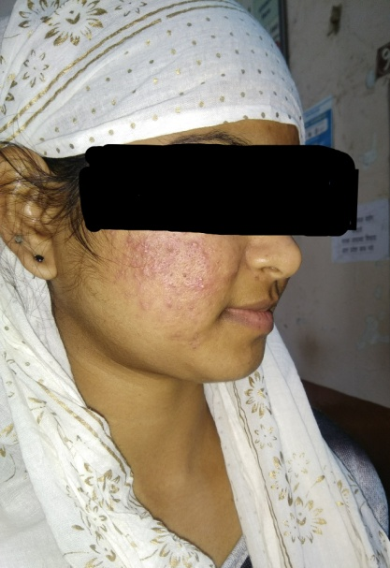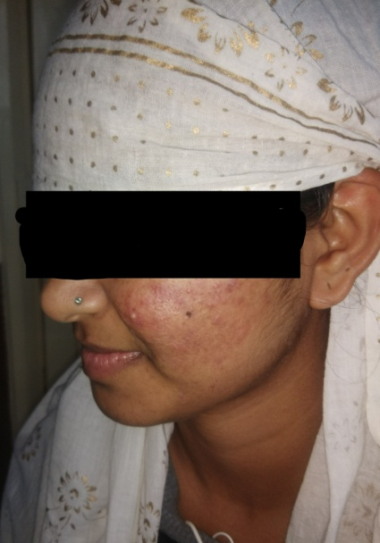
Before treatment
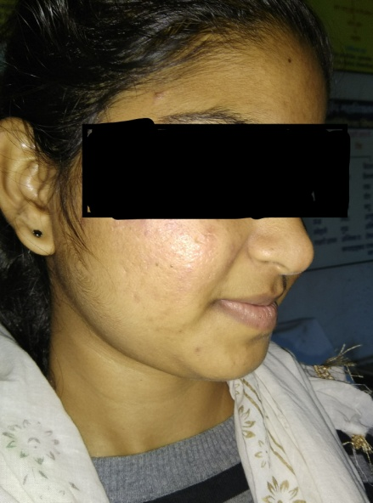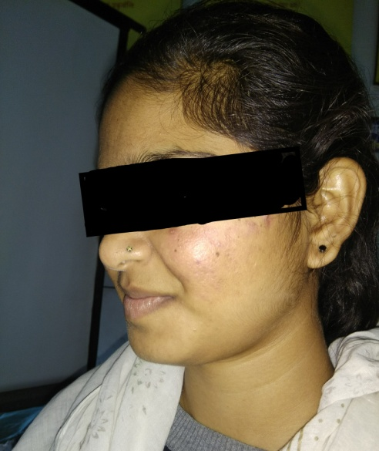
After treatment

Probable mechanism of action of Dviharidradi Taila local application karma
/Mode of Action of Drugs used in formulations-

Sr  no | Drug name | Latin name | Family | Rasa | Guna | Virya | Vipaka | Karma
1. | Haridra | Curcuma Longa | Zingiberacae | Katu  Tikta | Ruksha | Ushna | Katu | Varnya  Kushtaghna  Krimighna
2. | Daruharidra | Berberis Aristata | Berberidaceae | Tikta  Kashay | Laghu  Ruksha | Ushna | Katu | Shophahara  Vranajit  Kandu  Kushtahara
3. | Yashtimadhu | Glycerrhiza Glabra | Leguminosae | Madhur | Guru  Singdha | Sheeta | Madhur | Varnya  Shothahara  Kandughna  Vedanasthapana
4. | Kaliyak | Aquilaria Agalocha | Thymelaeceae | Tikta  Katu | Laghu  Ruksha  Teekshna | Ushna | Katu | Vranashodhana
5. | Raktachandan | Ptero Carpus Satalinus | Leguminosae | Tikta | Guru  Ruksha | Sheeta | Katu | Raktashuddhikara  Dahaprashamana
6. | Prapondarik  (Blue lotus) | Nymphaea Nouchali | Nymphaeaceae | Kashay  Madhur  Tikta | Laghu  Snigdha  Picchila | Sheeta | Madhur | Varnya  Dahaprashamana  Sthambhana
7. | Manjishtha | Rubia Cardifolia | Runiaceae | Tikta  Kashay  Madhur | Guru  Ruksha | Ushna | Katu | Shothahara  Vranaropana  Kushtaghna
8. | Padma | Nelumbo Nucifera | Nelumbonaceae | Kashaya,Madhura  Katu  Lavana  Tikta | Guru  Ruksha | Sheeta | Madhur | Varnya  Dahashamaka  Krimighna
9. | Padmak | Prunus Cirasoidus | Rosaceae | Tikta  Kashay | Laghu  Sheet | Sheeta | Katu | Vranaropana  Shothahara
10. | Kumkum | Crocuss Sativus | Iridaceae | Katu  Tikta | Snigdha | Ushna | Katu | Varnya  Shothahara
11. | Kapittha | Limonia Acidissima | Rutaceae | Madhur  Amla  Kashaya | Laghu | Sheeta | Madhur | Vrananasha  ,lekhana
12. | Tinduk | Diospyrous Peregrina | Ebenaceae | Kashay | Laghu  Ruksha | Sheeta | Katu | Shothahara  Stambhana
13. | Plaksha | Ficus Lacor | Moraceae | Kashay | Guru  Ruksha | Sheeta | Katu | Raktashodhana  Shothahara  Vranaropana  Stambhana
14. | Vata | Ficus Bengalensis | Moraceae | Kashay | Guru  Ruksha | Sheeta | Katu | Vranaropana  Shothahara  Vedanasthapana
15. | Tila taila | Sesamum Indicum | Pedaliaceae | Madhur  Kashaya  Tikta | Guru  Snigdha  Tikshna  Sukshma  Vyavai  Sara | Ushna | Madhur | Vranhit  Twachya  Shoolanashan  Vataghna

DISSCUSSION – Ayurveda describes the development of Mukhadushika due to vitiation of vata and kapha dosha.These vitiated doshas further vitiates rakta dhatu ,which inturn leads to vitiation of medadhatu.Due to this Medodhatu dushti excessive sweda is formed,which gets deposited in romakupa and produce swedavhastrotas dushti which leads ultimately to Mukhadushika .we selected shaman aushada like Dviharidradi Taila for study . Dviharidradi Taila is described in the Ayurvedic classical text bhaishjya ratnavali under the kshudra rogadhikara. Describing the properties of this oil ,it is said that applying dviharidradi taila on the face every day removes piplav,tilakalaka,nilika ,vyanga and mukhadushika .Dviharidradi taila contains 14 herbal drugs.These include Haridra , Daruharidra ,Yashtimadhu ,Kaliyak kashta, Raktachandan, Prapondarik , Manjishta,Padma , Padmak, Kumkum ,Kapittha,Tinduk , Plaksha And Vata . The effect of these drugs is Varnya,Kandughna, Krimighna ,Ropana ,Shothahara,Vranaropana,Stambhana ,Raktashodhana ,Varananashana ,Lekhana etc. Modern science uses Systemic antibiotics are mainstay in the treatment of moderate to severe inflamatory acne vulgaris .also they use birth control pills for harmonal balancing,Isotretinoin and laser therapy which does not treat permanently and also shows severe side effects.

CONCLUSION- Dviharidradi Taila is effective on Mukhadushika without any side effect.

REFERENCE –
1.Sharma Dinesh Chandra ,Chahas Devendra ,Singhal Harish Kumar, Meena M.S.
‘A scientific study on rakta Dhatu and its related disorder and effect of varnya Mahakashaya ghanvati and Chandraprabalepa in the mamagement of yuvana pitika ‘Acne vulgaris ’’/ IJA Pharma Research .2014;2(2);page no 33-39
2. Shastri Ambhikadatta ,Shuruta Samhita Nidan Sthana /chap 13 th /Chaukhamba Sanskrit Sansthan Publication reprint 2018 ;page no 365.
3. Tripathi B,Ashtang Hriday Uttarsthana 31 st chapter /Chaukhambha Sanskrit Publication ,Reprint 2015;page no 1113.
4. Sharma Monika ,Sharma Anita ,Sani Rashmi ,A conceptual study of Ayurvedic Management of Mukhadushika W.S.R. To Acne Vulgaris ,IJA Pharma Research sept 2016 ;4(9 p);Page no 78 -82.
5.Tripathi B, Ashtang Hridaya ,Uttarsthana 32 chapter /Chaukhambha Sanskrit publication ,reprint 2015 ;page no.1119
6.Seth Vikas ,Mishra Anuj “Acne Vugaris Management: Whats new and whats still true?”/International journal of Advance in medicine , feb 2015 ;2(1);page no 1-5.
7.Ambikadatta shastri ,Bhaishajya ratnavali khudrarogadhikar /chaukhambha Sanskrit sansthan
8. EFFECT OF SHODHANA AND SHAMANA CHIKITSA IN MUKHADUSHIKA (ACNE VULGARIS )A CASE STUDY.-EKTA SHARMA ,ANUPJAIN,ARUN GUPTA.
9.Sushruta samhita ,sutra sthana ,46/525,editor yadavji trikamji acharya,9 th ed.varanasi chaukhambha orientila.
10.Sushrut samhita aacharya yadavji trikamji ,nidansthana 13/39, choukhambha publication 2005 varanasi.
11.Gaurav Gaur ,Suneel pal and kulratan ;YUVANPIDAKA - A CONCEPTUAL STUDY W.S.R.ACNE VULGARIS :AYUSHDHARA ;An International Journal of Research in AYUSH and Allied Systems ;2018 ;January – February ;Vol5 ;Issue 1;Page 1564 -68.
12. Jayaram Krishna M,Gopikrishna ,Rashmi pujar and Nandesd Mohan ;A Review on Samprapti and Lakshana of Mukhadushika with special reference to Acne Vulgaris

Conflict of Interest: Non | DOI  https://doi.org/10.52482/ayurline.v5i03. | Source of funding:  Nil
Cite this article:
D
Ayurline: International Journal of Research In Indian Medicine 2021; 5(3):01-

