AYURVEDIC APPROACH IN TREATMENT OF URETHRAL STRICTURE BY UTTARBASTI WITH A CASE PRESENTATION

Dr. SANGRAM K. INDORE
M.S. shalya
Professor
Yashwantrao ayu college,Aurangabad

Abstract
Urethral stricture is a common condition that can lead to serious complications such as urinary infections and renal insufficiency secondary to urinary retention. Treatment options include catheterization, urethroplasty, endoscopic internal urethrotomy, and dilation. Optical internal urethrotomy offers faster recovery, minimal scarring, and less risk of infection, although recurrence is possible. However, technical difficulties associated with poor visualization of the stenosis or of the urethral lumen may increase procedural time and substantially increase the failure rates of internal urethrotomy.In ayurved uttarbast has definate contribution which encourages us to find solution for this burning problem of soceity.Uttarbasti is a prime approach for mutraghat.so this topic was chosen for review

KEYWORDS- Urethral stricture, mutraghat ( mutrotsang), Urethral dilatation,uttarbasti

URETHRAL STRICTURE
Urethral strictures are fibrotic narrowings composed of dense collagen and fibroblasts. Fibrosis usually extends into the surrounding corpus spongiosum, causing spongiofibrosis.
These narrowings restrict urine flow and cause dilation of the proximal urethra and prostatic ducts. Prostatitis is a common complication of urethral stricture. The bladder
muscle may become hypertrophic, and increased residual urine may be noted.

Acquired urethral stricture is common in men but rare in women. Most acquired strictures are due to infection or trauma.
- Infection-
Although gonococcal urethritis is seldom a cause of stricture today, infection remains a major cause—particularly infection from long-term use of indwelling urethral catheters.
- Trauma-
- Internal trauma-
Large catheters and instruments are more likely than small ones to cause ischemia and internal trauma.
- External trauma-
for example, pelvic fractures can partially or completely sever the membranous urethra and cause severe and complex strictures. Straddle injuries can produce bulbar strictures.

Clinical Findings
A. SYMPTOMS AND SIGNS
1.A decrease in urinary stream is the most common complaint.
2.Spraying or double stream is often noted, as is postvoiding dribbling.
3.Chronic urethral discharge, occasionally a major complaint, is likely to be associated with chronic prostatitis.
4. Acute cystitis or symptoms of infection are seen at times.
5.Acute urinary retention seldom occurs unless infection or prostatic obstruction develops.
6. Urinary frequency
7. mild dysuria may also be initial complaints.
8.Induration in the area of the stricture may be palpable.
9. The bladder may be palpable if there is chronic retention of urine.

B. LABORATORY INVESTIGATIONS-
1.haemogram
2.urine r and m
3.rfts
4.uroflowmetry
C. X-RAY INVESTIGATIONS-
urethrogram (RGU) or voiding cystourethrogram .
D. INSTRUMENTAL EXAMINATION-
Urethroscopy

Treatment
A. SPECIFIC MEASURES
1. Dilation—
Dilation may initially be required because of severe symptoms of chronic retention of urine. The urethra should be liberally lubricated with a water-soluble medium before instrumentation. First, a 22F sound should be passed down to the stricture site and gentle pressure applied. If this fails, a 20F sound should be used. Smaller sounds should be used with care, because they can easily perforate the urethral wall and produce false passages. Bleeding and pain are major problems caused by dilation.

2. Urethrotomy under endoscopic direct vision—
Lysis of urethral strictures can be accomplished using a sharp knife attached to an endoscope.

3. Surgical reconstruction—If urethrotomy under direct vision fails, open surgical repair should be performed. Short strictures (≤2 cm) of the anterior urethra should be completely excised and primary anastomosis done. Strictures >2 cm in length can be managed by patch graft urethroplasty.

Prognosis
A stricture should not be considered “cured” until it has been observed for at least 1 year after therapy, since it may recur at any time during that period. Urinary flow rate measurements and urethrograms are helpful to determine the extent of residual obstruction.

MATERIALS AND METHODS-
- Til taila-30ml
- Madhu-10ml standard and Authentified drugs
- Saidhav-10gm
1.2.3. Mixed together and autoclaved in glass bottle.
4. xylocain gelly 2؉
5. Male urethral dilators
6. Foleys catheter no.16
CASE STUDY-
Utratral stricture
Pt.name. xyz
Age-71 yrs/ male
Add-wagholi pune
Occupation- farmer
Opd no.12863
Ipd no.14/542
Dt of first visit- 23/05/2019
Chief complains-
1.Burning micturation since 1yr
2.Dribbling micturation since1yr
3.Dysurea since1yr
4.Pain in abdomen since 1yr
5.Acute on chronic retension of urine since 3days

History of present illness-
1. Pt was having symptoms of chronic retension of urine since 1to1.5 yrs.
2. two days before date of admission pt was admitted in pvt hospital for acute retension of urine with urosepsis where he was operated for suprapubic cystostomy under L.A
3. In pvt hospital pt was advised surgical procedure for urethral stricture. Pt came in Dhanwantari Hospital.wagholi to avoid surgical procedure.
Past history-
No any
General examination-
G.C. good , afebrile
Pulse-66/min
B.P-130/80 mm of hg
c.v.s- s1s2 normal
c.n.s-concious and oriented
r.s- mild bil. Basal crepts.
R/R-20/min
P/A . soft mild tenderness over lower abdomen

1.Lab investigation-
hb-9 gm%
wbc-15900/cumm
r.b.c-3.90 millions/ul
dc- N-92, L-06, E-1, B-00, M-01
plt-167000/cumm
bsl®- 118 mg/dl
B.U.L- 122 mg/dl
Sr. creatinine-3.1 mg/dl
Urine r and m-
Pus cell-30-40/hpf
Others normal

2. USG(ABD+PELVIC)
Bladder shows minimally thickened irregular wall s/o chronic cystitis. Other no obivious abnormality seen.
3.RGU-
Distal penile stricture 2cm length
Penoscrotal junction stricture 2cm length

DIAGNOSIS – Urethral stricture

CAUSE- infective cause
PROCEDURE OF UTTARBASTI-
Pre-op-
Prepare
Informed written cosent
Pre op iv antibiotics, antacids and antiemetics
Stanik Snehan with til taila and swedan with bashpa sweda
Operative-
- Supine position given
- Painting and drapping done
- Xylocain gelly 2% 10cc inserted thr penile urethra
- Then urethral dilation done with male urethral dilator 22f.
- Suprapubic cather which is previously inserted clamped.
- Uttar basti preparation 40cc inserted by bladder syringe into bladder thr urthra.
- Then Foleys cather inserted thr urethra and clamped.
- Pt then shifed in word in good condition.

Post op-
1.After 3 hr urethral clamp released.
2. clear urine with uttarbasti preparation seen in urosac.
3. pt discharged on same day with open urethral catheter and clamped suprapubic catheter.
4. pt dischared with
a)Bruhat varunadi kadha 4tsf tds
b) Gokshuradi guggulu 2bd
c) Chandraprabha vati 2bd
for 7 days
5.pt advised f/u after 7days.
FOLLOW UP CHART-
f/u.no | Date | Complain |  | Uttarbasti procedure | Rx given
  wbc | bul | Sr.creat | P.C in urine
1 | 31/05/19 | 1.pain in abd. Less  2.no other  complain | 10000 90 2.00 10-20 | Done.  Suprapubic catheter removed | Same as above
2 | 07/06/19 | 1.no pain at all | 7500 45 1.2 5-10 | Done | Same as above
3 | 14/06/19 | No any fresh complain | 7000 35 1.1 1-2 | Done.  Then urethral catheter removed.  Pt passed urine with good flow  Stream. No dribbling. | Same as above
4 | 20/06/19 | No any fresh complain.  No burning, no driblling,  Good urine flow stream | 7300 30 1.00 3-4 | R.G.U DONE.- no urethral stricture seen.  Uroflowmetry-  16ml/sec | Same as above

DISCUSSION-
- Main cause of urethral stricture is chronic cystitis and uretritis.
- After urethral dilatation urethral narrowing get wide.
- After use of uttarbasti chronic infection of bladder and urethra get significant reduced and cured.
- During treatement Leucocytosis, renal fuction tests, and pus cells in urine show significant curative changes.
- Uroflowmetry show good urine flow after treatement.
- RGU- show no urethral stricture seen after treatement.

MODE OF ACTION-
1.Main cause for urethral stricture is chronic infection of urinary bladder which is controlled and cured by uttarbasti.
2. Urethral dilatation also help in release urethral stricture.
3.Til Tail ( omega 6) has antioxidant and antibacterial properties.
4.Madhu is demulsent, antioxidant, strengthens the wbc which fight against bacterial and viral diseases, initiate growth of healthy granulation tissue.
5. Saindhav-84 elements na+ ,mg+, ca2+- healing, improve circulation, remove toxine.

CONCLUSION-
1.pt adviced surgical treatment in private hospital, but by using standard uttarbasti procedure surgery should be avoided.
2. uttarbasti show best result in infective urethral stricture.
3.It can be given on OPD basis and patients do not require any hospitalization
4.procedure is cost effective
5. It proves to be a significant tretement in urethral stricture.

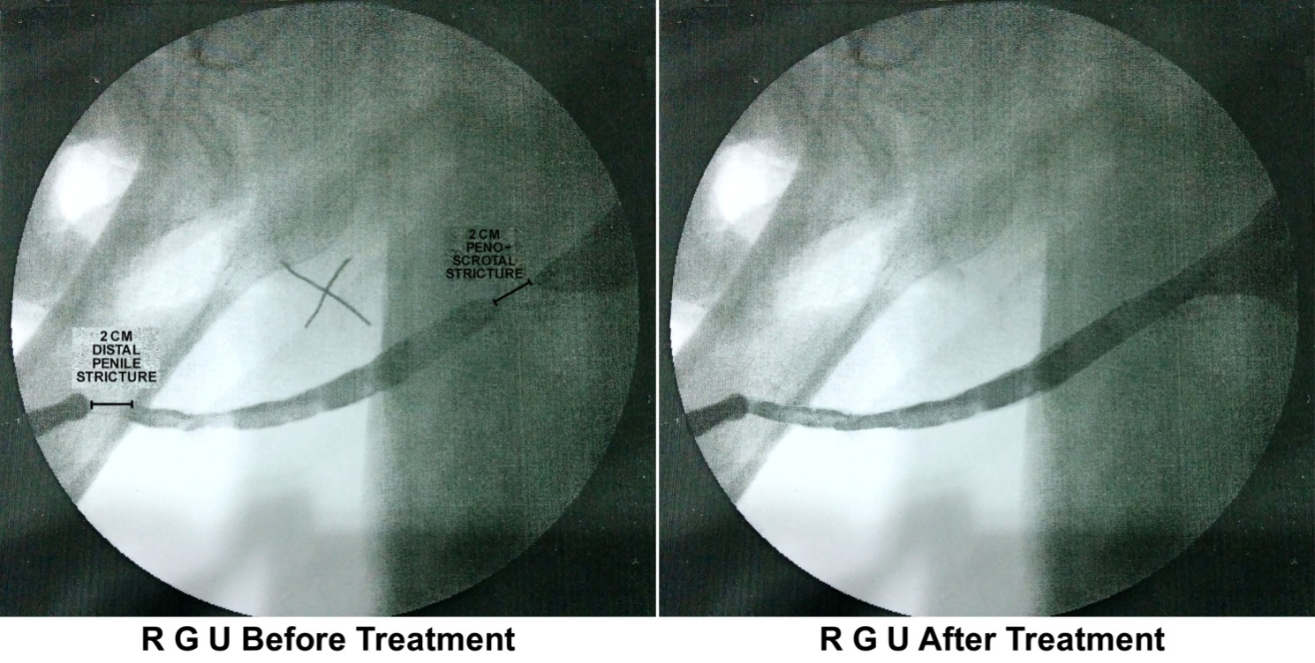

REFERANCES-
- Shalya Tantra vignanam; Dr. Ram Sundar Rao, G.S.I.M. ; Vijayavada,
2002Saushruti; Dr. Ramanath Dvivedi, M.A. A.M.S. Ph.D., Eighth
edition, 1998, Chaukhamba Amarbharati Prakashan-varanasi-22100.
- Sushruta-Samhita: Sutrasthanam Sanskrit Text with
“Ayurvedarahasyadipika” Hindi Comentry; Dr. Bhaskar Govind
Ghanekar B.Sc. MBBS., Reprint 1998,Meharchand Lachhmandas
Publications, New Delhi 110002 India.
- Dravya Guna Vidnyan; Prof. Vd, Vishnu Mahadev Gogate, First Edition
11 Feb 2008,Vaidya Mitra Prakashan, Pune.
- Dhanvantari Nighantu; Prof. Priya Vrata Sharma, Fourth Edition 2005,
Chaukhambha Orientalia, Varanasi.
- Bhavaprakasha Nighantu of Shri Bhavamishra, Dr. K.C.Chunekar,
A.M.S, Reprint 2006, Chaumhambha Bharati Acadamy, Varanasi.
- charaka Samhita : Pandit Kashinath Pandey, Dr. Gorakhnath
Chaturvedi , Choukhamba Bharati Academy ,2001
- Sushruta Samhita : Kavi.Dr.Ambikadatta Shastri , Choukhamba Bharati Academy , 2007
- Bhaishajya ratnavali: kaviraj shri govinddassen;edited by prof.sidhhinandan Mishra, Chaumhambha SurBharati prakashan, Varanasi, 2009
- Bhaishajya kalpana vidnyan, dr.awadhbihari agnihotri, Choukhamba Bharati Academy ,1987.
- Surgery Notes, Second Edition, Reprint Nov.2000, D.K.Publishing Hous
- Schwart’s Principles’ of Surgery; F.Charles Brunicardi, M.D. F.A.C.S., Eight Edition2005, Mc GRAW-HILL Medical Publishing Division.
- Manipal Manuel of Surgery; K. Rajgopal Shenoy MBBS. M.S.,, Second Edition, CBS Publishers and Distributors, NEW Delhi, India.
- Smith ‘general urology,17th edition,Mc Graw hill.
- http://iex123.hubpages.com/health-benefits-of-sesame-oil
- http://pradiiphira.hubpages.com/hub/honey-ayurveda
- http://ayurvedicdietsolutions.com/saindhav-salt.php

